OCR GCE A COMPUTER SCIENCE PROJECT H446-03

Name : Yonis Mahamed

Title Of Project: Maze Hunters

Analysis 1

Game 1

Stakeholders 1

Platform 2

User needs 2

Research 2

Interview Plan 3

Interview with Dheemaan 4

Interview with Joyal 4

Interview data review 5

Features of the proposed solution 5

Limitations and scope 7

Computational methods 8

Abstraction and Visualisation 8

Thinking ahead 8

Thinking procedurally 9

Thinking logically 9

Thinking concurrently 9

Hardware and software requirements 10

Success criteria 10

Design 13

Systems diagram 13

Decomposition of the problem 14

Key variables and structures 18

Key classes and attributes 18

Explanation and justification of data structures 21

Algorithms 22

Usability features 30

Explanation and justification of user interface 30

description and justification of usability features 35

Description and justification of validation required 35

Identification and justification of test data to be used during development 35

Test data for alpha testing 38

Developing the coded solution 40

Iterative development 40

Game setup 40

Setting up the menu 42

Setting up game states 46

Making the setting and help menu 51

Making the unit selection menu 58

Making the player character, computer character and maze 62

Making attacks for the units selected in the unit selection menu 70

Pathfinding for the computer-controlled units and unit collisions 75

Finishing the game 81

Evaluation 97

Testing to inform evaluation 98

Usability Features 101

Commentary on how well the solution matches the requirements 102

# Analysis

## Game

My game is a real time arcade style strategy game called Maze Hunters where the player battle with the computer to collect and retrieve a special item. Set in a maze-like cave, the player will control a special “hero” unit with its special weapons and command some soldiers to fight and retrieve the item from the centre. The player can also find various items randomly generated in the map to either receive upgrades or to collect gold to unlock new soldiers to purchase. The player will need to carefully spend their gold to make sure that they can buy the units that they need to buy. “hero” units from both sides can respawn if killed but the soldiers they command must be replaced. For the player, I’ll just use the keyboard to control the movement, for the soldiers, I’ll use the mouse to move them and for the computer and its soldiers, I will use a pathfinding algorithm.

## Stakeholders

A stakeholder is anyone who has an interest in the game that I am making. People who would be interested in my game are people familiar with the real -time/turn-based tactics genre or people who have played board games such as chess or checkers which those games are based off. Although my game will not have chess-based combat where every piece can instantly defeat another, the strategic long-term planning in chess will be present in my game. If they have played games like stick of war or even League of Legends, then they would have some familiarity with some of the features in my game. The game also is a bit difficult so young kids would have a harder time with this game so I would recommend for at least 11 or older. The game also isn’t gory or bloody so any age would be able to play it.

One stakeholder I can interview is Joyal. He is very familiar with chess and checkers since he’s played them for several years so he has a massive understanding of how strategic games should function. He has also played arcade games such as bomb it which also has the maze-like gameplay that is included in my project.

Another stakeholder that I can identify is Dheemaan since he has also played chess and therefore also has a massive understanding as to what makes strategy games enjoyable. He is less familiar with strategy games than Joyal but this would cause him to answer my questions from a different perspective than Joyal to give me more varied answers.

## Platform

The game will be designed to be played and run on PC and not console or mobile. The reason for this is because the target audience for strategy games on mobile or console is much smaller than on PC so going out of my way to port the game for those platforms would be unnecessary. Also, mobile has limited controls so I would have to fill my game with GUI which will make the game cluttered. The game will also be on desktop and not web based since web-based games aren’t as popular as desktop games and web-based games would require a lot of optimisations.

## User needs

The game is a long-term “tug of war” type strategy game so many features will need to be implemented to achieve that. To prevent the players from being too exploitive of the game's mechanics, random rewards will be used to make sure that the battle isn’t always in the favour of the player or the computer. The players and the computer will also have some way of levelling up to reward/punish the player, to increase/decrease difficulty and to combine quick thinking with long term strategy. The game will also use multiple controls to prevent the game from being cluttered with unnecessary GUI. The game would also require many different player characters with various different abilities to allow to provide the player with a variety of playstyles and strategies.

## Research

Stick war legacy is a strategy game in which stick warriors battle in a war of attrition against other stick warriors. The game has two modes: endless and campaign mode. In both modes, the player can summon miners to mine the gold ores to collect gold coins to purchase soldiers that the player can command to fight the enemy. The player also has a main statue to protect because if the statue is destroyed by the enemy, then the player loses. In endless mode, the player must survive as many days as possible against the endless waves of zombies with each day getting more difficult than the last. In campaign mode however, the player will fight against many different enemies with their own statues to destroy. The player can also upgrade troops in between these campaigns to face the progressively difficult levels. There are also spells that the player can purchase to interfere with the battle by either healing/upgrading the troops or by harming the enemy. The attrition style combat present in this game is a feature that I would really like to include in my game. I like to have battles that prolong over time to increase the tension and unpredictability of the battle.

Totally accurate battle simulator is more of a simulation game that an arcade style strategy game but still bears some aspects of those types of games. In TABS, the player can play in campaign mode or a sandbox mode. In sandbox mode, players can place down any units they want on both sides and have them fight in a battle. The units are physics based to make the combat more entertaining to watch. All the units have a rock, paper scissors style balancing where each unit has counters and can counter other units. The game is more of a comedic parody with its wacky physics making the battles more comedic than serious. But I do think that the game is well balanced with every unit, no matter how powerful, still having some exploitable weakness. The reason I believe this to be the case is due to the subtle “classes” that the units fit in. Despite the massive variation in the abilities and uses of the units, they all can be fitted into “classes” with their own strengths and weaknesses. This is a feature that I want to fit into my game.

Pac-man is a maze arcade game rather than a strategy game but still contains features that I want to include in my game. The player plays as Pac-man in an enclosed maze and tries to eat all the dots in an enclosed maze whilst avoiding several ghosts in the process. If the player eats all the dots, then they advance to the next level but if they touch one of the ghosts then they lose a life. When the player loses all their lives then they lose the level. There are four “power pellets” at the corners of the maze. When the player eats one of them, the ghosts turn blue and run away from the player. The player will eat the ghosts when they are touched by the player which causes the ghost’s eyes to return to the centre of the maze to return to normal. The four ghosts have their own unique AI where the red ghost chases the player, the pink and cyan ghost try to corner the player and the orange ghost switches between chasing and fleeing from the player. The way the game changes between the player being hunted and the ghost being hunted is a feature that I really like. This makes the game a lot more engaging since the ability to switch between being hunted and being the hunter prevents the player from getting bored. In my game, I would also like to have the game switch between having the players vulnerable and having the enemy vulnerable from collecting the special item.

## Interview Plan

**Main points**

* What makes a strategy game good?
* What should I include/ not include in my game?
* How should I make my game stand out?

**Questions**

What makes a strategy game good?

* What do you like about strategy games and why?
* What do you dislike about strategy games and why?
* What do you think all strategy games should have and why?
* What do you think all strategy games should avoid and why?

What should I include/not include in my game?

* Since my game is also a strategy game, what features do you think I must have in my game and why?
* What features should I not include in my game and why?

How should I make my game stand out?

* What do you think is lacking in most strategy games?
* What cliché in strategy games would you like for me to not include in my game?
* Do you think my game idea is unique and why?

## Interview with Dheemaan

What do you like about strategy games and why?

They are challenging and educational

What do you dislike about strategy games and why?

I hate losing because it makes me feel terrible and stupid

What do you think all strategy games should have and why?

a variety of units to produce complex strategies

What do you think all strategy games should avoid and why?

nothing because they are all amazing

Since my game is also a strategy game, what features do you think I must have in my game and why?

Make sure that the units are all fair so there isn’t any bias towards the enemy

What features should I not include in my game and why?

Making the game unnecessarily complex to reduce strategy

What do you think is lacking in most strategy games?

Having more players in a game so more people can enjoy them

What cliché in strategy games would you like for me to not include in my game?

The intense difficulty so the game goes faster

Do you think my game idea is unique and why?

yes because of the maze which adds complexity

## Interview with Joyal

What do you like about strategy games and why?

They stimulate my mind and help develop my strategical skills

What do you dislike about strategy games and why?

They’re time consuming, addictive and sometimes repetitive

What do you think all strategy games should have and why?

a player chat forum to ask for help with strategies

What do you think all strategy games should avoid and why?

#couldn’t think of anything

Since my game is also a strategy game, what features do you think I must have in my game and why?

a tutorial to help the player learn basic skills for the game, a time speed up

What features should I not include in my game and why?

No overpowered units to make the game fair

What do you think is lacking in most strategy games?

being realistic so it's more helpful in real life scenarios

What cliché in strategy games would you like for me to not include in my game?

Many revolve around famous wars

Do you think my game idea is unique and why?

Yes, I have never heard of such a game before

## Interview data review

Dheemaan seems to enjoy complex strategy games whilst also liking strategy games with a low barrier of entry. He wants to be challenged whilst also not being too overwhelmed by the complexity of these games. Although I cannot carefully adjust the difficulty for every player, I can add some difficulty settings so the challenge can still be present without the game becoming too difficult for less skilled players. Dheemaan also likes strategy games with a variety of units to provide complex strategies so I will include units with various strengths and weaknesses for the player to use. Dheemaan and Joyal does think that the maze is a unique addition, so my game does stand out from most strategy games. Joyal wants a tutorial so they can learn how to play the game. I might add a tutorial to teach the player how to play the game if I can figure out how to do one. Joyal does not like time consuming games, so I’ll try to make sure that the game does not last too long. Joyal does like strategy games with a forum but that require a website which is not something I plan to make. Joyal does not like unbalanced units so I will make sure that they are balanced. They both struggled to answer what strategy games should avoid so that means that strategy games can have anything if there is a reason for it.

## Features of the proposed solution

**Menu**

* When the program is run, a menu will load with a title screen and three buttons: the play button, a help button and a settings button
* The background will be a wavy background animated with math
* The play button will load the main game
* The help button will load a page that details the controls the player would need to know to play the game
* The settings button would control most constants in my code such as width and height of the screen, volume and effects

**Pre-gameplay**

* When the player presses the play button, there will be a player select screen for the player to choose what unit the player and computer will use which are:

**Melee units – higher damage but small range**

* + A sword melee unit with high DPS
  + A Warhammer melee unit with a slightly higher range than the sword. Has low speed but high damage.

**Ranged units – lower damage but very high range**

* + A sniper unit with high damage but low DPS
  + A rocket launcher unit with high AOE damage and faster reload time
* Each unit will have a button with their name and sprite on it which the player selects to use them.
* There will be a play button to play the game and a menu button to return to the menu
* The player will not be able to play the game until a unit is selected for the player and computer
* The player will not be able to select more than one unit for the player and computer

**Gameplay**

* Main game will have a maze, a special item and the player and computer characters
* The goal of the game is to retrieve the special item in the centre and bring it to the entrance of the maze
* The maze will have 2 entrances: one for the player and one for the computer
* The maze will be drawn using a sprite sheet
* Maze has collision detection with all units in the game
* The maze will also have the special item in the centre
* The player and main computer unit will be the unit selected by the player
* Screen will be a camera following the player
* The player and computer will enter from their entrances with their soldiers
* All units in the game have health which can be reduced by being attacked by other units
* The amount of health each unit has shall be displayed by a health bar on top of the unit
* If the player or computer loses all their health, then they will respawn in the entrances
* If the soldiers of the player or computer loses all their health, then they disappear permanently
* all units in the game have an attack that they can use to harm and kill other units
* the player will be able to walk in the direction that the maze allows them to so if the walls of the maze were below and on top of the player then they would only be able to move left and right
* any unit touches the special item then they will be holding the item
* when they are holding the item, they will be unable to attack at all
* all AI will have a wandering state, a hunting state, and an escaping state
* wandering state is a state that is triggered when the AI has not found the player yet. This causes them to wander around the maze looking for the player or the special item
* Hunting state is triggered when the player or their soldiers are found by the AI, this causes the AI to follow the player and try to kill them
* Escaping state is triggered when an enemy soldier is carrying the special item which will make them head towards the exit of the maze. The other soldiers and the main computer character will follow the soldier and kill any soldier that gets close
* The player can also carry the special item which will cause them to lose the ability to attack as well
* The player soldiers can be individually controlled by selecting them and moving them to their location
* Coins can be earned by killing soldiers and the amount shall be displayed in the corner of the screen
* Chests can randomly spawn around the map which the player or their soldiers can collect to earn coins
* If they earn enough money, they can either spawn extra soldiers or upgrade the health and damage of the soldiers by clicking one of two buttons that are at the top of the screen
* The computer will get new soldiers and upgrade them over time
* The player will win if they bring the special item to the player’s entrance and the computer will win if they bring the item to the computer’s entrance
* There will be a button at the top of the menu which will pause the game and load a pause menu
* The pause menu will have a resume button to resume the game
* The pause button will also have a menu button to return to the menu

**Post-gameplay**

* When the game is over, a game over screen will appear
* It will be written who won the game and how much coins the player earned
* There will be a play button to replay the game
* There will be a menu button to go back to the main menu

**Controls**

* the player will move using the WASD keys or arrow keys because it is the standard for player movement in games so the player will understand without me having to tell them.
* All buttons will be selected using the mouse since this is how most buttons are used
* The player will use the mouse to control the soldiers by selecting them and clicking the place that the soldier will move to, since I can just reuse the button code for the soldiers
* The player will use the K button to attack using their weapon since the mouse is already used for the soldiers.

## Limitations and scope

Unfortunately, I cannot implement every feature I like so I must limit the amount of features I include in my game. Since I am only working on this game for a couple of months, I can only code so many features in that time. So, I will only have 4 types of special units for the player and computer character since it would take too much time to program different weapons for many units. The game would also only have premade maps since the maze has to be designed to have 2 entrances and a centre for the special item so procedurally generating a maze with those qualities would be too complicated and time consuming for me to implement. Dynamic lighting is a complicated feature to implement so I will not include it in my game. The AI will just be a simple state machine and will not have machine learning or complex state machines. The buttons will just switch from one image to another and will not have full animations or effects since that feature would take too long to implement.

## Computational methods

### **Abstraction and Visualisation**

* The players movement will be controlled with the four arrow keys or WASD keys. The player will only be able to move in four directions. Up, down, left, and right. The player will have a single walk animation which is flipped or rotated depending on the direction. This is not how movement works in real life, but this does enough to depict movement and therefore should work fine in my game.
* The AI will only switch between the wandering, hunting, and escaping state and will not have more complex AI. Since the maze design already provides a challenge to the player, having complicated AI would make the game to difficult. So, having these states abstracts and simplifies the enemies' movements
* The maze will be tile based with the walls of the maze being a rocky texture and the ground itself just being brown. This shows the player that the game is set in a cave without having to design a realistic looking cave
* The coins collected by the player will be displayed in the corner of the screen, so the player does not need to keep track of how many coins they have earned in the game
* The Objects in my game are the player unit, a player soldier unit, the computer unit, a computer soldier unit, the walls of the maze, the chests that spawn randomly across the map the special item in the centre of the maze and buttons for all the menus.
* All units in the game will have a main idle sprite, walking animation with their weapons and a walking animation when they are carrying the special item.
* The buttons will have three sprites: one when the mouse is not hovering over the button, one when the mouse is hovering over the button and one when the mouse is hovering over the button and one when the button is clicked

### **Thinking ahead**

* The player will input through the controls: the WASD or arrow keys, the G key, and the mouse. The W or up arrow key will move the player up, the A or left arrow key will move the player to the left, the S or down arrow key will move the player down and the D or right arrow key will move the player to the right. The mouse can be used to press buttons or to select the soldiers and move them by clicking again. The G key will make the player attack with their weapon.
* When the player presses the WASD keys, or the arrow keys a walking animation will play and the player unit will face the direction the key makes them move in. If the player has a melee weapon, then the player unit will perform a slash animation which will harm any enemy unit near it and if the player has a ranged weapon, then a bullet is shot from that weapon which will harm any enemy unit that gets hit by it. If a player soldier unit is selected with the mouse, then they will have a white highlight over them which will cause them to move to the location pressed by the user

### **Thinking procedurally**

* The first game state is the main menu state. This is the state the game is in when the program is first run. There is a play button which loads the next state, the help button which gives the player a guide on how to play the game and a settings button to control the width and height of the screen and other constants in the game
* The next game state is run when the play button is pressed which is the pre-gameplay state. This is when the player must select which out of the four units the player and the computer will load onto the main game as. There is also a play button so they can play the game and a menu button to return to the menu.
* The next game state is run when the second play button is pressed which is the gameplay state. This is the main state where the game starts. The player and computer will spawn in their parts of the maze and will compete with each over to collect the special item and bring it to the exits of the maze to win.
* This game state occurs when the pause button is pressed during gameplay. The game will pause, and a pause menu will show up. The pause menu will have a resume button to resume the game and a menu button to return to the menu.
* The final game state occurs when the game ends. A game over screen will appear which will show who wins and how much coins the player earned in the game. There will be a play button to replay the game and a menu button to return to the menu

### **Thinking logically**

* In the main menu, there are options to press the play button, press the help button and an option to press the settings button which each do different things. The menu state shall be looped until one of these buttons is pressed.
* In the pre-gameplay state, the player can select one out of the four units that the player and the computer will play as. The pre-gameplay state will loop until either a unit is selected for both the player and the computer, and the play button is selected, or the menu button is selected.
* In the main game state, The AI must make a lot of decisions in the game. If the player or special item is not found yet, then the AI will be in a wandering state where they move to random points in the map. If the player is found, then they will be in a hunting state where they chase the player and try to get rid of them and if the special item is found, then the AI will enter an escaping state where the AI will follow the soldier with the item and try to kill any soldier that gets close. The game itself will loop until the pause button is clicked or the special item is brought to one of the entrances of the maze.
* In the game over state, the menu will loop till either the menu button is pressed, or the play button is pressed.

### **Thinking concurrently**

* If a unit is attacked by another unit, then their health will go down and there will be effects for damage taken at the same time. This is to give the player instant feedback for every attack.
* When an enemy soldier is killed, the enemy soldier dies and the number of coins the player has increases at the same time. This is so the player can instantly be rewarded for their actions. The player can also upgrade the soldiers instantly if they earn enough money so they can instantly improve their chances of winning.

## Hardware and software requirements

|  |  |
| --- | --- |
| requirements | Justification |
| hardware |  |
| keyboard | I need to write code for the game and the player needs it to control the player and attack |
| mouse | The player needs it to press buttons and to control the soldiers |
| Processor: 1.5GHZ+ | Need at least a 1.5 GHZ to run the game |
| Memory: 100MB | Game should not take more than 100MB of memory to run |
| Storage: 20MB | Should take no more than 20MB to store the game |
| Graphics: 50MB | Minimum amount needed to run the game |
| speaker | To hear the sounds in the game |
| software |  |
| Operating system: Windows, MACOS or LINUX | These are the operating systems that Pygame supports |
| Language: python | This is what programming language is used to write and run the game code |
| Pygame library | The python library that will be used to program the game |
| Extra libraries like Pytmx, random, math | Used for more advanced features like complex tile sheets, random events, and mathematical functions |

## Success criteria

|  |  |
| --- | --- |
| requirements | explanation |
| The buttons must switch sprites when pressed and clicked | When a button is hovered over, the button must switch to another sprite and when the button is clicked, the button switches to another sprite. The button sprite must return to idle when the mouse isn’t hovering over the button |
| The main menu has 3 buttons | The main menu should have three buttons, one for the play button, one for the settings menu and one for the help button |
| The play button loads up the pre-gameplay state | When the play button is pressed, the main menu is closed, and the pre-gameplay state is loaded |
| The settings button loads the settings menu | When the settings button is pressed, the main menu is closed, and the settings menu is loaded |
| The help button loads the help menu | When the help button is pressed, the main menu is closed, and the help menu is loaded |
| Constants can be modified in the settings | When the settings are opened, there should be a bunch of sliders which when dragged can change the constants in the game such as width and height of the screen, volume, effects etc. Because Dheemaan doesn’t like difficulty, I’ll add some difficult settings as well |
| All menus other than the main menu must have a back button | All menus excluding the main menu must have a button that returns to the menu or previous state that was running before it |
| The pre-gameplay state has 4 units to choose for the player and the computer | When the pre-gameplay is loaded, there will be 8 buttons to select from. Four units for the player and four units for the computer. The units that are selected from the pre-gameplay state are what the player and computer load into the game as |
| Only one unit can be selected for the player and computer | When a unit is selected for the player or computer, the other buttons should be disabled so the player can’t pick more than one unit for the player and computer |
| Each type of unit can be selected for the player and computer | The sniper unit, the rocket launcher unit, the sword unit and the warhammer unit should each have their own buttons that the player can select for the player unit and the computer unit. |
| The play button loads the game | When the play button is pressed, the main game state should be loaded |
| The play button can only be pressed when a unit is selected for both the player and the computer | The play button should be unclickable until a unit is selected for both the player and the computer |
| The units selected by the player and the computer are loaded into the game | When the main game loads, the player and computer unit spawn as the units selected in the menu |
| All objects spawn in the right locations | Special item spawns in the centre of the map, computer unit and its 10 soldiers spawn in the first entrance of the maze and the player and their 10 soldiers spawn in the second entrance of the maze |
| Maze is rendered from a tile sheet | The maze should spawn in the game as specified from the tile sheet |
| Maze has collision detection with units | No unit in the game should be able to walk through the walls of the maze |
| Camera following the player | The screen should be following the player as they move in the maze |
| All player soldiers follow the player if not given a command | Until the soldier unit is commanded by the soldier to move |
| All units have a certain amount of health | The player and computer unit should have 1000 health whilst the soldiers have 200 |
| All units take damage from attacks | When a unit is attacked by another unit, they should have their health reduced |
| Health bar is displayed at the top of a unit | There should be a health bar on top of every unit showing how much health they have |
| When a unit loses all their health, they die | When a unit loses all their health, they will disappear from the maze. If they are a soldier unit then they would have to be replaced but the player and computer unit should respawn in the entrances |
| All units can attack units of the other team | Every unit in the game should be able to attack other units if they are not on the same team |
| If a unit touches a special item, they should then hold it | When the special item is touched by another unit, the unit should then be holding it and switch to “holding item” animations |
| When a unit is holding the special item then they cannot attack | A unit should only be able to move when holding the item, and should never attack another unit |
| When the special item is brought to the entrance of the maze, the unit’s team wins | If the unit holding the item can bring the special item back to the entrance of the maze, then that unit's team wins, and the post gameplay state starts |
| If the unit carrying the special item is killed, then the item is dropped | If the unit holding the special item is killed, then the special item should respawn where the unit has died |
| All states of the AI function as intended | The wandering state must make the AI move to random locations in the maze. The hunting state must make the AI chase the player and the escaping state must make the AI travel to the entrance of the maze |
| All states are active at the right times | The wandering state must only be active when the AI hasn’t found the player or the special item, the hunting state must only be active if the player is found but the special item isn’t and the escaping state should only be active when the special item is found. |
| The player moves when the WASD keys or arrow keys are pressed | When the W or up arrow key is pressed, the player should move up, if the A or left key is pressed then the player should move left, if the s or the down arrow key is pressed, the plyer should move to the left and if the D or right arrow key is pressed, then the player should move to the right |
| The player should attack when pressing the G key | When the player presses the G key, then the player would shoot a bullet if they are using the sniper unit, they should shoot a rocket which explodes on contact if they are using the rocket launcher unit, and they should swing their weapon if they are using a melee unit |
| When they player clicks a player soldier unit, they should be able to move them | When a player clicks a unit with the mouse key, the unit should move to the location that the player clicks again |
| When a computer soldier is killed by the player units, they earn coins | If any unit in the player team kills a unit in the computers team, then they should earn 40 coins if they kill the main computer unit and 20 coins if they kill a soldier unit |
| The coin count at the top of the screen is accurate | The coin count displayed at the top of the screen start at zero and add all coins earned by the player team |
| Treasure chests randomly spawn across the map | When the game starts, several treasure chests should randomly spawn across the map |
| The player should earn 200 coins if they touch the chest | If a player or a player soldier unit touches a chest, then the chest should disappear, and the player should earn 200 coins |
| When the player earns enough money, they can upgrade and replace troops | If the player earns over 1000 coins, then 2 buttons will appear at the top of the screen, the upgrade button and the soldier button. The soldier button allows the player to purchase new soldiers for 200 coins and the upgrade button allows the player to upgrade the troops for 800 |
| The computer will automatically spawn soldiers | After every minute, the computer will spawn its soldiers at the entrance, and they will go to the computer unit |
| The pause button pauses the game | When the pause button is pressed, the game will freeze, and a pause menu will appear with a menu button to return to the menu and a resume button to resume the game |
| When the game is over, the game over menu should appear | When the game is won, the game over menu should appear which should show who wins and how much coins they earned. There should also be a menu button to return to the menu and a replay button to replay the game. |

# Design

## Systems diagram

## Decomposition of the problem

**Method Menu**

The first method that is run before all other methods. The title is drawn on top of a screen in a position specified in the code. In the background, the wavy animation will be programmed using sine curves. Three button objects will be instantiated from the button class and rendered onto the screen. All buttons are instantiated from the same Class since all buttons function the same way except for what happens when they are clicked so a condition can be used when the object is instantiated to make the buttons do different things when clicked. This makes writing the code more efficient since new buttons can be created without having to make new classes for them. The buttons are the play button, the help button and the settings button. The play button which loads the pre-gameplay method. The settings button which loads the settings menu which will close the menu and render the settings menu on top of the screen. There will be sliders which when clicked, will move with the mouse in the x axis. Depending on which slider is pressed, the corresponding constant such as the size of the screen will increase if the slider is moved to the left and decreased if the slider is moved to the right. The help button which loads the help menu



Background animated with sin waves

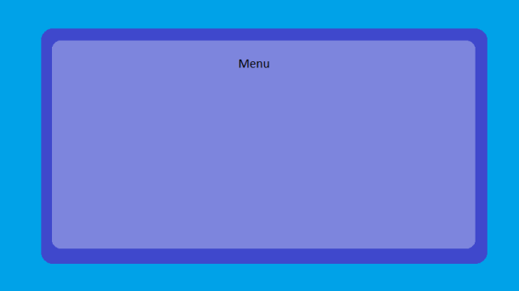

UI for all menus

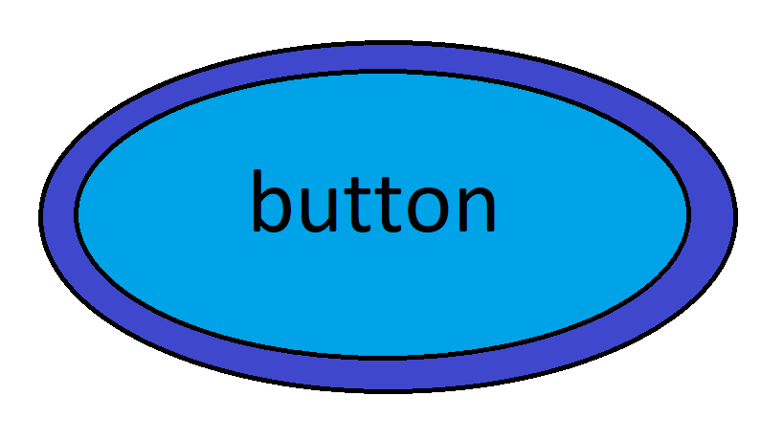

Button when no mouse hovering/clicking

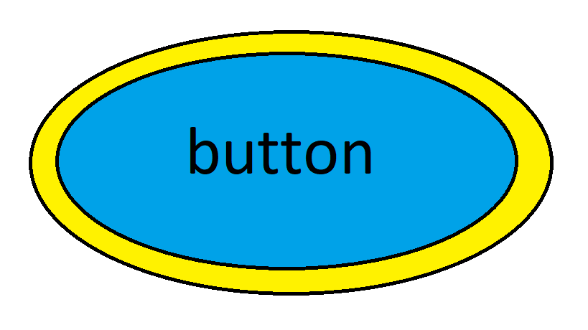

Button when mouse is hovering over it

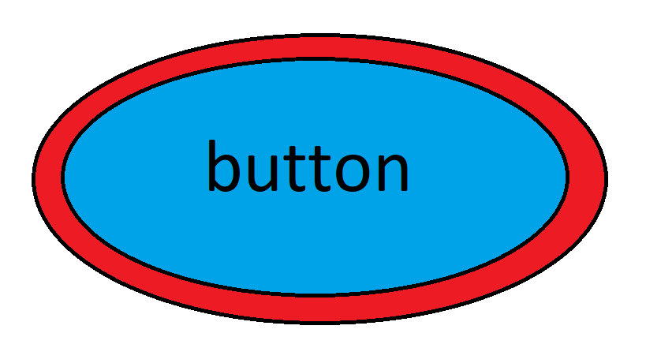

Button when mouse is clicked

**Method pre-gameplay**

Everything that runs during the pre-gameplay state is contained within the pre-gameplay method. “Computer” and “player” will be rendered on top of the screen and under them 8 buttons will be rendered under them. 2 lots of 4 button objects, one lot for the player and the other for the computer, are instantiated from the button class. They are the sniper button for the sniper unit, the rocket launcher button for the rocket launcher unit, the Warhammer button for the Warhammer unit and the sword button for the sword unit. If one of the buttons under the computer is selected, then a Variable that will be used during gameplay is assigned a string named after the unit and all other buttons will be disabled by adding a condition to prevent the “onclick” method from the button class from being used for the other three buttons. The same is also done for the buttons under player as well. The play button is also an object from the button class that is rendered below the unit buttons. This button when clicked will end the pre-gameplay method and load the gameplay method. This button will be disabled until one unit is selected from the player and the computer. The buttons will have a method to disable mouse detection. The reason this is the case is that the buttons must be fully functional all the time outside of certain conditions so the button will run on default if the disabled Boolean is false, which can be enabled true using the disable method. The player will not be able to play the game until exactly one unit is selected for the player and computer to prevent the player from causing game breaking errors.

**Method gameplay**

In this method, run after the pre-gameplay method, is run when the play button is pressed. The maze is rendered onto the screen using a library called Pytmx which allows me to use more complex tile sheets and to label sections of the maze using a software called Tiled. Using libraries such as Pytmx to label the entrances and walls of the maze makes me less prone to errors from programming it myself and speeds up development of these features. The maze collision code will be done by checking if the players Rect hitbox is hitting the walls and freezing movement if that is the case, the player will have their movement in that direction locked. Objects from for different classes are spawned in the entrances. The units whose team attribute is “player team” will spawn in the left entrance of the maze whilst the units whose team attribute is “computer team”, will spawn in the right entrance of the maze. The camera will be a section of the screen around the player that is cut out and rendered onto the screen, so the screen focuses on and follows the player. Using a camera instead of full screen adds an extra layer of difficulty since the computer team could take the item without you noticing or could ambush you. When the procedure first runs, several unit objects will be instantiated from the unit class. The player unit, the computer unit, 10 player soldier units and 10 computer soldier units. The units will be split into the player team and computer team based on the team attribute in that class. Units in the computer team will make the computer team win if they satisfy the win condition and units from the player team will make the player team win if they satisfy the win condition. Every unit in the game has health and damage. When one unit attacks another by running the attack method when they are a certain distance away from each over, the health attribute of the unit that is attacked will be reduced by the damage attribute of the other unit. If a soldier units health attribute reaches zero, then they will disappear permanently whilst the main units will just respawn at the entrances. The character unit subclass will be used for the main computer unit and the player unit. The class will have animations, sprites, and attack methods for all the units that were selectable in the menu and there will be a condition to check the value of the variable assigned in the pre-gameplay method and use that to assign what sprites, animations, and stats the player and computer will have. The main gameplay method will have a coin attribute to keep track of the number of coins the player has earned. When a player either kills a unit on the other team, has their soldiers kill a unit on the other team or finds a treasure chest that randomly spawns across the map, the coin count increases. If the coin count reaches a certain number, then two buttons will be rendered on the top of the screen. The upgrade button and the soldier button. When the upgrade button is pressed, the health and damage of all the units will be increased. If the soldier button is pressed, a player soldier will automatically spawn in the entrance and go towards the player. Both buttons will decrease the number of coins the player has. The computer team will automatically upgrade and replace soldiers over time. Having the player dictate when the computer replaces, or upgrades units would make the game to easy since the player could just limit them to the point where the player is not challenged a bit. Since programming neural networks is not only beyond my skill but also unnecessarily performance heavy so instead, I will use a simple state machine to control the computer teams’ AI. Booleans will be used to switch the states of the AI and the AI method is used to control the behaviour of the computer team. The special item will just be an image rendered in the centre of the maze. When a unit touches that object, then the special item object will be deleted, and the unit will switch to their carrying item animations and have their attack method disabled. If the unit carrying the item successfully brings it to the other players entrance, then the Boolean for that team’s win would be enabled true and the gameplay method ends. For controls, when the player presses the G button, the attack method for the player character occurs. If they press WASD or the arrow keys, the player will be moved left, right up or down and their walking animation would run. If they click a player soldier unit, the unit will light up (their hitbox would light up) and will path find to the place in the maze that the player clicks after. There is a button at the top right corner of the screen when pressed would freeze the game (the code where the update occurs would be disabled) and there would be several buttons rendered onto the screen. The menu button that would end the main gameplay state and load the menu state and the replay button would close the menu and resume the game.

**Method post-gameplay**

The winner and coin count are drawn onto the screen using the coin count attribute and the win Boolean from the previous method. There are also several buttons rendered at the bottom of the screen. The menu button would resume to the menu state and the replay button would return to the pre_gameplay state.

**Method AI**

The boolean from the pre-gameplay state is to determine whether the player should be in the wandering state, the hunting state and the escaping state. In the wandering state, all units in the computer state would path find to random dead ends in the maze. In the hunting state, every computer unit will path find towards the closest unit in the player team. In the escaping state will become true, and every unit in the computer team will path find towards the entrance to win the game. Pathfinding will be done using A* algorithm since it is the industry standard.

**Method coin_system**

This method checks to see if the conditions to give the player coins have been met. If the player is touching the treasure chest then 200 is added to the coin attribute. If the main computer unit is killed, then 40 is added to the coin attribute and if a computer soldier Is killed, the 20 is added to the coin attribute. If the coin attribute is over 1000, then 2 buttons will be rendered at the top of the screen. The upgrade menu and the replace menu. When the replace menu is clicked a soldier would be spawned at the entrance of the maze and subtract 200 from the coin attribute. when the upgrade menu is clicked, all the units in that team would have their health and stats increased and 800 is subtracted from the player count.

**Method pause_menu**

This method is run when the pause button rendered at the top of the screen is pressed. When the game is paused in the gameplay method, a menu is loaded with a menu button and a resume button. The menu button would run the main menu method and the resume button would resume the game.

**Method attack**

This method will not actually do anything since polymorphism will be used to make the units attack in their own way but since every unit should have an attack, having a method makes that clear.

**Method selected_unit**

Contains the animations and attacks for the four different units and depending on the value of the Boolean from the pre_gameplay state, will instantiate the player and main computer unit with the appropriate sprites and attacks. the sniper units attack will spawn a bullet image that moves fast and will not disappear until it contacts any object. If it is an enemy unit, the bullet would deal damage. The RPG units attack spawn an RPG image that moves until it hit something or if it is over 4 seconds old in which it would play an explosion animation and then disappear. Any enemy unit within a certain radius receives damage. Both melee weapons just play a swing animation and harms any enemy unit touching it.

**Method Button_function –** makes the clicked attribute true if the button is clicked

**Method Walk –** moves the unit in the direction specified and plays a walking animation

**Method Carry_item –** disables the attack method and changes the walking animation

**Method Controls –** runs selected when clicking soldier, runs attack when g is pressed and runs walk when WASD or arrow keys are pressed

**Method selected –** moves the soldier to the spot on the map selected by the mouse

## Key variables and structures

### **Key classes and attributes**

Game

menu()

pre_gameplay()

gameplay()

post-gameplay()

selected_unit()

AI()

coin_system()

pause_menu()

Winner (string)

coin_count (int)

player_team (list)

player (object)

computer_team (list)

computer (object)

health (integer)

damage (integer)

team (string)

Unit

attack()

walk()

carry_item()

…

soldier_animation()

Computer soldier unit

…

Player soldier unit

…

…

Controls()

…

selected_unit (string)

Computer unit

…

selected_unit (string)

Player unit

…

…

soldier_animation()

selected()

maze

touch_unit()

Carried (bool)

Special Item

button_func()

text (string)

clicked (boolean))

Button

Treasure chest

collide()

Camera

Width(integer)

Height(integer)

### **Explanation and justification of data structures**

Colour attributes

For the background of the menu, I will need the colours light blue and dark blue. These colours will be a global variable stored as a tuple. All colours can be represented as a RGB value which in Pygame would be a tuple with 3 numbers from 0 to 255. These are constants that don’t need to be changed so they will be represented as a tuple.

Images for animations

The images for all the animations in the game would be stored in a list with each animation being stored in its own dictionary. This makes it so that the code would be able to just increment over the list to play the animations, making it easier to code. The images themselves would be strings that refer to a file in the folder specified in a different section of the code.

Weapon stats

The stats for all the different weapons that the player or computer will use will be stored as a dictionary. If I used a list instead of a dictionary, then there would be no way to know what numbers refer to what whilst dictionaries can store variables in it as keys, making the code easier to read and easier to code. For each item in the dictionary the key would be the name of the stat like SPEED and the value would be the value of the stat.

Sounds

Sounds shall also be stored in a dictionary for similar reasons. The use of the sound would be the key like “button pressed” and the key would be a string used to refer to the sound file.

tiled map

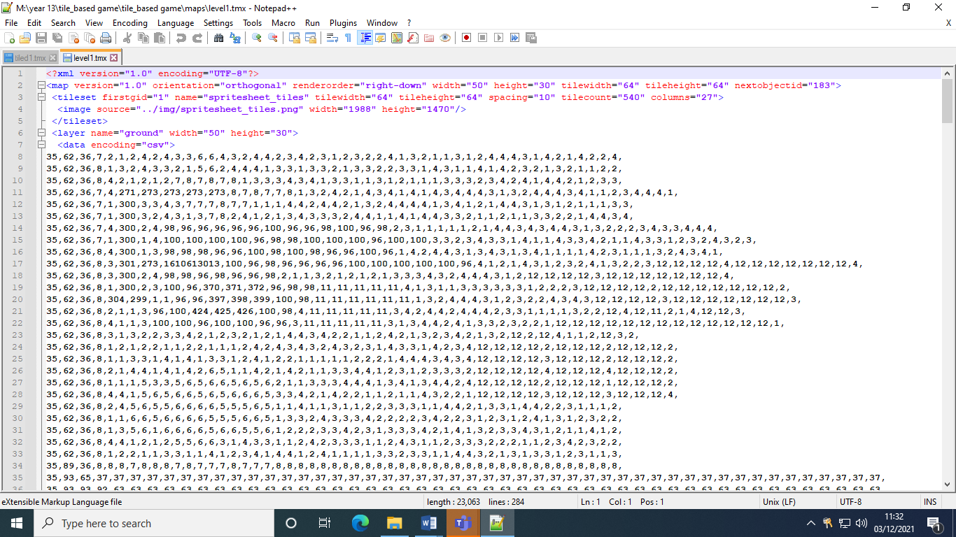

Images from the tile sheet will be accessed and used in the game using software called Tiled which allows me to produce a tiled map and convert it into a file that the Pytmx library can read. The benefit of this is that I can use much more complex features such as labelling sections of the maze to identify the walls of the maze and the entrances of the maze as well.

## Algorithms

* Method main_menu():
  + Render Title image X position = WIDTH/2, Y position = HEIGHT*(¾)
  + For i in range 10:
    - Render swirls colour dark blue X position = 0, Y position 0 + (i-1) *(HEIGHT/10)
  + Instantiate button as play button, text “play”
  + Render play button X position = WIDTH/2, Y position = HEIGHT/2
  + Instantiate button as help button, text “help”
  + Render help button X position= WIDTH/2, Y position = HEIGHT/3
  + Instantiate button as settings button, text “settings”
  + Render settings button X position = WIDTH/2, Y position = HEIGHT/4
  + If play_button.clicked == true:
    - End main_menu()
    - Play_button.clicked = false
    - pre_gameplay()
  + If help_button.clicked == true:
    - Close play button, help button, settings button
    - Instantiate button as close_button, text “close”
    - Render close_button X position = WIDTH*(5/6), Y position = HEIGHT*(7/8)
    - Render button_img size(200,100)
    - Render text “WASD or arrow keys to move. G to attack. Right mouse clicks to select and move soldiers”, X position = WIDTH/2, Y position = HEIGHT/2
    - If close_button.clicked == true:
      * Close button_img, text, close_button
      * Open play button, help button, settings button
      * help_button.clicked = false
      * close_button.clicked = false
  + If settings button.clicked == true:
    - Close play button, help button, settings button
    - Instantiate button as close_button, text “close”
    - Render close_button X position = WIDTH*(5/6), Y position = HEIGHT*(7/8)
    - Render text “width of screen”
    - Instantiate button as width_button, text “”
    - Render width_button X position = WIDTH*(1/2), Y position = HEIGHT*(6/8)
    - Instantiate square object as square1
    - Render square1 X position = width_position
    - If width_button.clicked == true:
      * Temp = width_button.x
      * Width_button.x = mouse_click.x in range (square1.x – square1.length/2, square1.x + square1.length/2)
      * WIDTH += Width.button.x – Temp
      * If right_click_release == true:
        + width_button.clicked = false
    - Render text “height of screen”
    - Instantiate button as height_button, text “”
    - Render height_button X position = WIDTH*(1/2), Y position = HEIGHT*(5/8)
    - Instantiate square object as square2
    - Render square2 X position = height_position
    - If height_button.clicked == true:
      * Temp = height_button.x
      * height_button.x = mouse_click.x in range (square2.x – square2.length/2, square2.x + square2.length/2)
      * HEIGHT += height.button.x – Temp
      * If right_click_release == true:
        + height_button.clicked = false
        + Render text “height of screen”
    - Render text “FPS”
    - Instantiate button as FPS_button, text “”
    - Render FPS_button X position = WIDTH*(1/2), Y position = HEIGHT*(3/8)
    - Instantiate square object as square3
    - Render square3 X position = FPS_position
    - If FPS_button.clicked == true:
      * Temp = FPS_button.x
      * FPS_button.x = mouse_click.x in range (square3.x – square3.length/2, square3.x + square3.length/2)
      * FPS += (FPS.button.x – Temp)/square3.length *30
      * If right_click_release == true:
        + FPS_button.clicked = false
    - Render text “number of enemies”
    - Instantiate button as enemies_button, text “”
    - Render enemies_button X position = WIDTH*(1/2), Y position = HEIGHT*(1/4)
    - Instantiate square object as square4
    - Render square4 X position = enemies_position
    - If enemies_button.clicked == true:
      * Temp = enemies_button.x
      * enemies_button.x = mouse_click.x in range (square4.x – square4.length/2, square4.x + square4.length/2)
      * ENEMY_COUNT+= (enemies.button.x – Temp)/square4.length *ENEMY_COUNT
      * If right_click_release == true:
        + enemies_button.clicked = false
    - If close_button.clicked == true:
      * settings button.clicked = false
      * Close close_button
      * Open play button, help button, settings button
      * close_button.clicked = false
* Method pre_gameplay()
  + Render text “player”
  + Instantiate button object as player sniper button, text = “sniper”
  + Render player sniper button X position = WIDTH/10, Y position = HEIGHT*½
  + If player sniper button.clicked == true:
    - Player unit = “sniper”
  + Instantiate button object as player RPG button, text = “RPG”
  + Render player RPG button X position = WIDTH/9, Y position = HEIGHT*½
  + If player RPG button.clicked == true:
    - Player unit = “RPG”
  + Instantiate button object as player war hammer button, text = “war hammer”
  + Render player war hammer button X position = WIDTH/8, Y position = HEIGHT*½
  + If player war hammer button.clicked == true:
    - Player unit = “war hammer”
  + Instantiate button object as player sword button, text = “sword”
  + Render player sword button X position = WIDTH/7, Y position = HEIGHT*½
  + If player sword button.clicked == true:
    - Player unit = “sword”
  + Render text “computer”
  + Instantiate button object as computer sniper button, text = “sniper”
  + Render computer sniper button X position = WIDTH/5, Y position = HEIGHT*½
  + If computer sniper button.clicked == true:
    - computer unit = “sniper”
  + Instantiate button object as computer RPG button, text = “RPG”
  + Render computer RPG button X position = WIDTH/4, Y position = HEIGHT*½
  + If computer RPG button.clicked == true:
    - Computer unit = “RPG”
  + Instantiate button object as computer war hammer button, text = “war hammer”
  + Render computer war hammer button X position = WIDTH/3, Y position = HEIGHT*½
  + If computer war hammer button.clicked == true:
    - computer unit = “war hammer”
  + Instantiate button object as player sword button, text = “sword”
  + Render player sword button X position = WIDTH/2, Y position = HEIGHT*½
  + If computer sword button.clicked == true:
    - Computer unit = “sword”
  + Instantiate button object as play button, text=””
  + Render play button X position = WIDTH/2, Y position = HEIGHT/4
  + If player unit != “” and computer unit != “”:
    - If play button.clicked == true:
      * gameplay()
      * play_button.clicked = false
  + If menu button.clicked == true:
    - Menu button.clicked = false
    - main_menu()
* Method gameplay()
  + For walls in maze_tilesheet:
    - Instantiate maze object as maze
    - Render maze position = walls.position
  + Instantiate Player unit(1000, 100, “player team”, Player unit) object as player
  + Render player position = maze_tilesheet.player_team_entrance
  + Instantiate computer unit(1000, 100, “computer team”, computer unit) object as computer
  + Render computer position = maze_tilesheet.computer_team_entrance
  + For I in range ENEMY_COUNT:
    - Instantiate Player soldier unit(200, 100, “player team”) object as player soldier
    - Player soldiers.append(player soldier)
    - Render player soldier position = maze_tilesheet.player_team_entrance
    - Instantiate computer soldier unit(200, 100, “computer team”) object as computer soldier
    - computer soldiers.append(computer soldier)
    - Render computer soldier position = maze_tilesheet.computer_team_entrance
  + Instantiate Special item object as special item
  + Render special item position = maze_tilesheet.special item
  + Render
  + For unit in units:
    - If unit moving in the x axis:
      * hits = collisions between unit and maze
      * if hits:
        + if hits[0].centerx > unit.centerx:

unit.x = hits[0].left – unit.width / 2

* + - * + if hits[0].centerx < unit.centerx:

unit.x = hits[0].right + unit.width / 2

* + - * + unit.vel.x = 0
    - If unit moving in the y axis:
      * hits = collisions between unit and maze
      * if hits:
        + if hits[0].centery > unit.centery:

unit.y = hits[0].top – unit.height / 2

* + - * + if hits[0].centery < unit.centery:

unit.y = hits[0].bottom + unit.height / 2

* + - * + unit.vel.y = 0
    - hits = collisions between unit1 and unit2
    - if unit1.team != unit2.team and (unit1 and unit2) != (computer unit or player unit) or (unit1.selected_unit and unit2.selected_unit != “sniper” or “RPG”):
      * if hits and unit1.attack():
        + unit2.health = unit2.health – unit1.damage
      * if hits and unit2.attack():
        + unit1.health = unit1.health – unit2.damage
    - elif unit1 or unit2 == (computer unit or player unit):
      * if unit1.selected_unit or unit2.selected_unit == sniper or RPG:
        + hits = collision between bullet and unit2
        + if hits and unit1.attack():

unit2.health = unit2.health – unit1.damage

* + - * + hits = collision between bullet and unit1
        + if hits and unit2.attack():

unit1.health = unit1.health – unit2.damage

* + - * Else:
        + hits = collisions between unit1 and unit2
        + if hits and unit1.attack():

unit2.health = unit2.health – unit1.damage

* + - * + if hits and unit2.attack():

unit1.health = unit1.health – unit2.damage

* + - if unit.health <= 0 and unit != player_unit or computer unit:
      * Unit.kill()
      * If unit.team == “player team”:
      * Soldier_kill = 1
    - Elif unit.health <= 0 and unit == player unit:
      * Unit.position = maze_tilesheet.player_team_entrance
    - Elif unit.health <= 0 and unit == computer unit:
      * Unit.position = maze_tilesheet.computer_team_entrance
      * Main_unit_kill = 1
    - if unit.class == player soldier unit and unit.selected != true:
      * walk_vec = player soldier unit.pos - soldier.pos - 2
      * unit.walk(walk_vec)
    - instantiate rectangle object as empty_health_bar, length = unit.length, color = white
    - instantiate rectangle object as health_bar, length = (unit.health/unit.total_health) * empty_health_bar.length, color = green
    - render empty_health_bar and health_bar, X position = unit.x, Y position = unit.y + 2
    - hits = collision between unit and special item
    - if hits:
      * special_item.kill()
      * unit.carry_item()
    - if unit.pos = maze_tilesheet.computer_team_entrance and unit.carry_item() and unit.team = “computer team”:
      * winner = “computer team”
      * post_gameplay()
    - if unit.pos = maze_tilesheet.player_team_entrance and unit.carry_item() and unit.team = “player team”:
      * winner = “player team”
      * post_gameplay()
  + If unit.team = “computer team”:
    - AI(unit)
  + If mouse.click.position == unit.position and unit.class == player_soldier_team:
    - unit.selected()
  + screen = Camera(CAMERA_WIDTH, CAMERA_HEIGHT)
  + Controls()
  + Coin_system()
  + Pause_menu()
* Method post_gameplay():
  + Render text “winner:” + winner
  + Render text “coin count” + coin_count
  + Instantiate button object as menu button, text “menu”
  + Render menu button, X position = WIDTH/4, Y position = HEIGHT/2
  + Instantiate button object as replay button, text “play again”
  + Render replay button, X position = WIDTH*(¾), Y position = HEIGHT/2
  + If menu button.clicked():
    - Main_menu()
  + If replay button.clicked():
    - pre_gameplay()
* Method AI():
  + For unit2 in unit:
    - if unit2.team == player_team:
      * if dist(unit, unit2) > unit.len * 2 and unit.carrying_item == true:
        + state = “escaping”
      * elif dist(unit, unit2) < unit.len * 2:
        + state = “attacking”
      * else:
        + state = “wandering”
      * If state == “wandering”:
        + point = random.choice(maze_tilesheet.deadends)
        + unit a*pathfind towards point
      * If state == “attacking”:
        + unit a*pathfind towards unit2
      * if state == “escaping”:
        + unit a* pathfind towards maze_tilesheet.player_entrance
      * if dist(unit, unit2) < unit.len and unit != computer unit and unit.selected_unit != sniper unit and RPG unit:
        + unit.attack()
      * else:
        + if dist(unit, unit2) < 30:

unit.attack()

* Method coin_system():
  + Hits = collision between player unit and treasure chest
  + If hits:
    - treasure_chest.kill()
    - coin_count += 200
    - Coin_count += (20*soldier_kill) + (40*main_unit_kill)
    - main_unit_kill = 0
    - Soldier_kill = 0
  + If coin_count >= 1000:
    - Instantiate button object as upgrade button. Text = “upgrade”
    - Render upgrade button, X position = WIDTH/3, Y position = HEIGHT
    - Instantiate button object as spawn button. Text = “spawn”
    - Render spawn button, X position = WIDTH/5, Y position = HEIGHT
    - If upgrade button.clicked() and (coin_count – 200) >= 0:
      * For unit in units:
        + if unit.class == player soldier unit:

unit.health += UPGRADE

count_count -= 200

* + - If spawn button.clicked() and (coin_count – 800) >= 0:
      * Instantiate Player soldier unit(200, 100, “player team”) object as player soldier
      * Player soldiers.append(player soldier)
      * Coin_count -= 800
* Method pause menu():
  + Instantiate button object as pause menu, text “pause”
  + Render pause menu, position = (WIDTH, HEIGHT)
  + If pause menu.clicked():
    - Render menu button, X position = WIDTH/4, Y position = HEIGHT/2
    - Instantiate button object as replay button, text “play again”
    - Render replay button, X position = WIDTH*(¾), Y position = HEIGHT/2
    - If menu button.clicked():
      * Main_menu()
    - If replay button.clicked():
      * pre_gameplay()
    - freeze_game()
  + if pause_menu.clicked():
    - replay game()
* Method selected_unit():
  + If selected unit == “sniper”:
    - unit.attack animations = sniper_animation
    - if unit.attack():
      * instantiate bullet object
      * render bullet object position = unit.position
      * bullet.move(BULLET_SPEED)
      * hits = collision between bullet and anything
      * if hits:
        + bullet.kill()
  + If selected unit == “RPG”:
    - unit.attack animations = RPG_animation
    - if unit.attack():
      * instantiate RPG object
      * render RPG object position = unit.position
      * RPG.move(RPG_SPEED)
      * hits = collision between RPG and anything
      * if hits:
        + RPG_explosion_animation()
        + RPG.kill()
  + If selected unit == “warhammer”:
    - unit.attack animations = warhammer_animation
  + If selected unit == “sword”:
    - unit.attack animations = sword_animation
* Method button_function()
  + If mouse.click.position == button.position:
    - button.clicked = true
* Method walk():
  + Play walking animation
  + Unit.move(WALKING_DIRECTION)
* Method Carry_item():
  + Replace walking animation with carry walking animations
  + Unit.attack.disable()
* Method controls():
  + If W or up arrow is pressed:
    - player unit.walk(UP)
  + If A or left arrow is pressed:
    - player unit.walk(LEFT)
  + If S or down arrow is pressed:
    - player unit.walk(DOWN)
  + If D or right arrow is pressed:
    - player unit.walk(RIGHT)
  + If G is pressed:
    - player_unit.attack()
* Method selected():
  + If mouseclick:
    - player soldier unit.walk(mouseclick)

## Usability features

### Explanation and justification of user interface

**Menu**

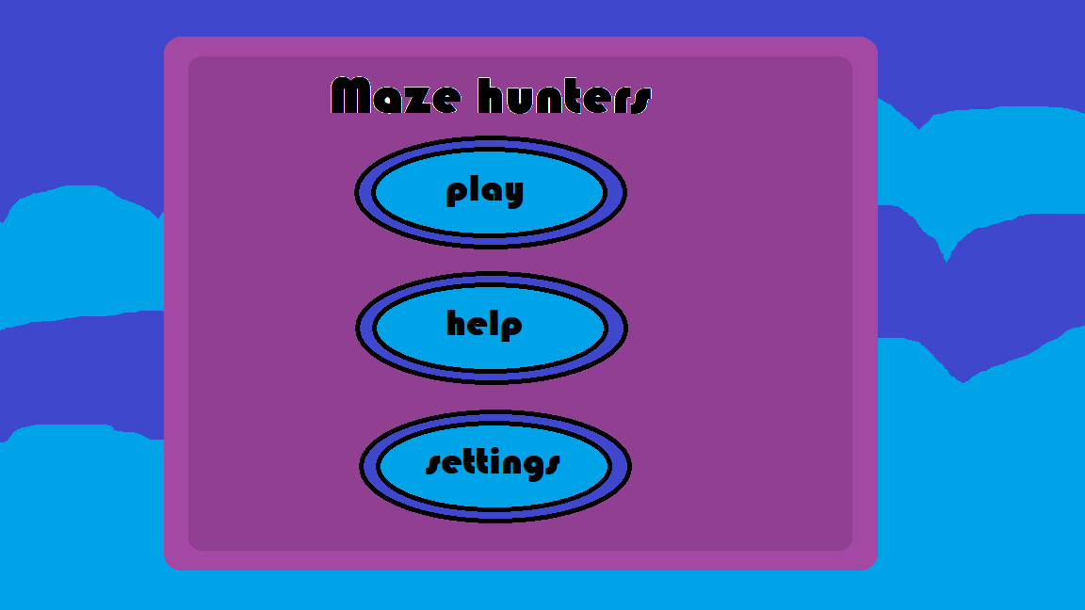

* The background is light blue and dark blue because those are complementary colours which go together
* The background is also animated waves to make the game feel less static and to make the menu more aesthetically pleasing
* The purple box is used to make the menu stand out against the animated background. The box is purple to complement the blue background
* The buttons are all placed in a column to reduce empty space and are all clearly labelled to show the player what each button does

**Help screen**

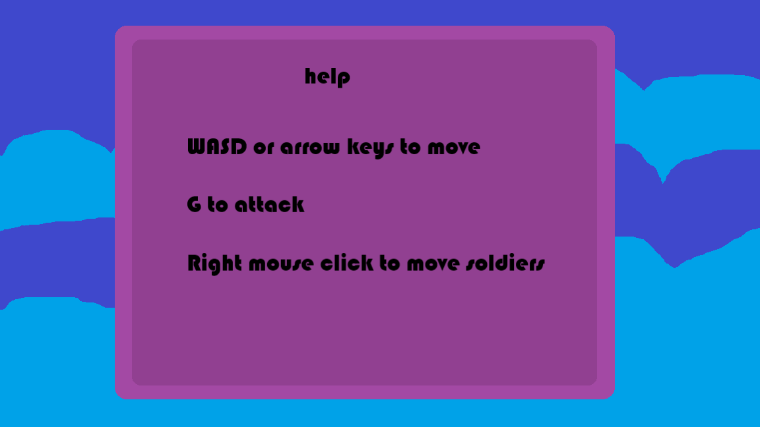

* Similar style as the main menu for the same reasons and to maintain an aesthetic
* Clear instructions on how to play the game to help new players

**Settings menu**

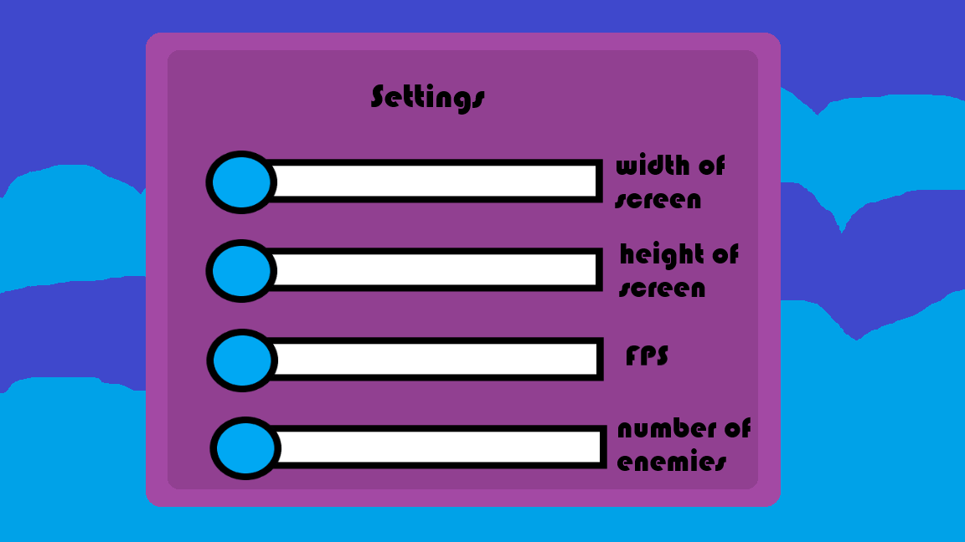

* Same format as the main menu to maintain an aesthetic
* Sliders are used instead of text boxes to make the menu more aesthetically pleasing for the user and to also make changing the settings more convenient
* The buttons on the slider are also the same colour as the buttons to hint towards the user that the button should be pressed

**Unit selection menu**

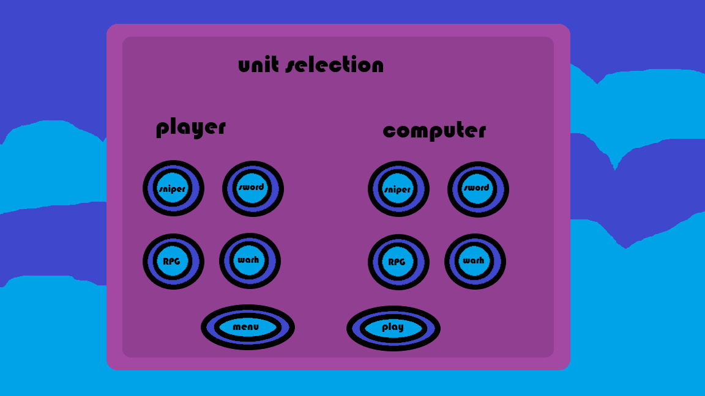

* Same colour palette and design as the other menus to maintain an aesthetic and to be consistent
* Buttons located under the player and computer titles to show which unit the buttons are for
* The play button will not change state like the other buttons to show the user that they cannot play the game until a unit is selected for the player and computer

**Game screen**

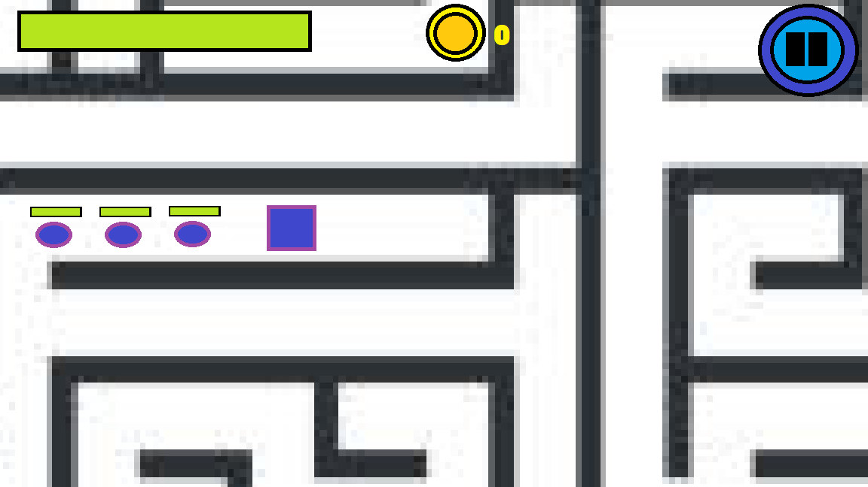

* All the UI is located at the top of the screen to prevent the player from having to look at many separate locations on the screen
* Health bars over the non-player units to show the amount of health every unit has in a simple and easy to understand way
* Pause button has the same colour scheme as the previous buttons to show the user that it is also a button that can be pressed
* Health bars switch from green to yellow to red to give a clear visual sign of the amount of damage the unit has received. The bar in the health bar also gets smaller in size to give a more precise indicator of how much heath the unit has
* Upgrade and soldier spawning buttons not visible so the player knows that they can’t upgrade or spawn soldiers until the coin count is at 1000
* The coin count at the top of the screen updates frequently so the user is always aware of how much money they have earned

**Paused screen**

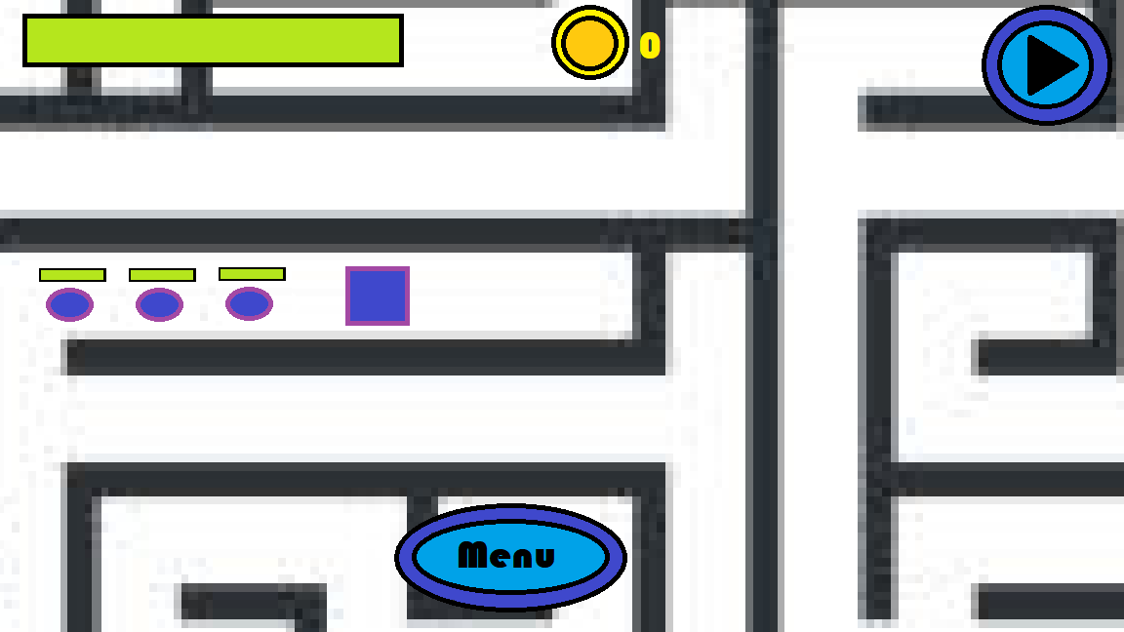

* Pause button changes look to show the user that the game is paused
* Not shown in the picture but there would be a dark overlay to show that the game is paused to make it more clear to the user that the game is in the paused state
* The menu button is placed at the bottom of the screen to make the UI less cluttered
* The menu button has the same colour scheme as all other buttons in the game to clearly show that it can be pressed

**Game Over screen**

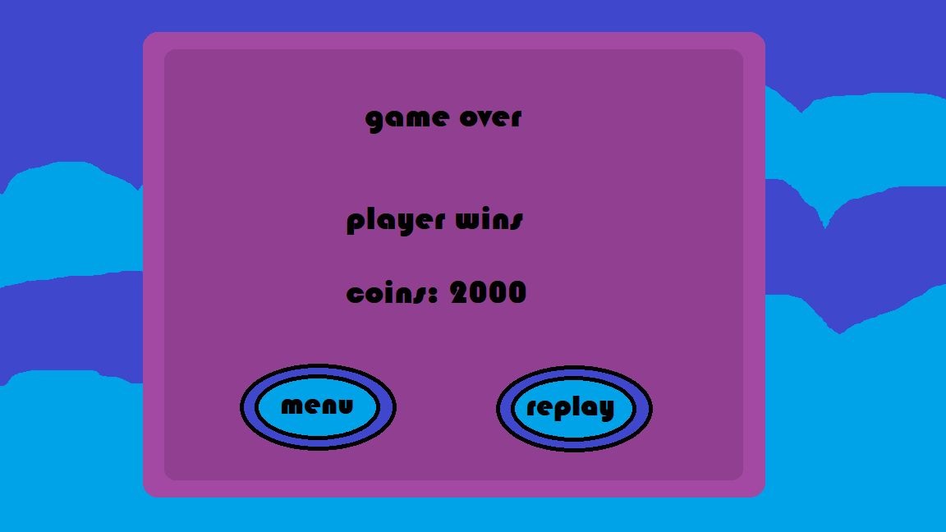

* Same design and colour palette as all the over menus to maintain an aesthetic
* Buttons coloured the same way as all the other buttons to make it clear to the user that it can also be pressed
* Information on who wins and how much money the player earned is displayed in the center of the screen as a way of showing the player how well they performed in the game

### description and justification of usability features

* The standard movement for most games is the WASD keys or the arrow keys so in my game, I will also have WASD keys and the arrow keys for moving the player character. The W key or the up-arrow key will move the character up, the A key or the left arrow key to move the character to the left, the S key or the down arrow key to move the character down and the D key or the right arrow key to move the character down. The game will have 4-way movement so the character would not be able to move in diagonal directions since the paths in the maze are not diagonal.
* Usually, the mouse is used for attacks in games but since I need to have the mouse used to select and control units, I have decided to make the G key used for attack instead. I thought about using the mouse for both selecting units and attacking but that could overcomplicate the gameplay, so I decided to keep them separate.

### Description and justification of validation required

My game has limited inputs so not much validation is used, but the player can’t leave the map since there will be collision detection between the player and the maze to prevent the player from leaving the map.

## Identification and justification of test data to be used during development

**Main Menu**

|  |  |  |
| --- | --- | --- |
| What is being tested | Data input | Expected output |
| The play button works | Mouse click on the button | The unit selection screen is loaded |
| The help button works | Mouse click on the button | The help menu is loaded |
| The settings button works | Mouse click on the button | The settings menu is loaded |
| Sliders in the settings menu increase the corresponding constant | Mouse click and movement of the mouse | The corresponding constant such as height or width of the screen will increase when the slider is dragged to the left and decrease when the slider is dragged to the right |
| Close button in menus work | Mouse click on the button | The menu that was open is closed and the main menu is loaded |

**Unit selection menu**

|  |  |  |
| --- | --- | --- |
| What is being tested | Data input | Expected output |
| Sniper button for the player works | Mouse click on the button | The player unit variable should be set as sniper |
| RPG button for the player works | Mouse click on the button | The player unit variable should be set as RPG |
| Sword button for the player works | Mouse clicks on the button | The player unit variable should be set as sword |
| Warhammer button for the player works | Mouse click on the button | The player unit variable should be set as Warhammer |
| Sniper button for the computer works | Mouse click on the button | The computer unit variable should be set as sniper |
| RPG button for the computer works | Mouse click on the button | The computer unit variable should be set as RPG |
| Sword button for the computer works | Mouse click on the button | The computer unit variable should be set as sword |
| Warhammer button for the computer works | Mouse click on the button | The computer unit variable should be set as Warhammer |
| Play button only works when a unit is selected for the player and computer | Mouse click on the button | There shouldn’t be any response from the button if the unit for the player or computer isn’t chosen and if it is chosen then the gameplay method is loaded |

**Player controls**

|  |  |  |
| --- | --- | --- |
| What is being tested | Data input | Expected output |
| Player can move to the left | A or left arrow key | The player moves to the left and stops when it hits the walls of the maze |
| Player can move to the right | D or right arrow key | The player moves to the right and stops when it hits the walls of the maze |
| Player can move up | W or up arrow key | The player moves up and stops when it hits the walls of the maze |
| Player can move down | S or down arrow key | The player moves down and stops when it hits the walls of the maze |
| Camera moves with player | Arrow keys or WASD keys | Every sprite’s render is moved in the opposite direction of the player |
| Player can attack | G | The player should attack with the weapon of their choice |
| The player can move their soldier units | A first mouse clicks to select a soldier unit and a second mouse click to move it | The soldier unit should be highlighted in the first click and should then move to the location that the second mouse click leads to |

**Coin system**

|  |  |  |
| --- | --- | --- |
| What is being tested | Data input | Expected output |
| Player can collect coins from treasure chest | Player moving towards a treasure chest and touches it | The treasure chest should de-spawn and the number of coins the player has should increase |
| Player can earn coins from killing units | N/A | The number of coins the player has should increase after killing a unit from the computer team |
| Upgrade button increases the stats of the units | Mouse clicks on the button | The health and damage of all the soldier units increase |
| Spawn button spawns a new soldier | Mouse clicks on the button | A new soldier will spawn at the player entrance |

**Player interaction with the computer**

|  |  |  |
| --- | --- | --- |
| What is being tested | Data input | Expected output |
| Computer attacks if player or their soldiers get too close | N/A | The computer unit attacks |
| Computer unit switches to hunting state when it first attacks the player | Player moves away from the computer units | The computer switches to the hunting state and starts chasing them |
| Player soldiers follow player | Player moves away from soldiers | The soldier follows them |

**Pause menu**

|  |  |  |
| --- | --- | --- |
| What is being tested | Data input | Expected output |
| Pressing the pause button pauses the game | Mouse click on the button | The game is frozen, and the pause menu is loaded |
| Pressing the pause button after the pause menu has loaded replays the game | Mouse click on the button | The pause menu is closed and the game resumes |

**Player attacks**

|  |  |  |
| --- | --- | --- |
| What is being tested | Data input | Expected output |
| If the player selected the sniper button in the unit selection menu, then they should have the sniper weapon and do sniper attacks | G key | A bullet is fired from the sniper gun and that bullet deals damage when it hits something |
| If the player selected the RPG button in the unit selection menu, then they should have the RPG weapon and do RPG attacks | G key | An RPG is fired from the RPG launcher and it explodes when it hits something and deals damage to any unit in range of the explosion |
| If the player selected the Warhammer button in the unit selection menu, then they should have the Warhammer weapon and do Warhammer attacks | G key | The Warhammer is swung and damages any unit it hits |
| If the player selected the sword button in the unit selection menu, then they should have the sword weapon and do sword attacks | G key | The sword is swung and damages any unit it hits |

**Post gameplay menu**

|  |  |  |
| --- | --- | --- |
| What is being tested | Data input | Expected output |
| Pressing the menu button opens the menu | Mouse clicks on the button | The game over menu is closed and the main menu is opened |

**Buttons**

|  |  |  |
| --- | --- | --- |
| What is being tested | Data input | Expected output |
| The buttons react to having the mouse hover over them | Mouse hovering over button | The button switches to the hovering button image |
| The buttons react to having the mouse click them | Mouse clicking button | The button switches to the clicked button image |

## Test data for alpha testing

|  |  |
| --- | --- |
| What is the requirement | How will it be tested for functionality |
| The buttons must switch sprites when pressed and clicked | I will hover over every button to see if it changes to the hovering image and then click it to see if it changes to the clicking image |
| The main menu has 3 buttons | N/A |
| The play button loads up the pre-gameplay state | Click the play button and if it loads the unit selection menu then it works |
| The settings button loads the settings menu | Click the settings button and see if it loads the settings menu |
| The help button loads the help menu | Click the help button and see if it loads the help menu |
| Constants can be modified in the settings | Drag the sliders and see if the constants change |
| All menus other than the main menu must have a back button | Check all menus to see if they have a back button |
| The pre-gameplay state has 4 units to choose for the player and the computer | Look at the unit selection menu and see if there are 4 buttons for each unit |
| Only one unit can be selected for the player and computer | Select 2 buttons for each unit and see when the game is loaded if only the second button is the one that set the unit |
| Each type of unit can be selected for the player and computer | See if there are buttons for sword, RPG, sniper and war hammer for both the player and the computer |
| The play button loads the game | Click the play button and see if it loads the game |
| The play button can only be pressed when a unit is selected for both the player and the computer | Try to press the play button before a unit is selected for the player and computer and nothing should happen |
| The units selected by the player and the computer are loaded into the game | Load the game and see if the player and main computer unit are the units selected in the unit selection menu |
| All objects spawn in the right locations | See if the player and their soldiers are spawned in the player entrance, the main computer unit and their soldiers are spawned in the computer unit entrance and if the special item spawned in the centre of the maze |
| Maze is rendered from a tile sheet | Check if the maze matches the tilesheet |
| Maze has collision detection with units | See if any units phase through the maze |
| Camera following the player | See if the camera moves with the player |
| All player soldiers follow the player if not given a command | See if the non selected player soldiers follow the player |
| All units have a certain amount of health | Output the amount of health the units have |
| All units take damage from attacks | Output the amount of health a unit has after they are hit |
| Health bar is displayed at the top of a unit | See if there is a health bar above every unit |
| When a unit loses all their health, they die | See what happens when a unit has no health |
| All units can attack units of the other team | Check to see if there are any units that don’t attack |
| If a unit touches a special item, they should then hold it | See if the sprite of the unit switches to the holding sprite |
| When a unit is holding the special item then they cannot attack | See if a unit holding the item is attacking anything |
| When the special item is brought to the entrance of the maze, the unit’s team wins | See if the post gameplay screen opens when the unit carrying the item reaches the entrance |
| If the unit carrying the special item is killed, then the item is dropped | See if the item is there after the unit dies |
| All states of the AI function as intended | Check the behaviour of the units in the computer team and see if they function like the state they are in |
| All states are active at the right times | Output the state the AI is in |
| The player moves when the WASD keys or arrow keys are pressed | Press the WASD or arrow keys and see if the player moves in the direction of the key pressed |
| The player should attack when pressing the G key | Press the G key and see if the player attacks |
| When they player clicks a player soldier unit, they should be able to move them | Click a soldier unit then click a location and see if they are able to move to that location |
| When a computer soldier is killed by the player units, they earn coins | See if the number of coins increase when a soldier unit is killed |
| The coin count at the top of the screen is accurate | Output the number of coins the player has and see if it matches |
| Treasure chests randomly spawn across the map | See if the chests are spawning in various locations every game |
| The player should earn 200 coins if they touch the chest | See what the coin count is before and after touching the chest |
| When the player earns enough money, they can upgrade and replace troops | Check to see if the upgrade and spawn buttons appear after earning 1000 coins |
| The computer will automatically spawn soldiers | See if new soldiers spawn at the computer entrance |
| The pause button pauses the game | Press the pause button and see if it pauses the game |
| When the game is over, the game over menu should appear | When the game is won, see if the game over menu appears |
| The game is fun | Have a user play the game and give feedback |
| The game provides some difficulty but is still playable | If I am able to complete the game easily in a short amount of time or fail to beat the game many times in a row then the difficulty needs to be adjusted |
| The game can perform well with many units | Increase the amount of enemies in the game and keep track of the FPS and see if there is a massive drop |
| The game can deal with erroneous inputs | Press buttons on the keyboard other that WASD, arrow keys and G key and see if something happens |

# Developing the coded solution

## Iterative development

### Game setup

Main.py

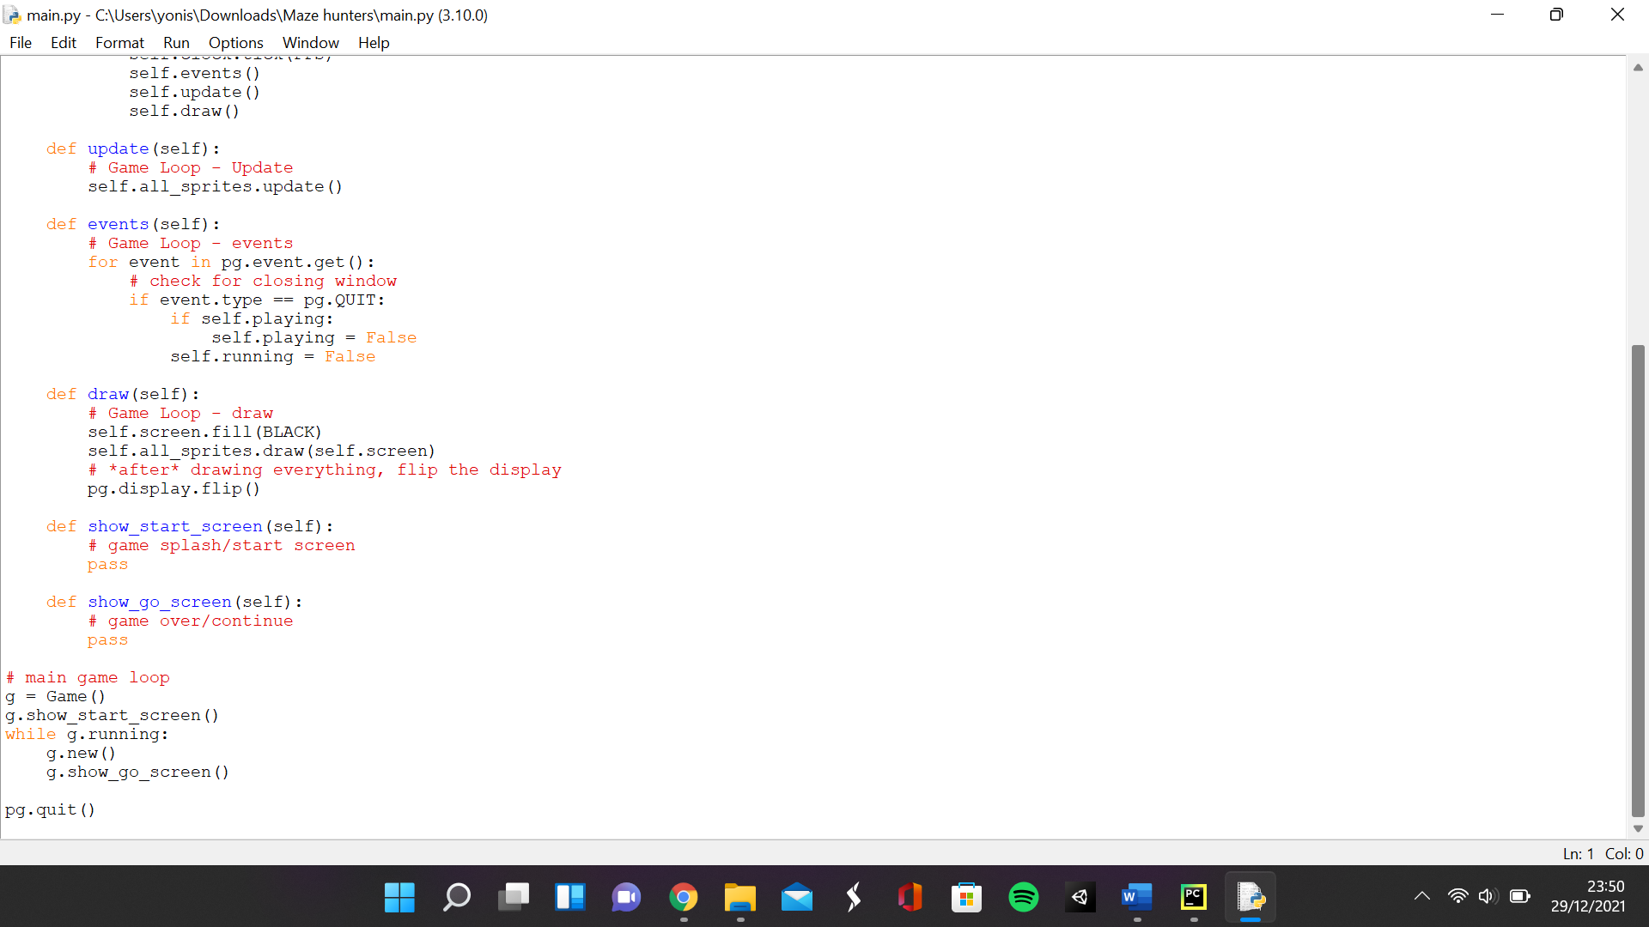 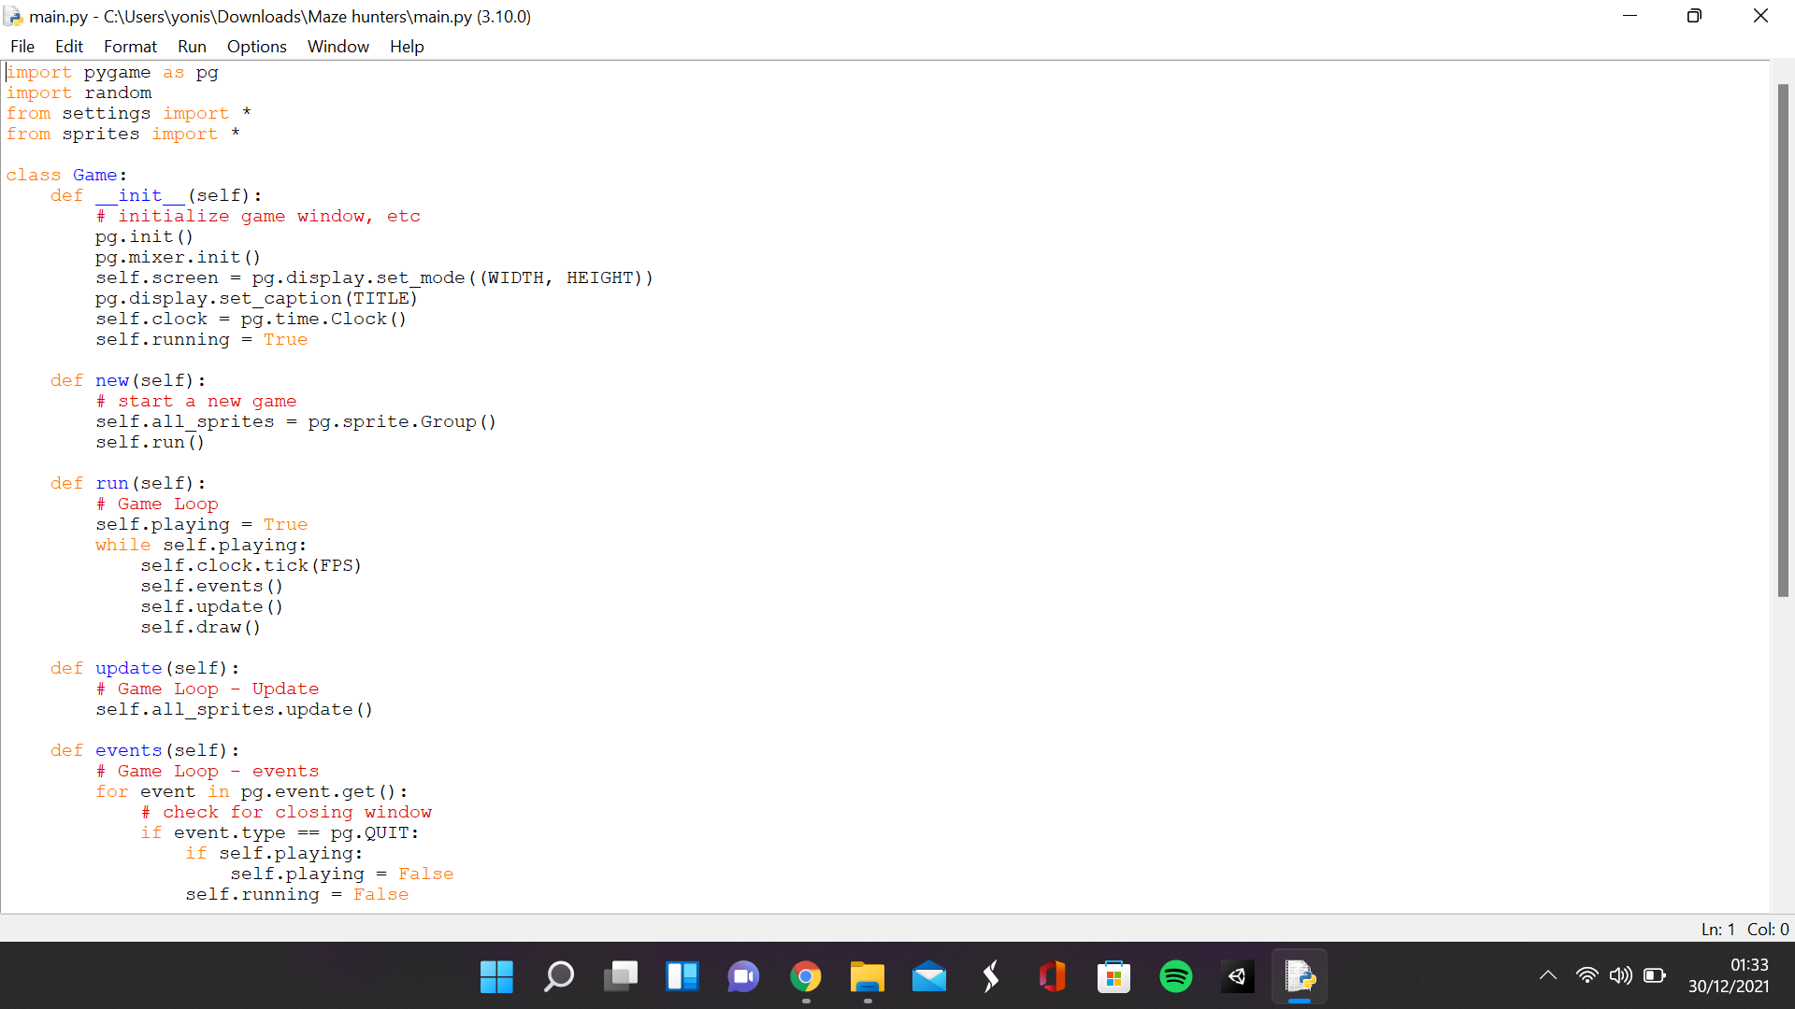

lines:

1 – this is used to import the Pygame library and get the functions needed to run the game

2 – this is used to import the random library to produce random events

3 – this line of code imports all the classes and variables from the settings script

4 – this line of code imports all the classes and variables from the sprite script

5 – the line creates the Game class

6 to 13 – this initialises the game window, the screen, the window caption, sound, the clock used to refresh the screen and sets the Boolean running as true

14 to 17 – this function creates a group for all sprites and calls the run function

18 to 25 – this function runs the main game loop by updating the clock to prevent the game running faster than the given FPS and runs the events, update and draw functions

26 to 28 – this function runs the update function in all the sprites in the all sprites group

29 to 36 – this function ends the program if the cross button is pressed

37 to 42 – this function fills the screen black, then draws all sprites from the sprite group on top of the screen and then updates the screen to display them

43 to 48 – these are empty functions used to represent the menu and the game over screen

49 to 55 – this is where the program is run with the start screen function being run, then the actual game and the game over function are run in a loop and then pygame is closed when the loop ends

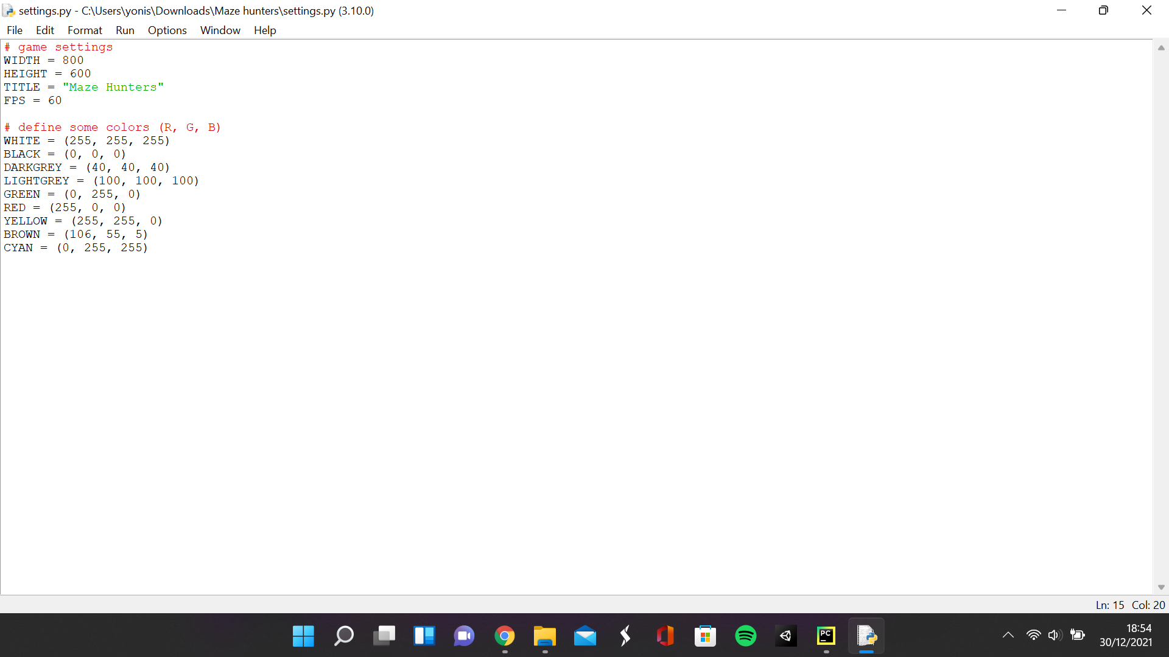

This is the settings file that contains all the constants I used in the main file

### Setting up the menu

**Main.py**

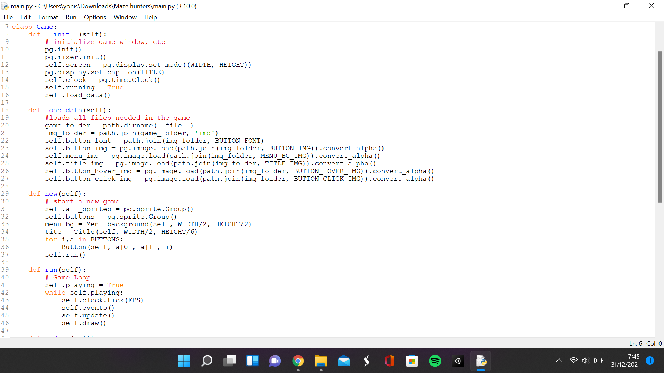

**Sprites.py**

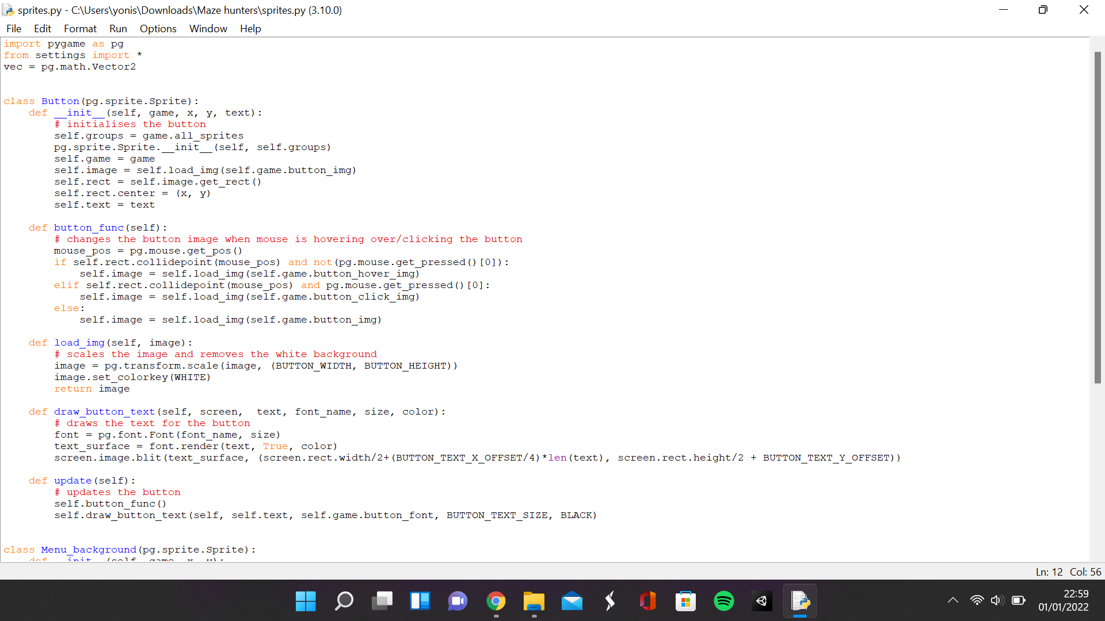

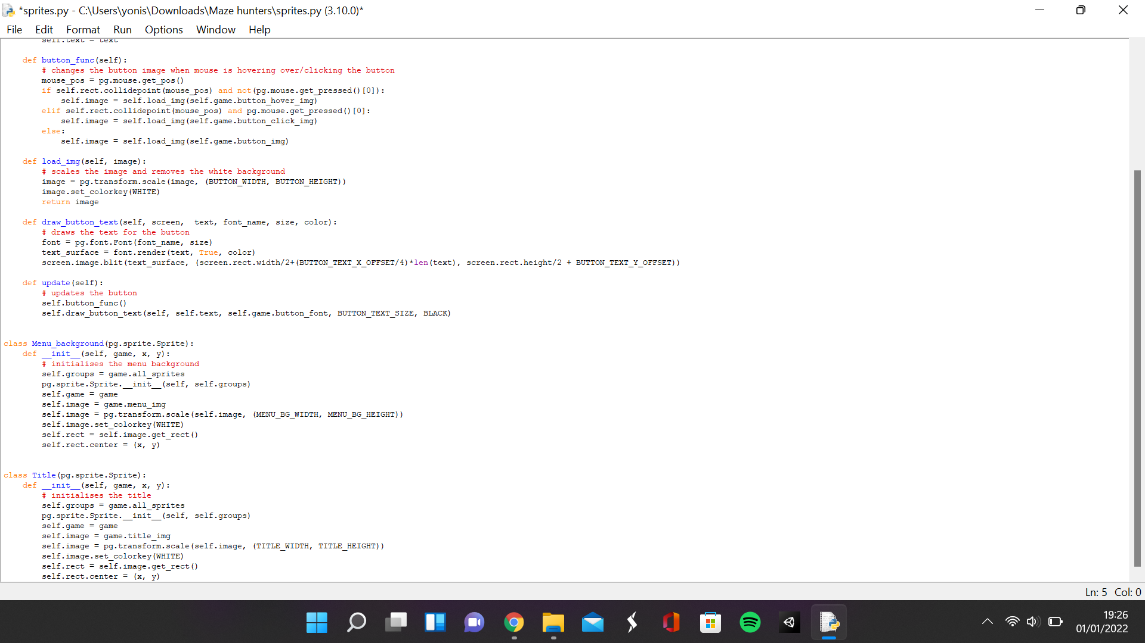

**Settings.py**

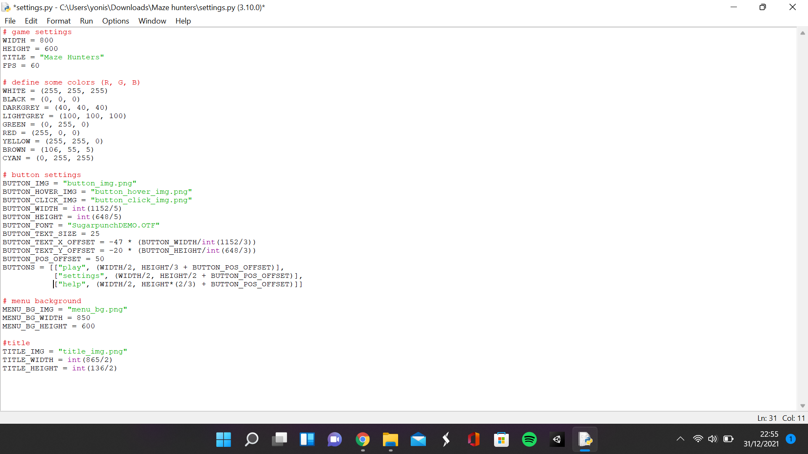

This section is for the first 2 requirements of the success criteria, the menu having 3 buttons and the buttons switching sprites when clicked. After setting up the game, I created a new method in the main script called load data which is supposed to load all the files that I will need in the game. Using the os library, I located the game folder that contains all the scripts and images. In that folder, I located the image folder and loaded all the images within that folder. In the new function, where all the objects for the game are created, I created the menu background by creating a menu background object in the sprites script and positioned it in the centre of the screen. I then created the title by creating a title object and positioning it in the top middle part of the screen. The BUTTONS variable is a 3D array used to contain the name of the button and its position. So in the new function, I created a loop that takes these 2 items and creates buttons using the first item for the text in the button and the second item for the position of the button.

In the sprites script, I created 3 classes: the menu background class, the title class and the button class. In the initialisation of the button class, I made it the button class a subclass of Sprites and put the class in the all sprites group. I then assigned the game parameter as the attribute game which refers to the main game and then I use the method load img to scale down the image and remove extra whitespace. I created a rectangle the size of the image to move the button and position it using the x and y parameters as the centre. I then assigned the text parameter as text. In the button func method, was to make the button work like a button. First, I got the position of the mouse and stored it in a variable. If the mouse position was in the rect of the button and the mouse is being clicked, then the button would switch to the clicked image. If the mouse position was in the rect of the button and the mouse is not being clicked, then the button would switch to the hovering image. And if neither of those things are happening, then the button would switch to the original image. The method draw button text, gets the font using the font name and size parameters and since pygame does not allow me to draw text directly on the button, I had to draw the text onto an image surface and then draw it onto the button. In pygame, the position of the text is not from the centre, so I had to use an X and Y offset to position it in the centre. But since the text is not positioned from the centre, if the text had less or more than 4 characters, the text would not be in the centre, so I decided to increase/decrease the offset based on how many characters the text had but the letters were not the same length, so it was not perfect, but it was closer to the centre than before, so it works for now. The menu background and title are just images so the code in the constructors is the same as the code in the button constructor except without the text attribute and with a different image. There are not any extra functions in the code since they do not need to be interactable.

In the settings script, I added more settings for the buttons, the menu background, and the title. For the button I had: a 3D array which contained the position of the buttons and the text within them, A button offset variable to move all the buttons up and down at once, a text position offset that moves the text to the centre of the button and stays in the centre when the button size is changed, the height and width of the button (which is the width and height of the original image divided by a number to prevent the image from getting squashed), the font of the text in the button and the images for all the different states of the button. For the menu background and title, I had the weight and height of the image. The title width and height is also just a factor of the width and height to prevent squashing.

|  |  |  |  |
| --- | --- | --- | --- |
| What is being tested | Data input | Expected output | Actual outcome |
| The buttons react to having the mouse hover over them | Mouse hovering over button | The button switches to the hovering button image | The button switches to the hovering button image |
| The buttons react to having the mouse click them | Mouse clicking button | The button switches to the clicked button image | The button switches to the clicking image |

**Screen without the mouse hovering over the button**

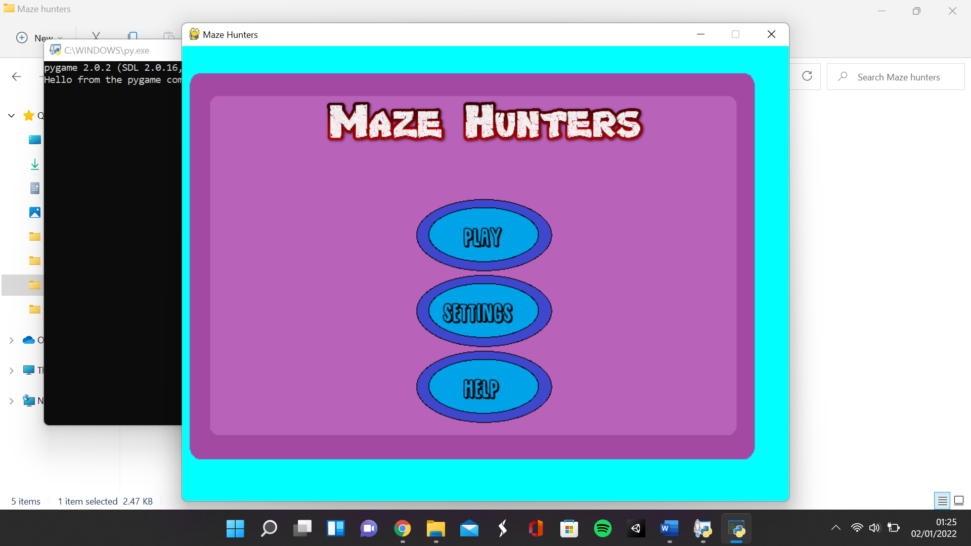

**Screen when the mouse is hovering over the button**

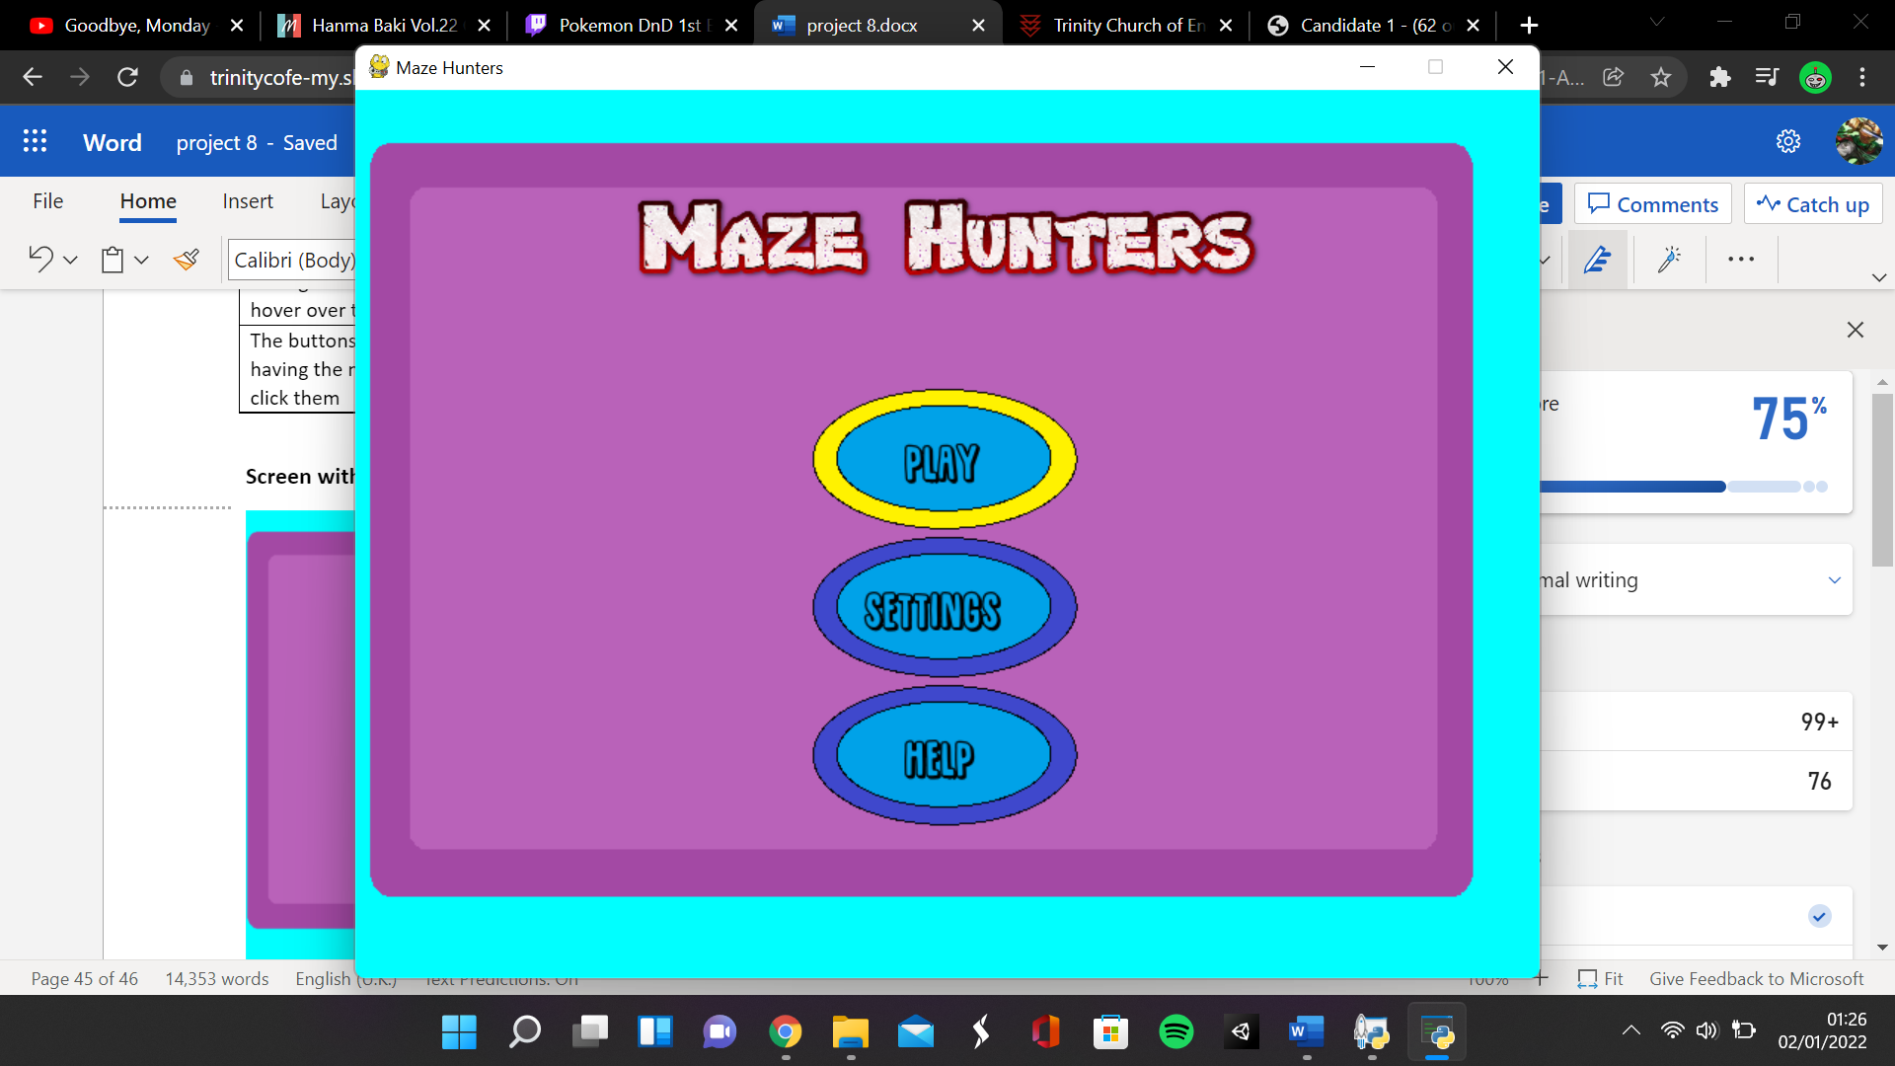

**Screen when button has been clicked**

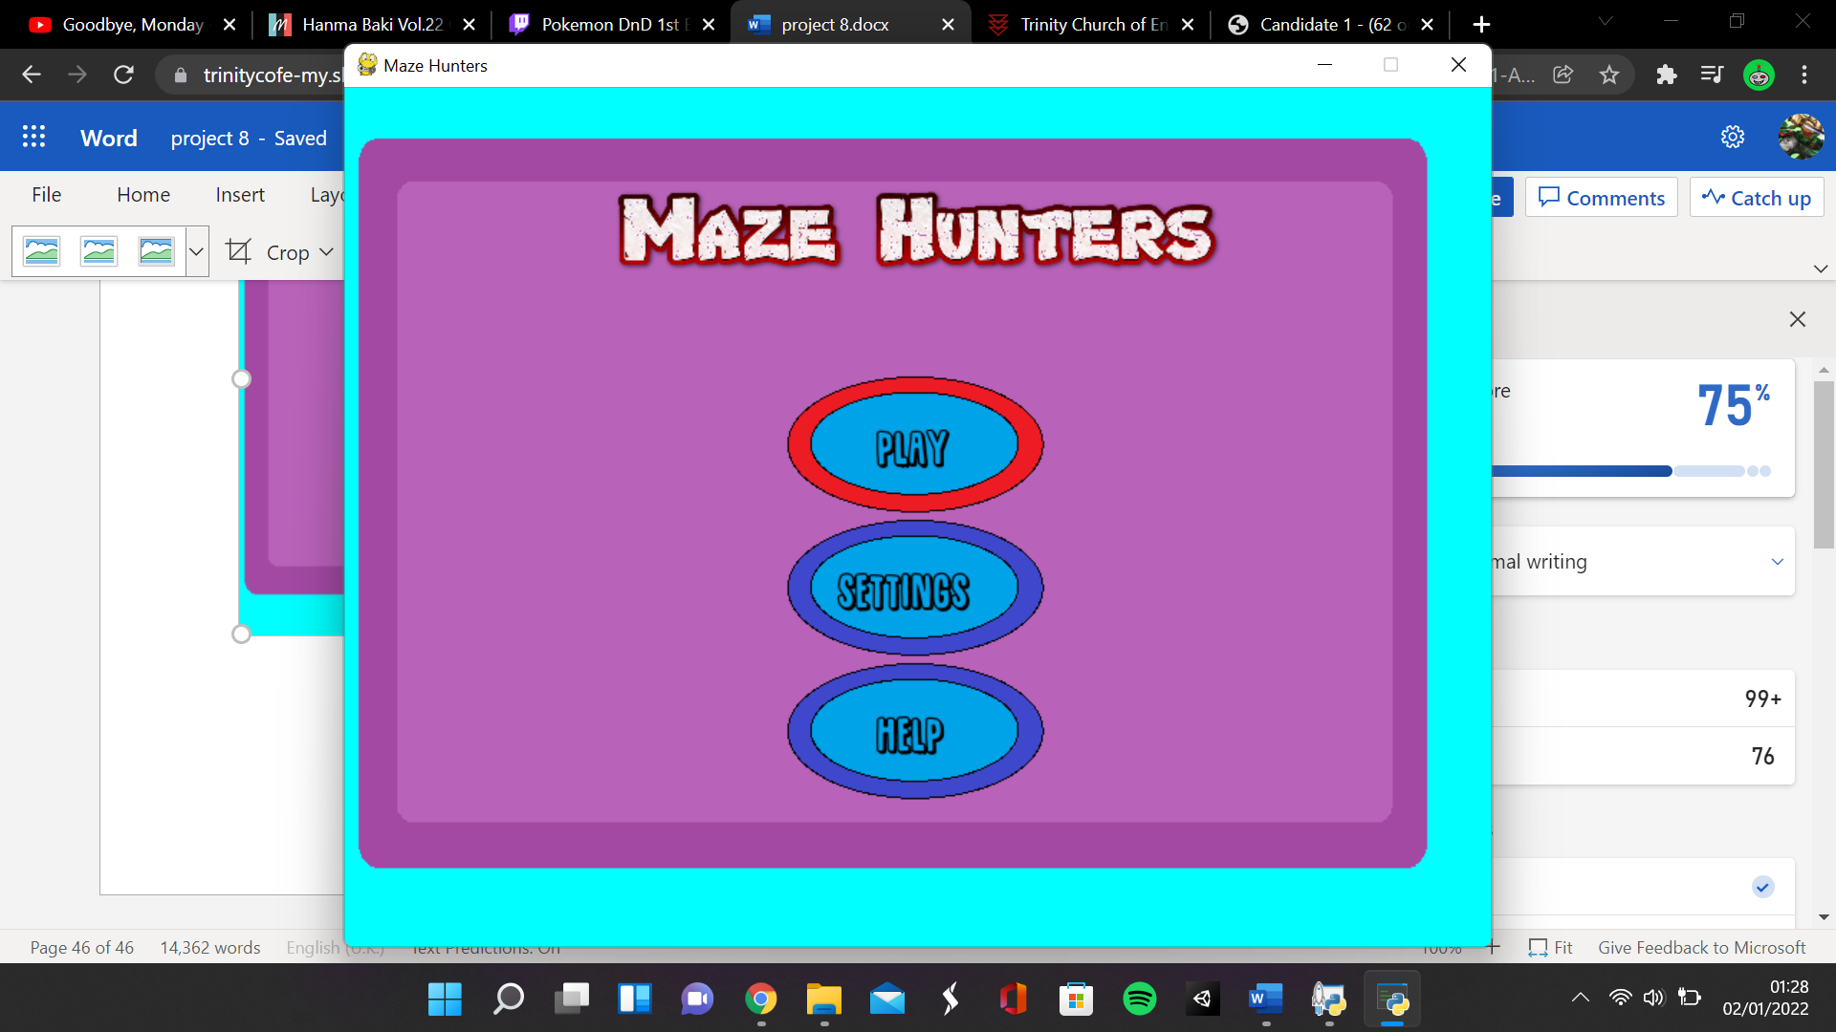

### Setting up game states

**Main.py**

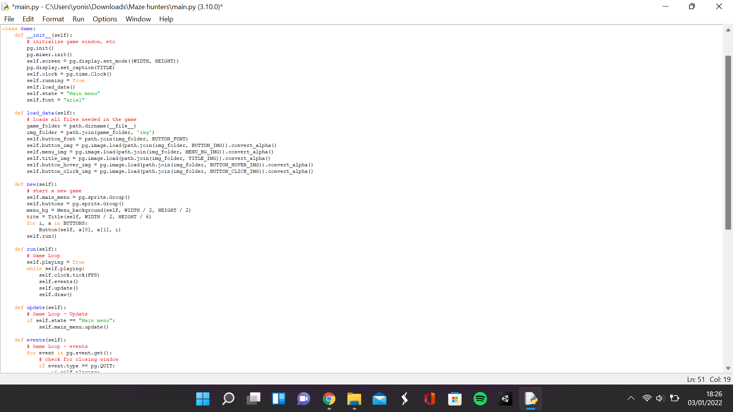

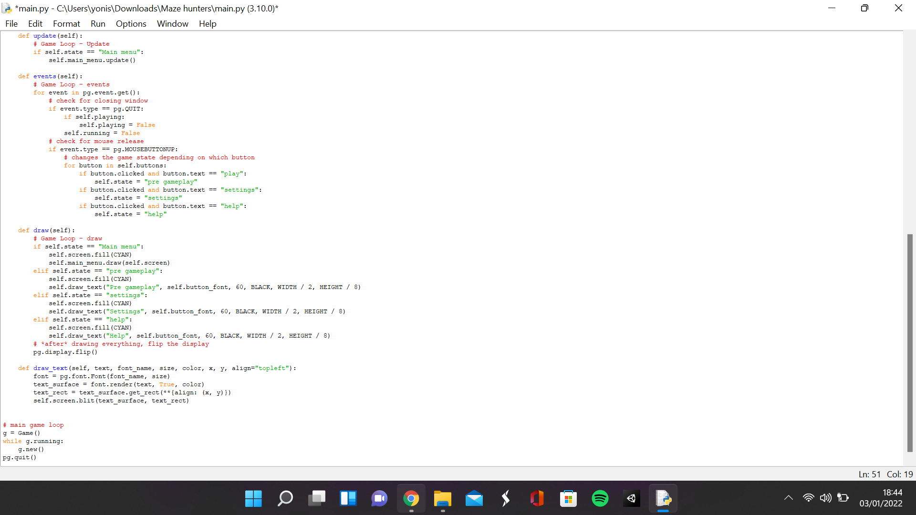

**Sprites.py**

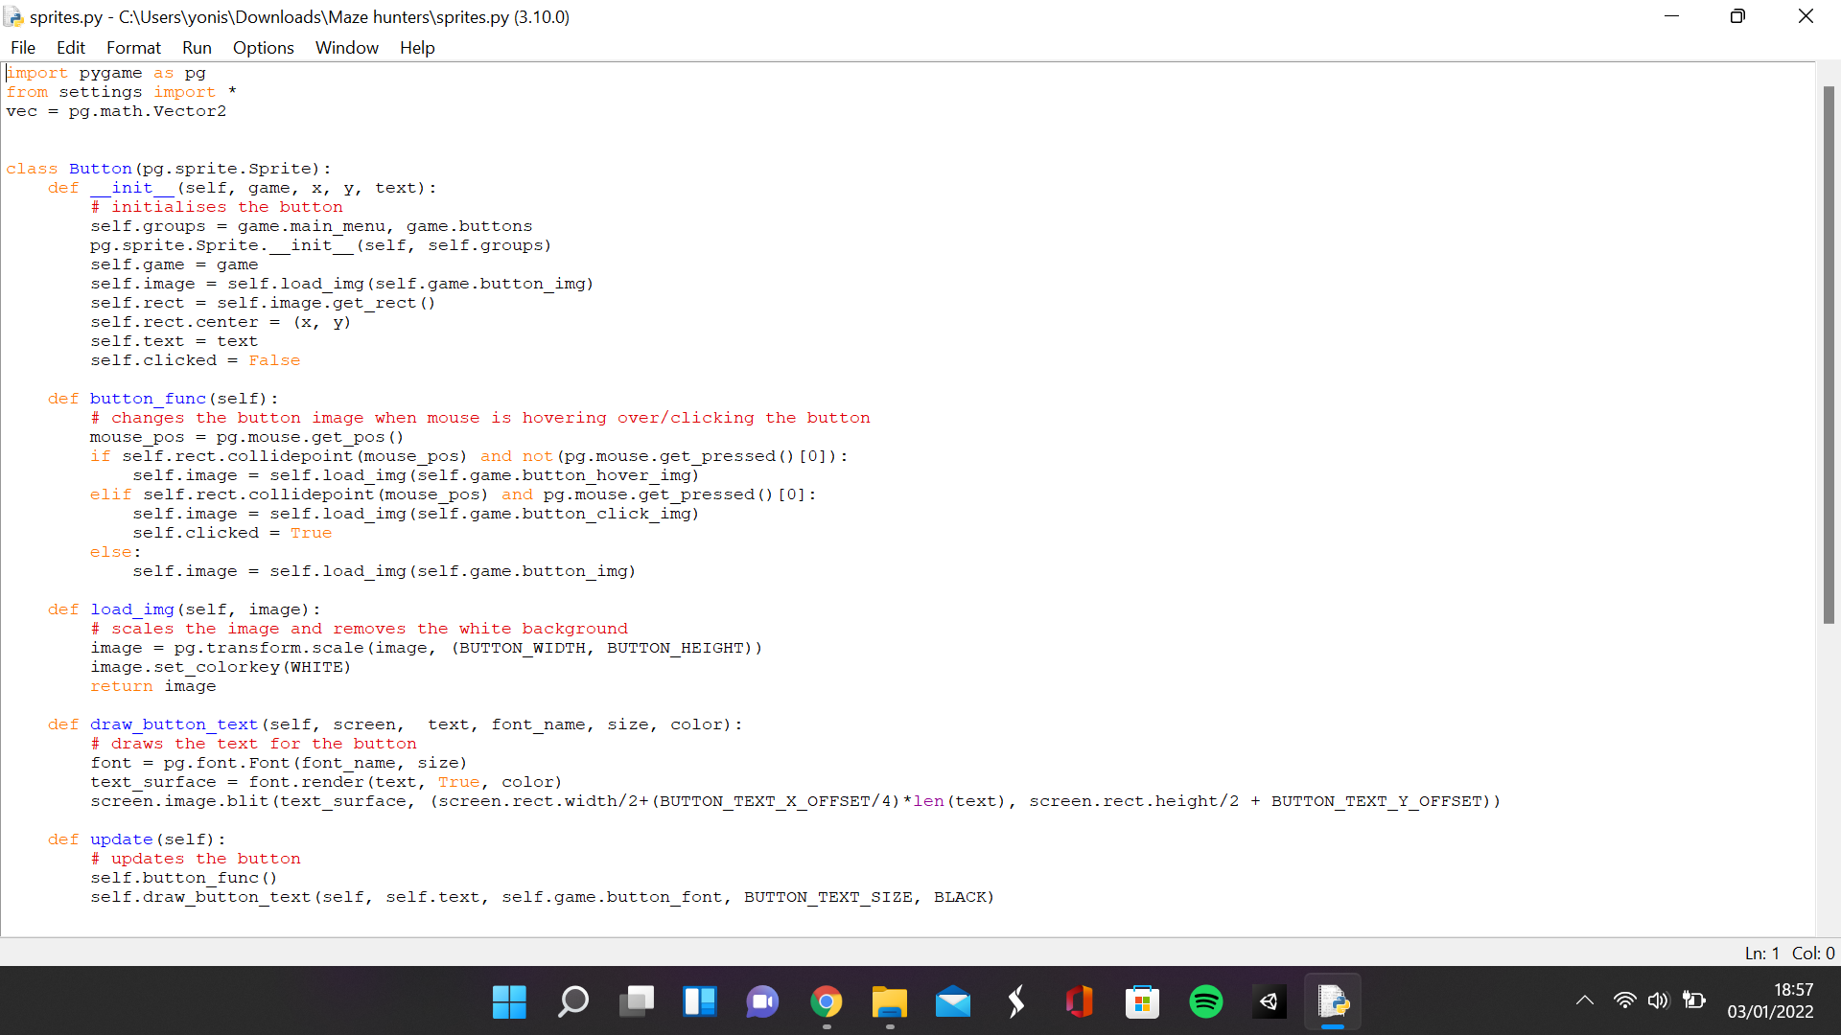

This was to satisfy the next 3 requirements of the success criteria: the play button loads the pre gameplay state, the settings button loads the settings menu, and the help button loads the help menu. In the main script. I got rid of the start screen and game over screen methods and decided to take a different approach to setting up the states. I renamed the all sprites group to the main menu group and added an attribute called state which is initially the main menu. When the state is the main menu, then all the sprites in the main menu group are updated and rendered on top of a cyan background. If the state is pre gameplay, then the text pre gameplay is drawn on top of a cyan background. If the state is settings, then the text settings is drawn on top of a cyan background. If the state is help, then the text help is drawn on top of a cyan background. In the button class in sprites, I added an attribute called clicked which is initially false but becomes true when the button is clicked in button func. So, in the events method, I looped through every button in the buttons group and checked what the name of the button was using the text attribute. If the text was play, the state would be pre gameplay, If the text was settings, the state would be settings and If the text was help, the state would be help. I also made a new function called draw text which is almost identical to the draw button text except it draws the text onto the screen instead of a button and the text is aligned towards the left.

|  |  |  |  |
| --- | --- | --- | --- |
| What is being tested | Data input | Expected output | Actual outcome |
| The play button works | Mouse click on the button | The unit selection screen is loaded | The unit selection screen is loaded |
| The help button works | Mouse click on the button | The help menu is loaded | The help menu is loaded |
| The settings button works | Mouse click on the button | The settings menu is loaded | The settings menu is loaded |

**Nothing is clicked**

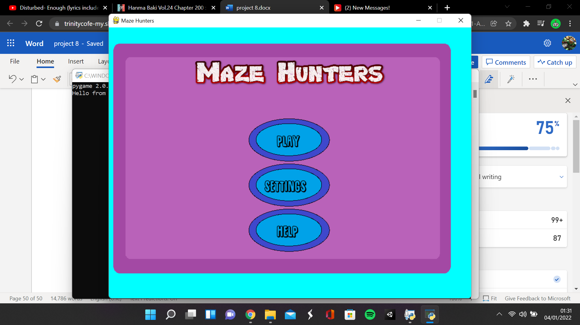

**Play button is clicked**

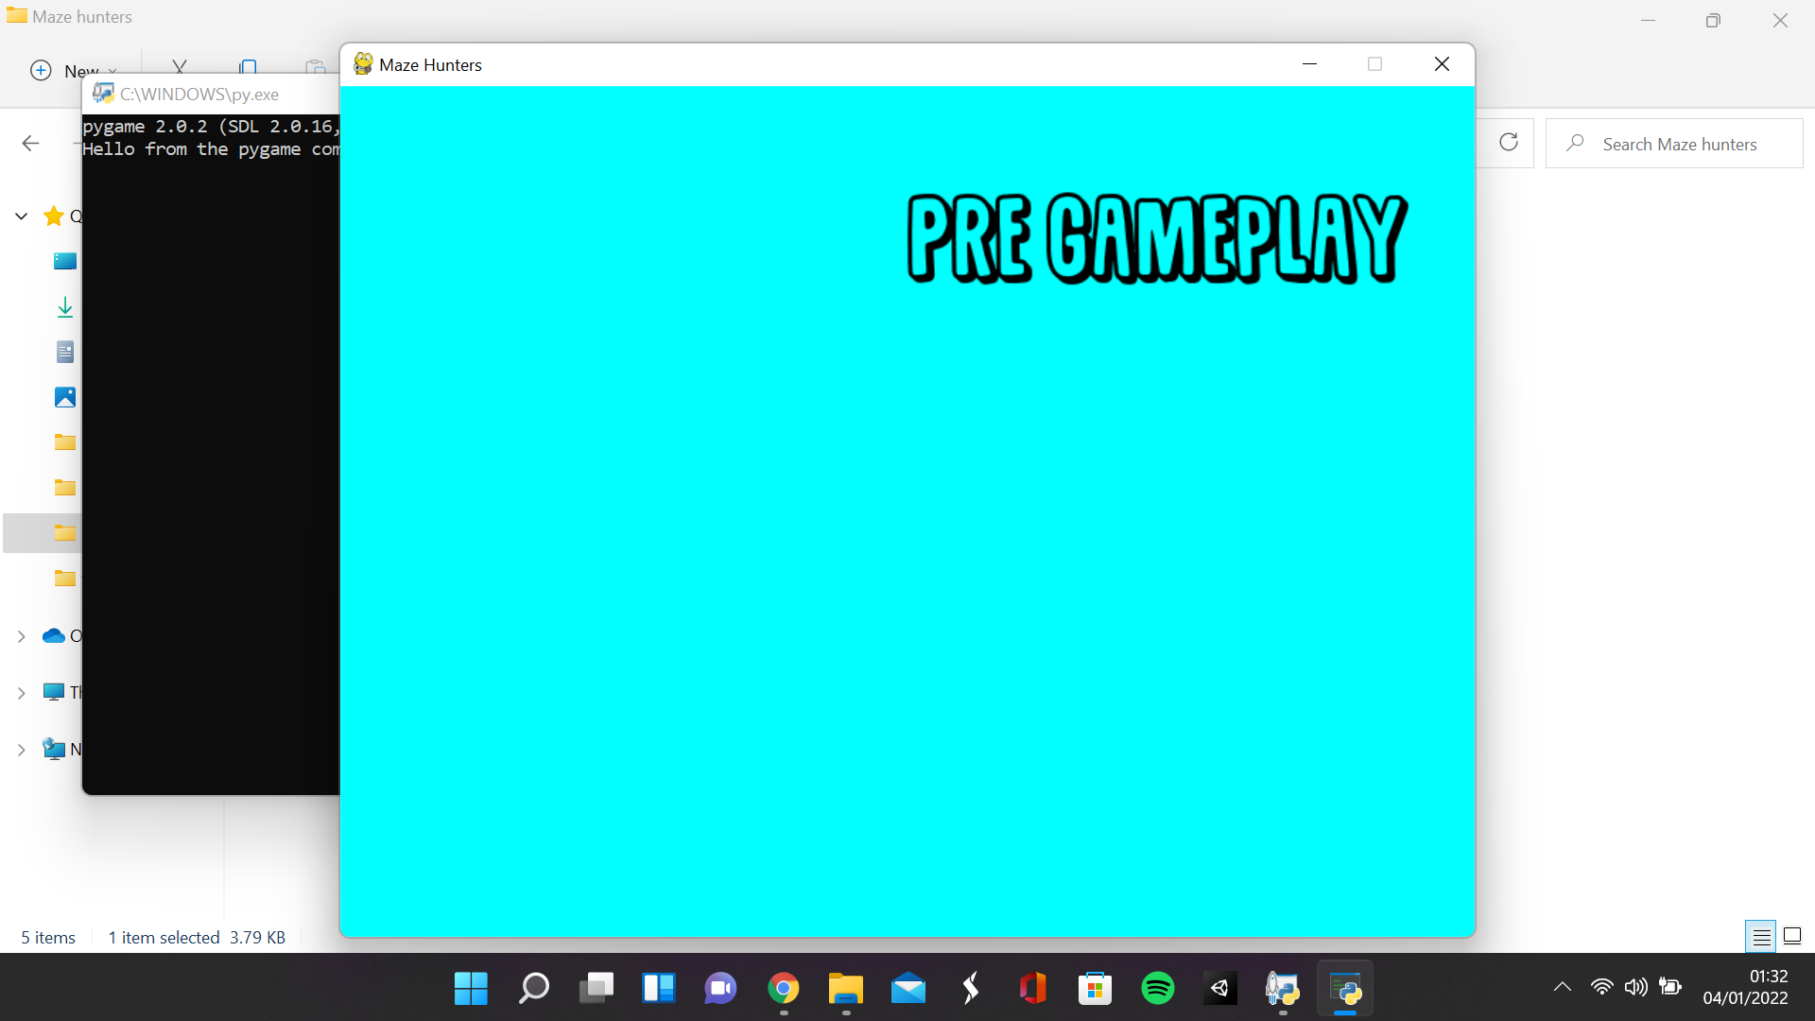

**Settings button is clicked**

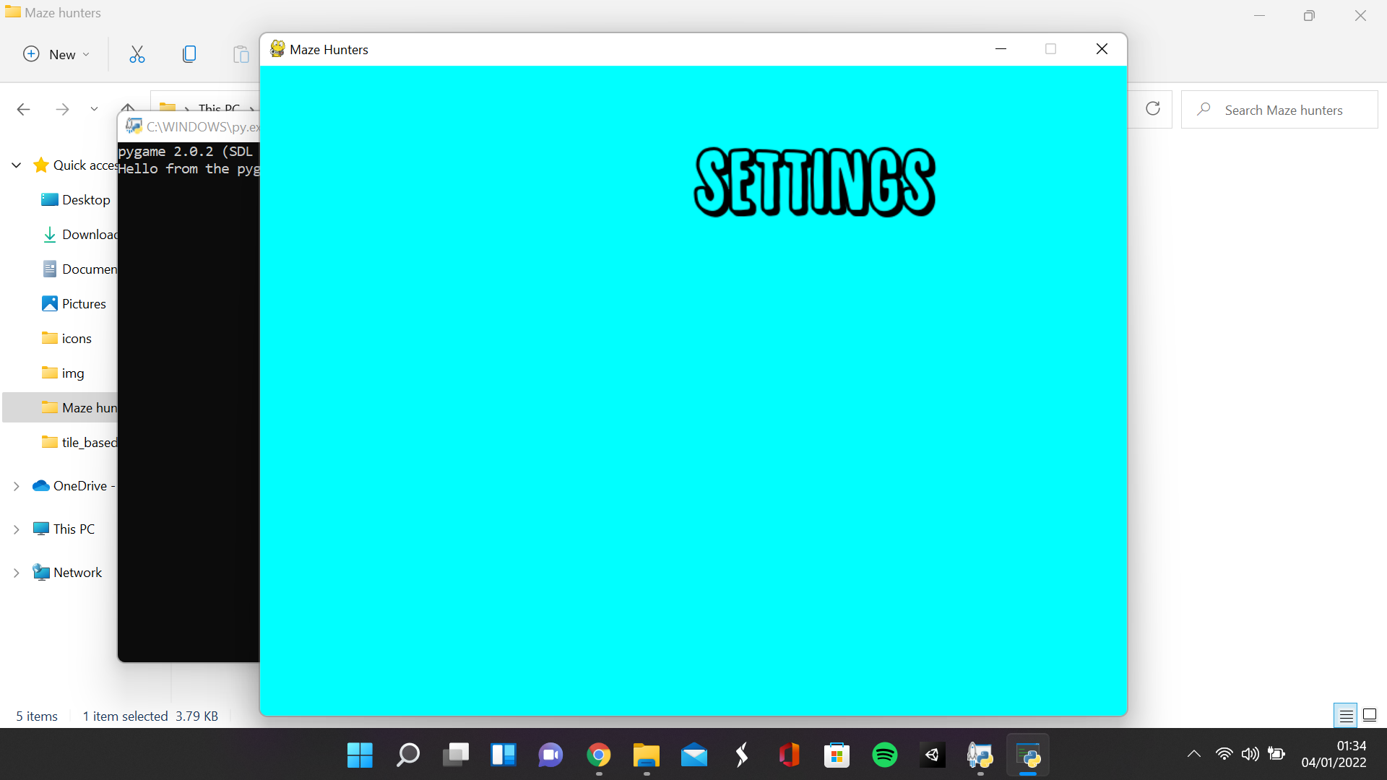

**When the help button is clicked**

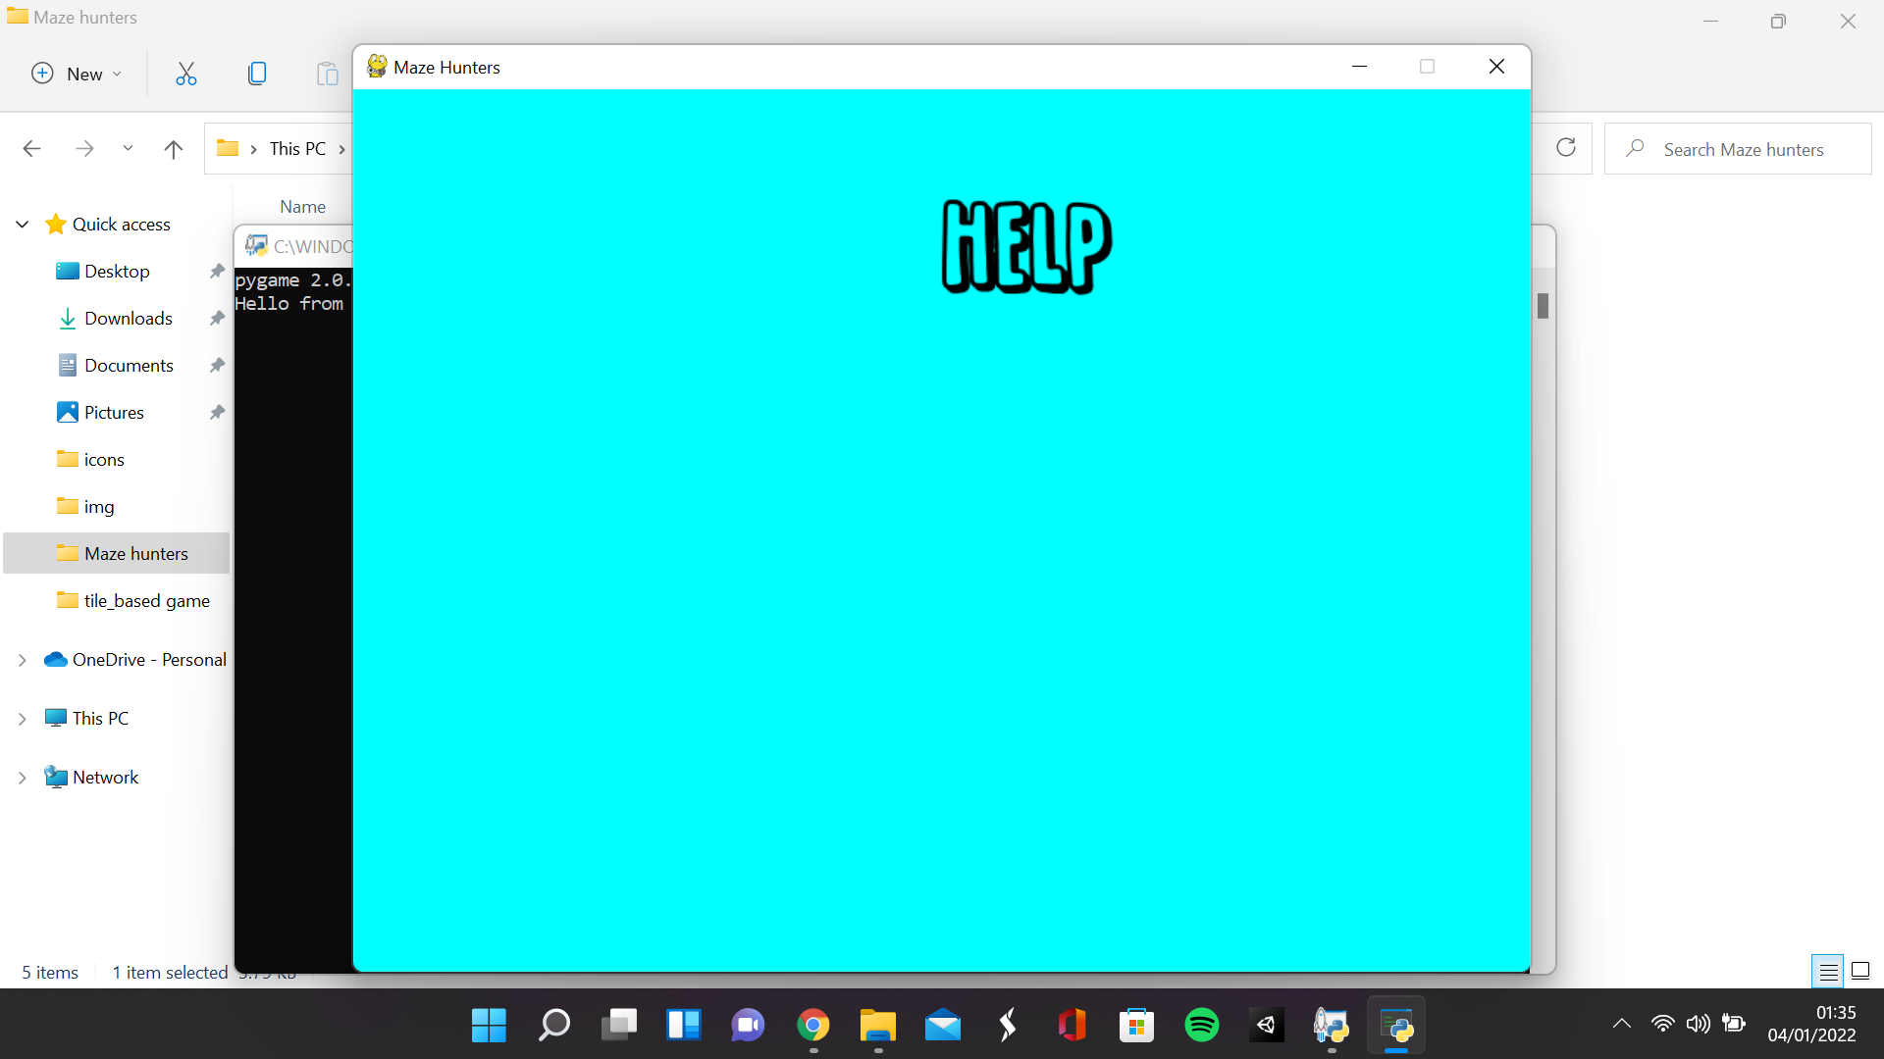

### Making the setting and help menu

**Main.py**

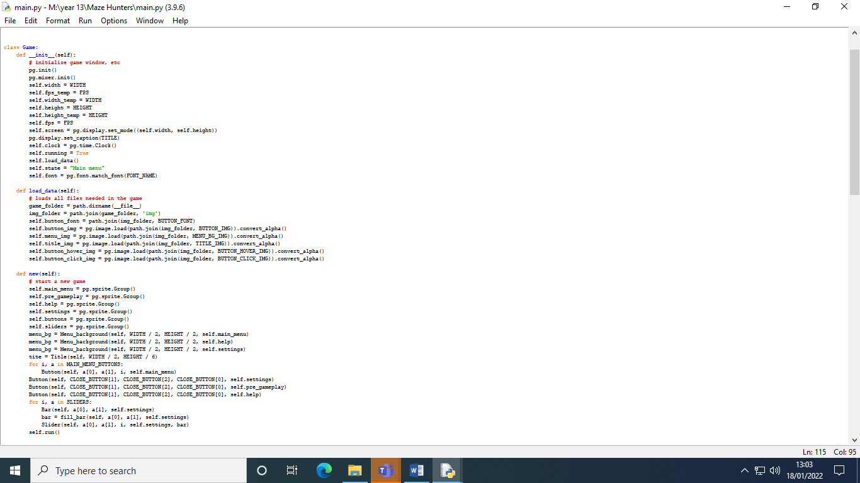

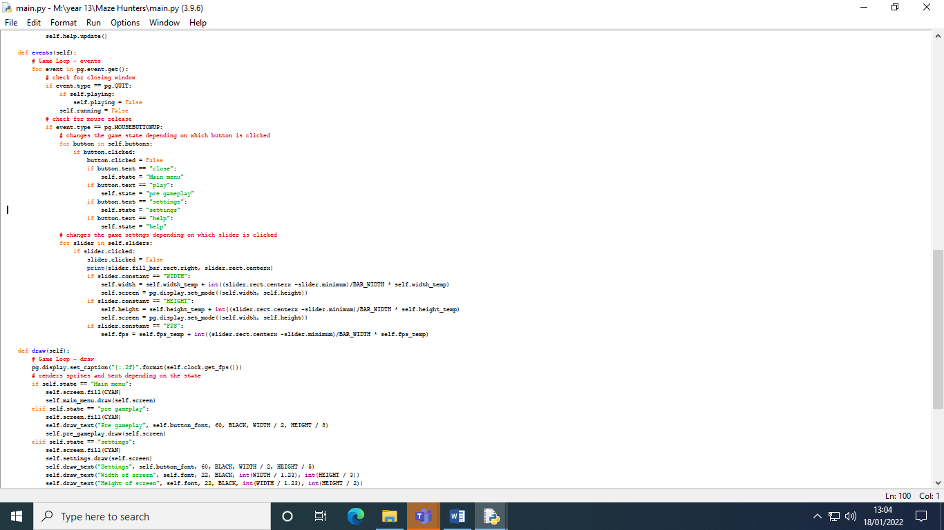

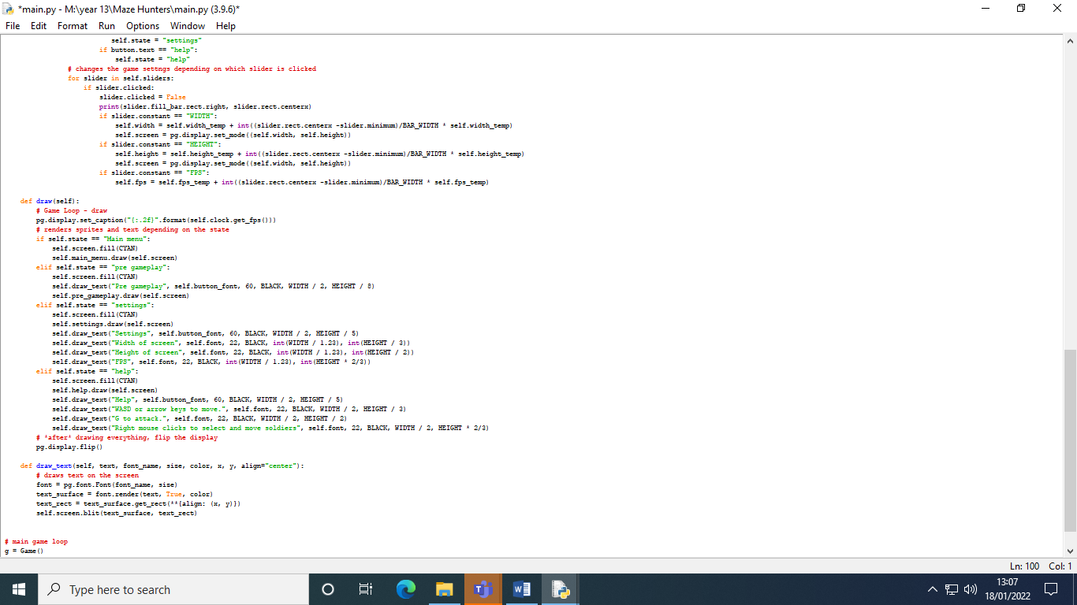

**Sprites.py**

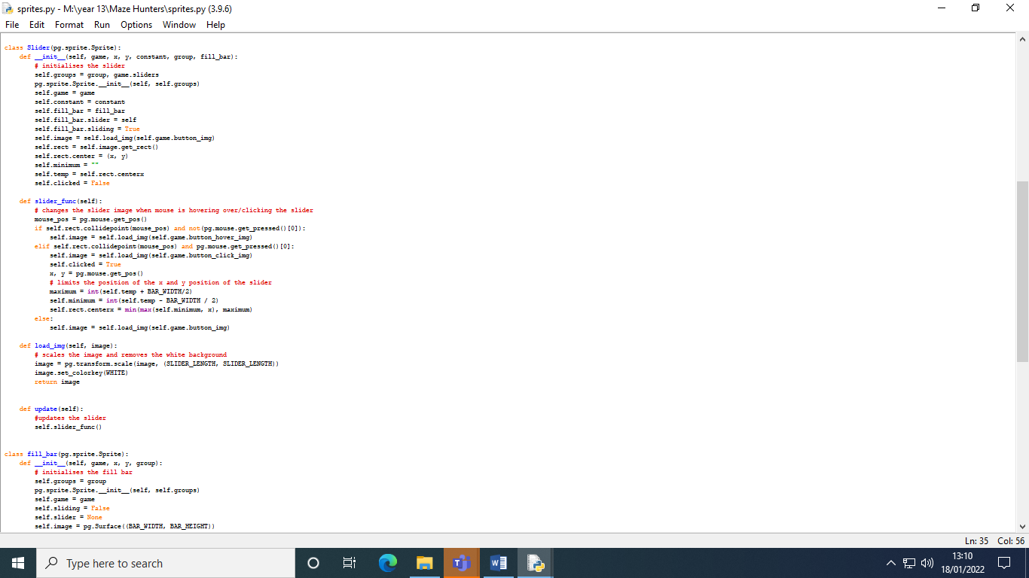

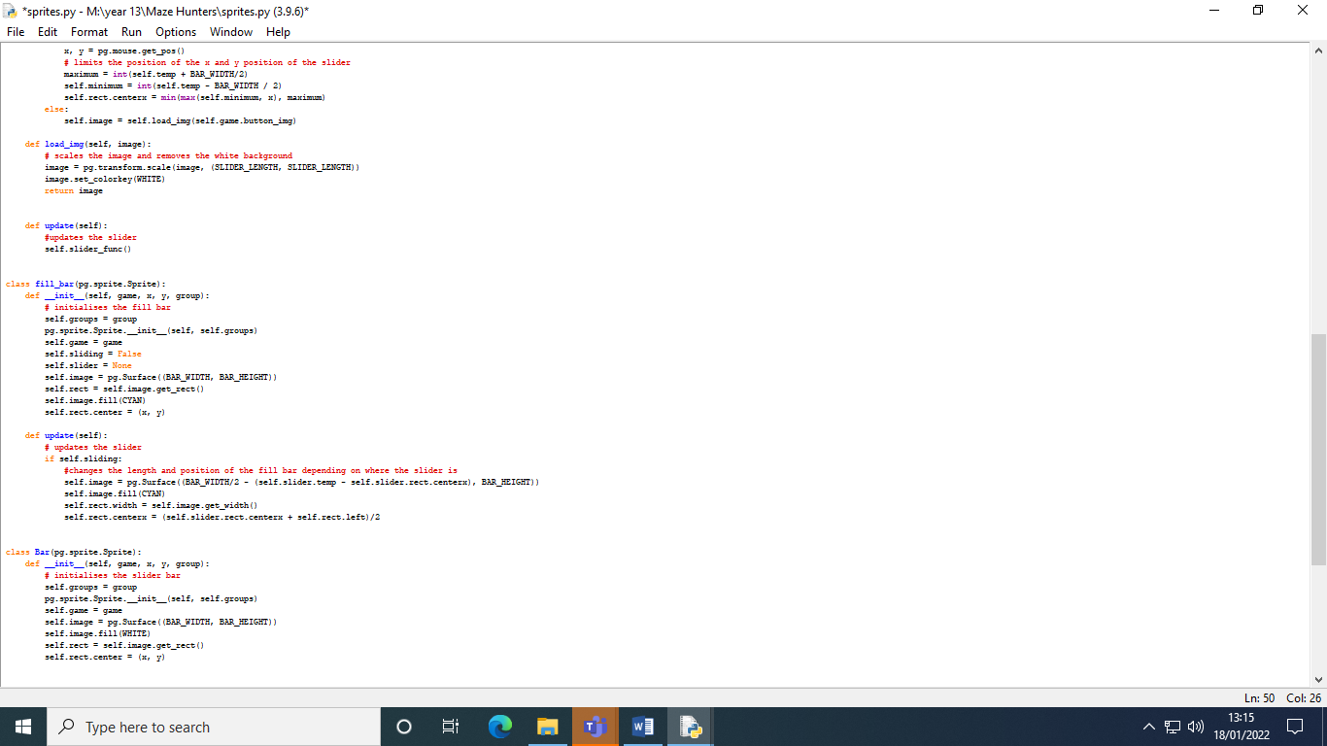

**Settings.py**

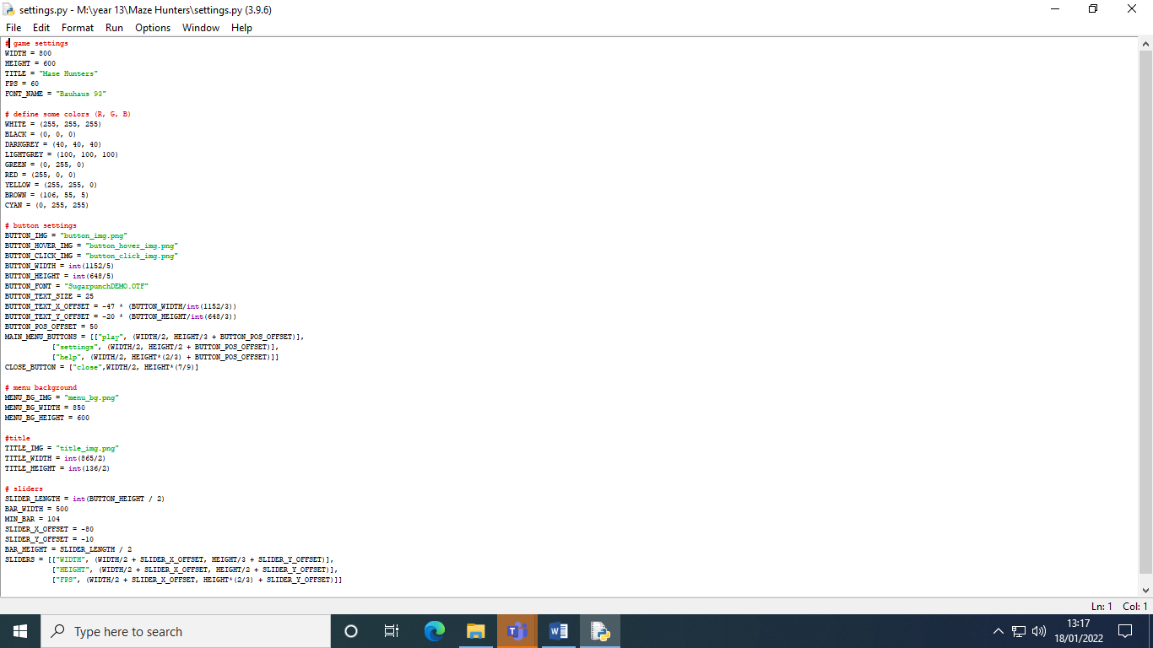

This section is to satisfy the next 2 requirements of the success criteria, to modify constants in the settings menu and to add a close button that links back to the main menu. In the main file, when trying to make the settings menu, I encountered a problem with my original idea. The variables imported from the settings file cannot be changed in the main or sprites file, so I had to reassign the values in initialisation of the main script in order to change the variables. I also created some attributes to temporarily store the variables to make sure that the constants don’t increase exponentially. I also realised that I had assigned fonts incorrectly so I changed the font attribute so the attribute can be used to assign fonts in the draw text function. I added more groups for the other states such as the help menu, the settings menu and the pre gameplay state.

In the sprites script I created 3 classes. One was slider, which is the button used in the slider. Bar which is just a sprite used to show the empty bar and fill bar which is the bar on top of the empty bar which extends to the position of the slider. In the slider class, I assigned several attributes in the initialisation method. The slider group, the main game, the constant that the slider affects, the fill bar the slider is attached to, the minimum position that the slider can extend which is initially assigned as nothing, the position of the centre of the sprite and the attribute used to check if the button has been clicked. The image of the sprite is defined as the button image, and the rectangle is defined as the images rectangle with its centre being positioned with the x, y parameters. The fill bar’s slider attribute is assigned the slider object and the fill bar’s sliding attribute is a Boolean variable used to tell the fill bar when the slider is being used. The method slider func is used to control the sliders functionality. In this method, the code is almost identical to the button function method, but in the condition where the mouse is clicked and the mouses position is equal to the sliders position (the slider is clicked), there is extra code added in which assigns the centre x position of the slider to be equal to the x position of the mouse. I used the max and min functions to limit the X position of the slider to be between the left and right side of the empty bar. The load image function is the same as the buttons load image function and in the update method, the slider func method is run.

The fill bar class is initialised as a rectangle with its initial length being the BAR WIDTH and initial height being BAR HEIGHT with the colour CYAN. There is also a Boolean attribute called sliding which checks whether the slider is sliding and another attribute that refers to the slider itself. These attributes are reassigned values when the slider object is instantiated. In the update method, if the sliding attribute is reassigned true when the slider is instantiated, then the width of the fill bar is changed to be the original width minus the distance between the original position of the slider and the new position of the slider. The position of the fill bar is the midpoint between the slider and the end of the bar. The bar is the same as the fill bar but without the slider attributes and update method.

In the new method in the main script, I instantiated some extra buttons for closing the menus and instantiated some sliders in the same way I instantiated the buttons but with the fill bar attribute being the previously instantiated fill bar. In the events function, I added a new condition which checks if the button’s text is close in which it will change the state into the menu state which would return the game to the main menu. I also made sure that the button is false when clicked so they can function when I return to a menu. I added another loop that checked if a slider was clicked just like the buttons. When the slider is clicked, the constant is increased by the percentage of the distance between the slider and the end of the bar in relation to the full bar width. If the sliders constant attribute is width, then the width is the constant that is increased, if the constant attribute is height, then it is the height attribute that is increased and if the constant attribute is FPS, then the fps is increased (I couldn’t fit 4 sliders on so I decided to not include number of enemies). In the draw function, I rendered the sprites in all the other state groups and rendered some text in those menus as well.

In the settings script, I added an array for close buttons which contains the text for the button, the x position of the button and the y position of the button. And for the slider, I created variables for the length of the slider, the bar width and the bar height, the minimum x position of the slider, the slider x and y offsets and the sliders themselves which contain their constant and their position.

|  |  |  |  |
| --- | --- | --- | --- |
| What is being tested | Data input | Expected output | Actual output |
| Sliders in the settings menu increase the corresponding constant | Mouse click and movement of the mouse | The corresponding constant such as height or width of the screen will increase when the slider is dragged to the right and decrease when the slider is dragged to the left | The constants do increase when the slider is dragged to the right and decrease when the slider is dragged to the left but sprites that use those constants aren’t affected |
| Close button in menus work | Mouse click on the button | The menu that was open is closed and the main menu is loaded | The main menu is loaded after the menu is closed |

**Settings menu**

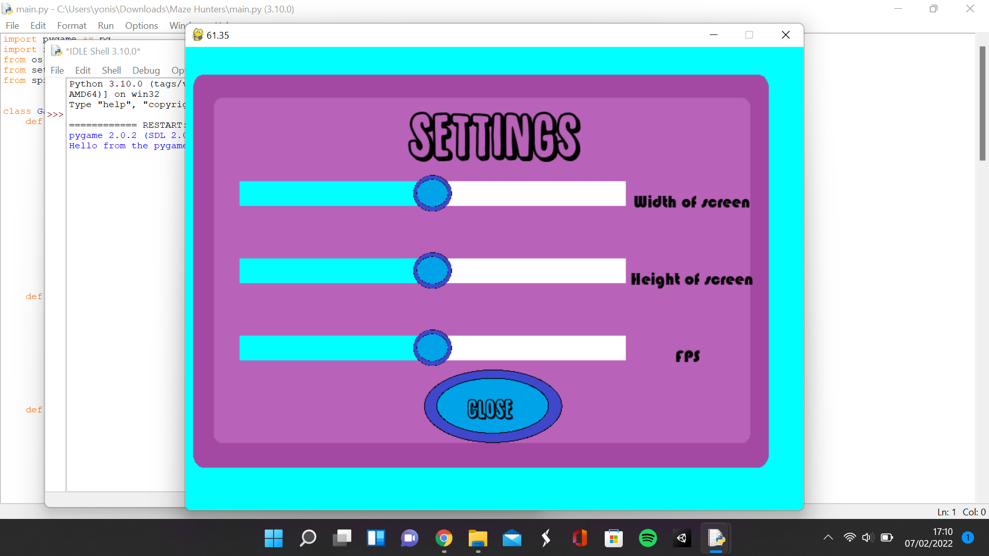

**Width slider is dragged to the left**

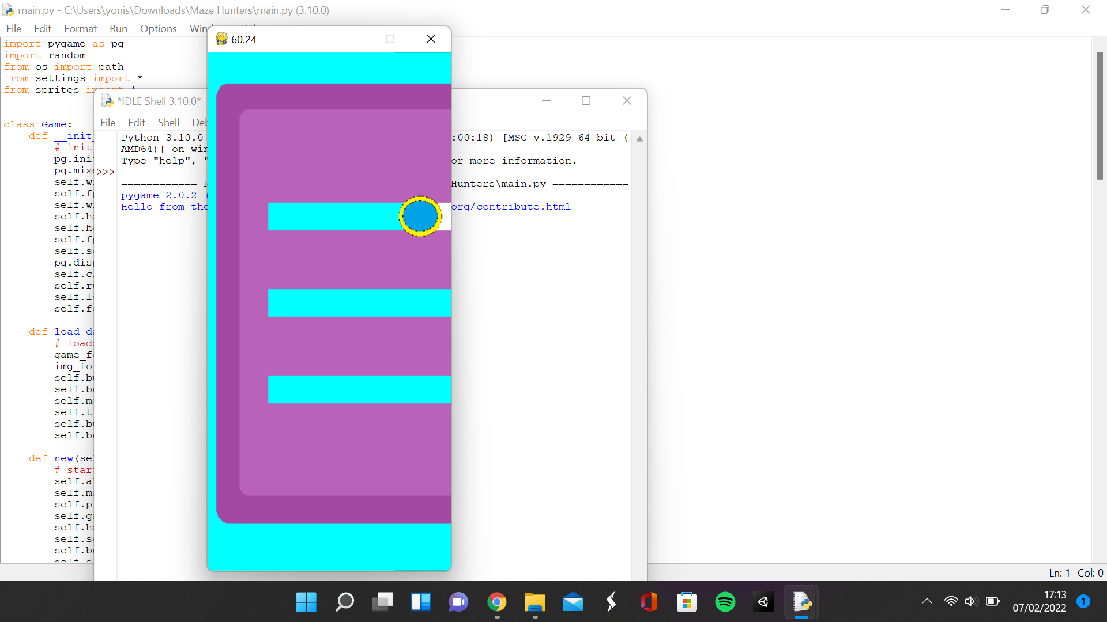

**Height slider is dragged to the right**

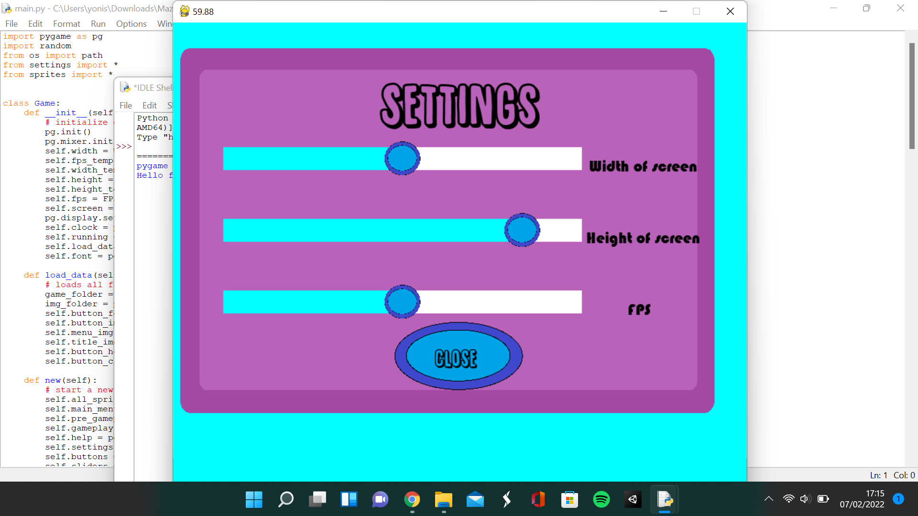

**FPS slider is dragged to the right**

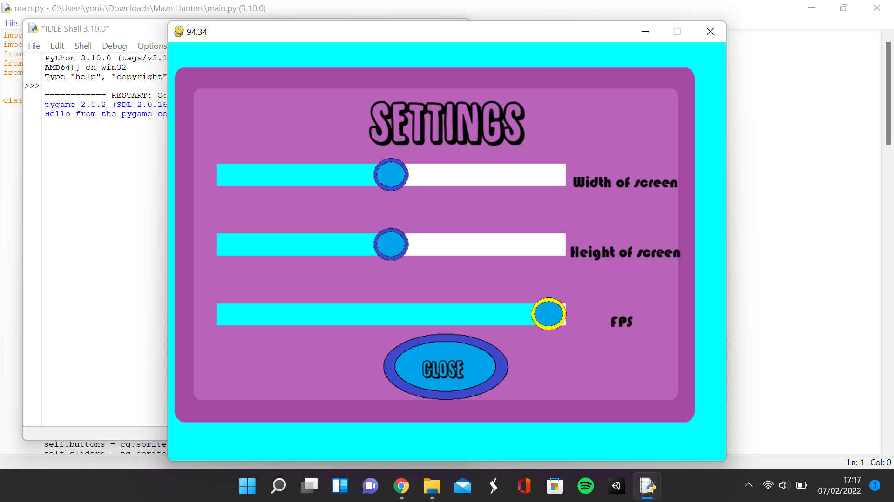

**Help Menu is Opened**

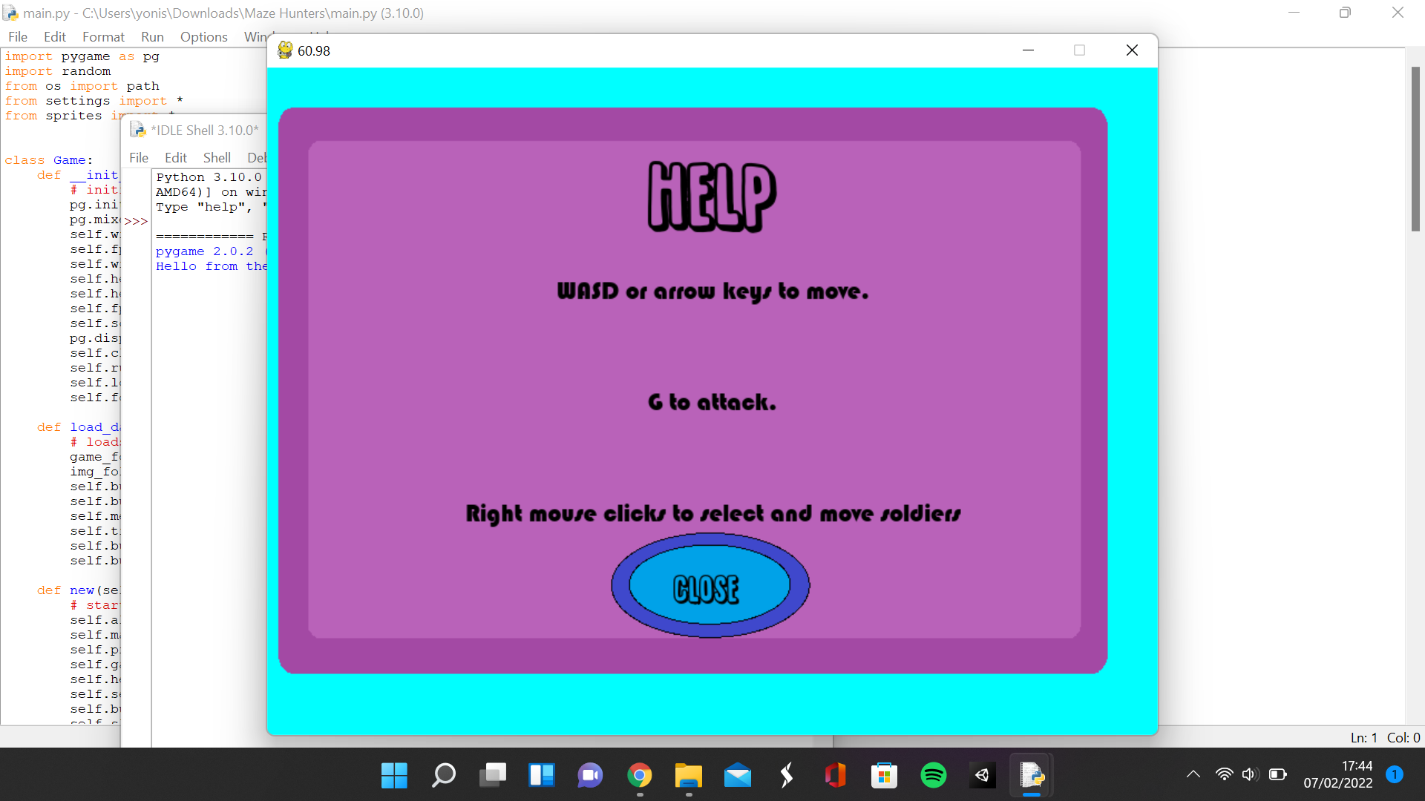

### Making the unit selection menu

**Main.py**

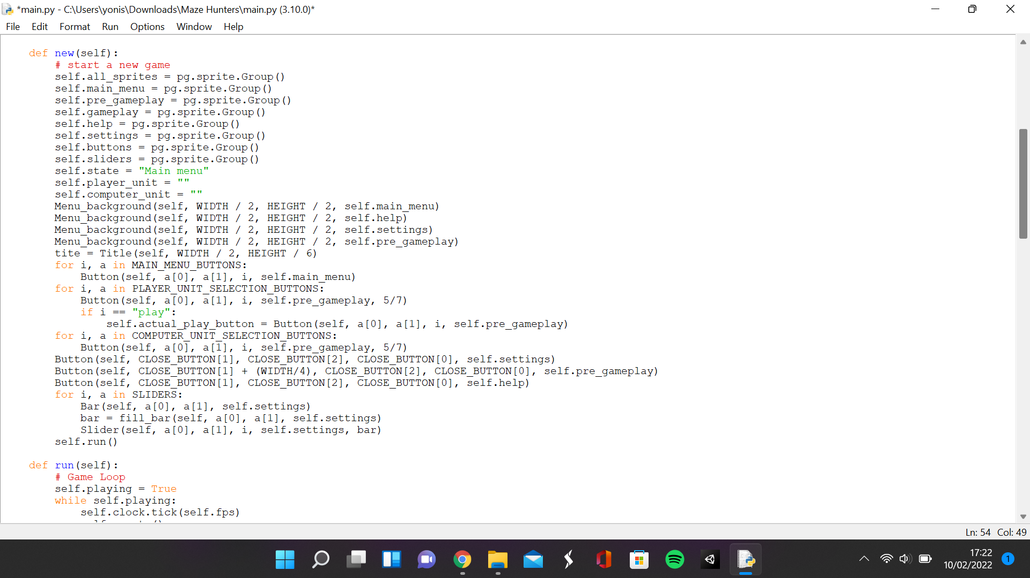

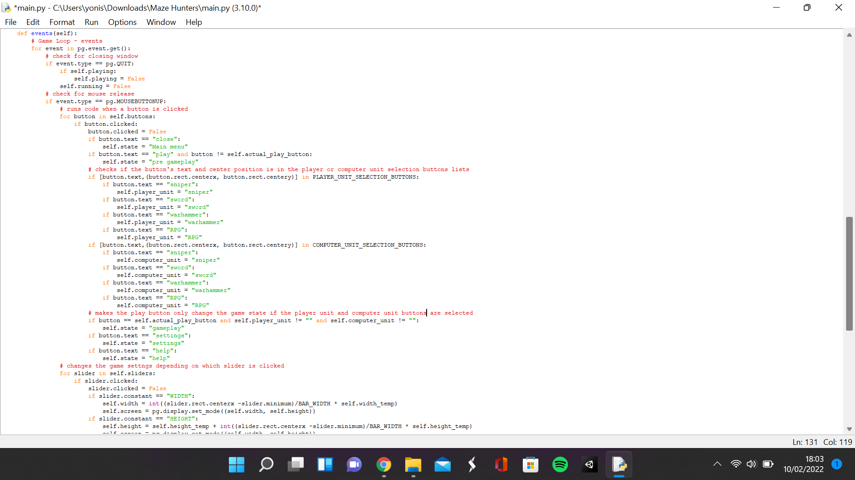

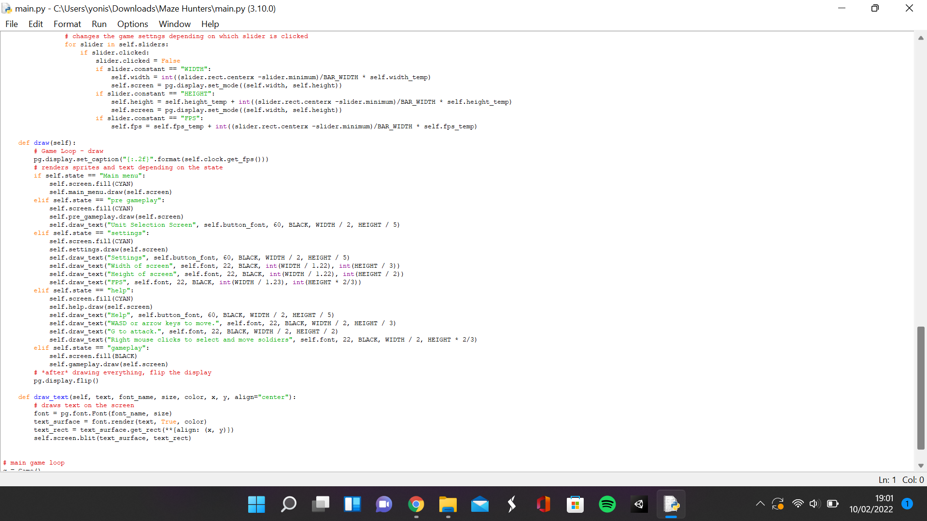**Sprites.py**

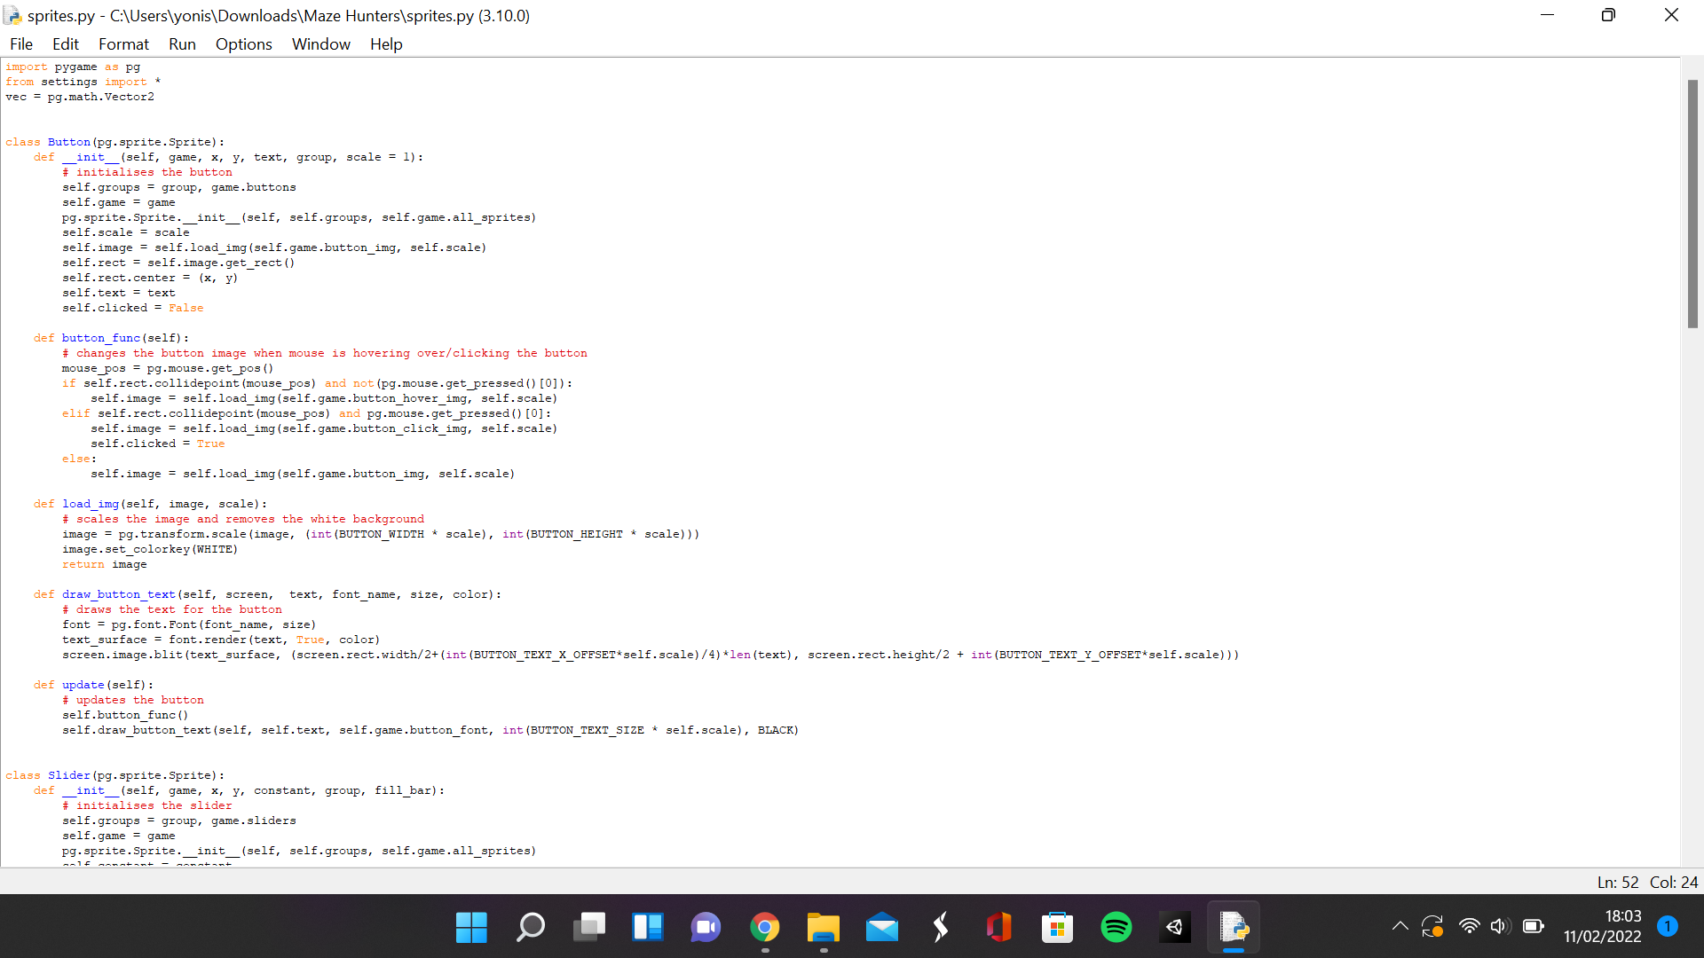

**Settings.py**

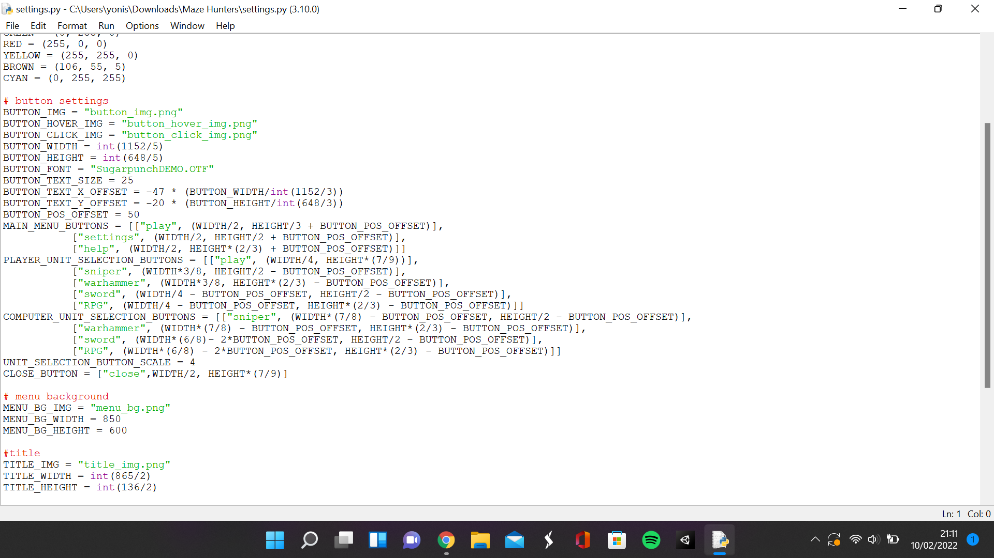

This is to satisfy the next 5 requirements of the success criteria. The pre-gameplay state having 4 units to choose for the player and the computer, only one unit can be selected for the player and computer, each type of unit can be selected for the player and computer, the play button loads the game, and the play button can only be pressed when a unit is selected for both the player and the computer. In the main script, I instantiated a background for the pre gameplay state and some more buttons with the same method that I rendered all the main menu buttons. I immediately encountered a problem where the normal size for the buttons was too large to fit in the menu background, so I decided that I had to add the ability to scale the buttons. In the buttons class I added the parameter scale and assigned the scale attribute with it. The default value of the scale parameter is 1 so I only need to define the scale parameter for the unit selection menu buttons. In the load image method of the button class, I added a scale parameter which the width and height of the rescaled image is multiplied by and used the scale attribute when calling the function in the button func method. I also multiplied the offset of the text and the size of the text by the scale to properly scale the text with the buttons.

In the main script, I added 2 attributes. A player unit attribute for assigning the player unit and a computer unit attribute for assigning the computer unit. I also added an extra group to contain every sprite in the game. I also had to differentiate between the play button in the main menu and the play button in the unit selection menu, so I assigned the play button attribute as the unit selection menus play button. In the events method’s button for loop, I checked to see if the unit selection menu buttons were for the player or for the computer. I used the text of the button and the centre position of the button and compared it to the values in the player or computer unit selection buttons. If it was part of the player array, then it would affect the player unit attribute and if it were part of the computer array then it would affect the computer unit attribute. If the buttons text was sniper, then it would change the unit attribute to sniper, If the buttons text was war hammer, then it would change the unit attribute to war hammer, If the buttons text was sword, then it would change the unit attribute to sword, If the buttons text was RPG, then it would change the unit attribute to RPG. The play button only changes the game state to the gameplay state after the computer unit and player unit have been selected.

In the settings script, I added extra variables for the player and computer unit selection buttons. These arrays are formatted in the same way the other button variables are with a 2D array where each Item contains the text for the array ands a tuple for the x and y position of the button. I also added a unit selection scale integer for scaling the unit selection buttons.

|  |  |  |  |
| --- | --- | --- | --- |
| What is being tested | Data input | Expected output | Actual output |
| Sniper button for the player works | Mouse click on the button | The player unit variable should be set as sniper | the button is clicked, and the player unit variable is set as sniper |
| RPG button for the player works | Mouse click on the button | The player unit variable should be set as RPG | the button is clicked, and the player unit variable is set as RPG |
| Sword button for the player works | Mouse clicks on the button | The player unit variable should be set as sword | the button is clicked, and the player unit variable is set as sword |
| Warhammer button for the player works | Mouse click on the button | The player unit variable should be set as Warhammer | the button is clicked, and the player unit variable is set as Warhammer |
| Sniper button for the computer works | Mouse click on the button | The computer unit variable should be set as sniper | the button is clicked, and the computer unit variable is set as sniper |
| RPG button for the computer works | Mouse click on the button | The computer unit variable should be set as RPG | the button is clicked, and the computer unit variable is set as RPG |
| Sword button for the computer works | Mouse click on the button | The computer unit variable should be set as sword | the button is clicked, and the computer unit variable is set as sword |
| Warhammer button for the computer works | Mouse click on the button | The computer unit variable should be set as Warhammer | the button is clicked, and the computer unit variable is set as Warhammer |
| Play button only works when a unit is selected for the player and computer | Mouse click on the button | There shouldn’t be any response from the button if the unit for the player or computer isn’t chosen and if it is chosen then the gameplay method is loaded | If the play button is clicked without pressing the other buttons, nothing happens. If a button for the player and computer is pressed, then the gameplay state is loaded |
| Close button in menus work | Mouse click on the button | The menu that was open is closed and the main menu is loaded | The main menu is loaded after closing the unit selection menu |

**Unit selection menu**

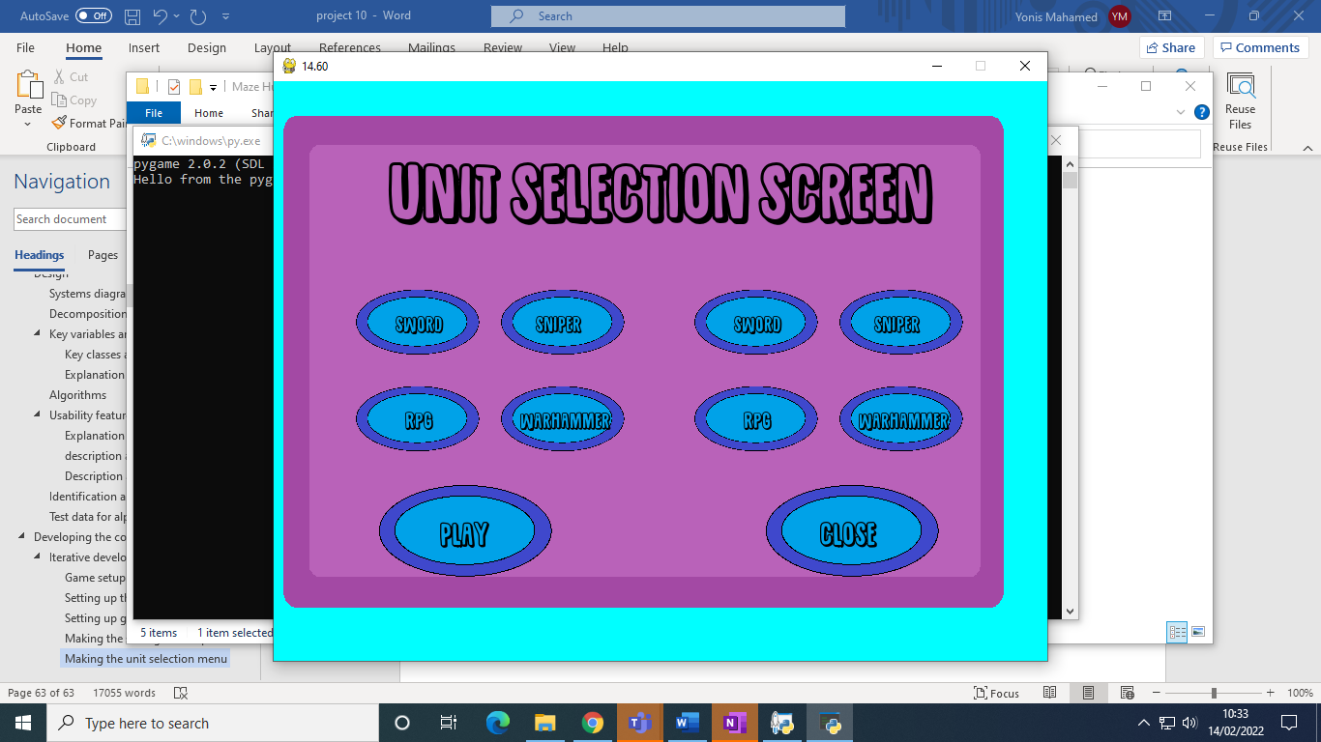

### Making the player character, computer character and maze

**Main.py**

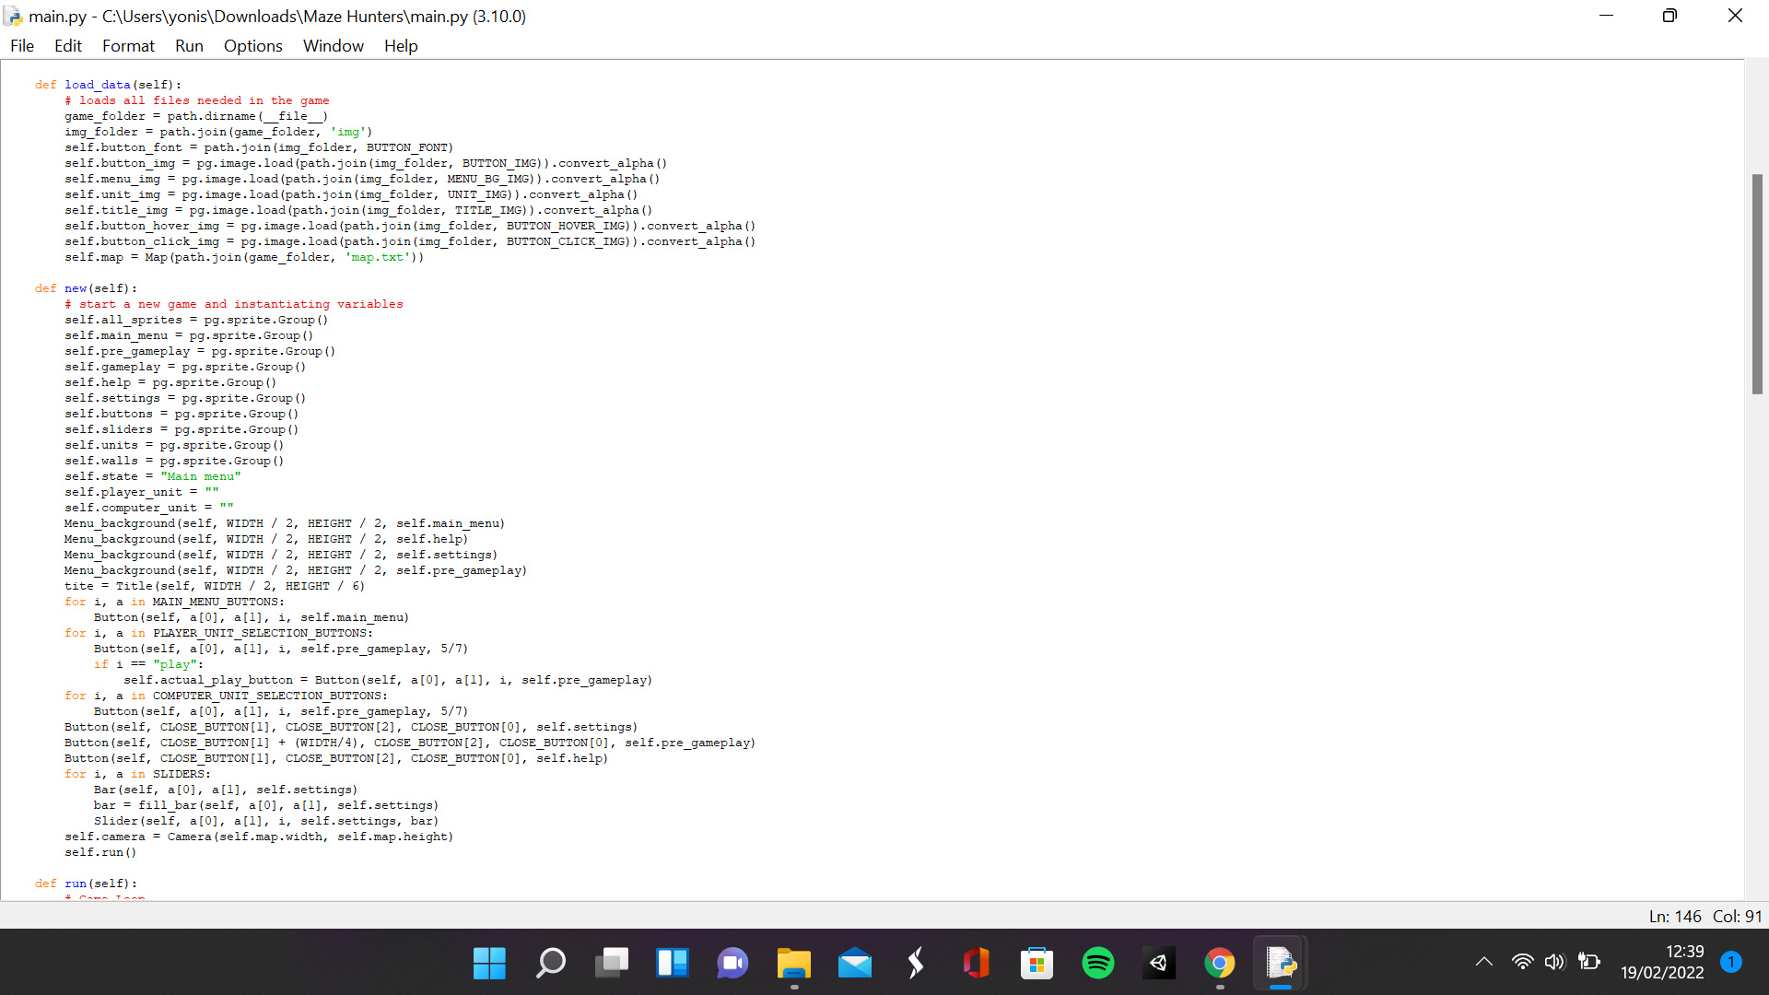

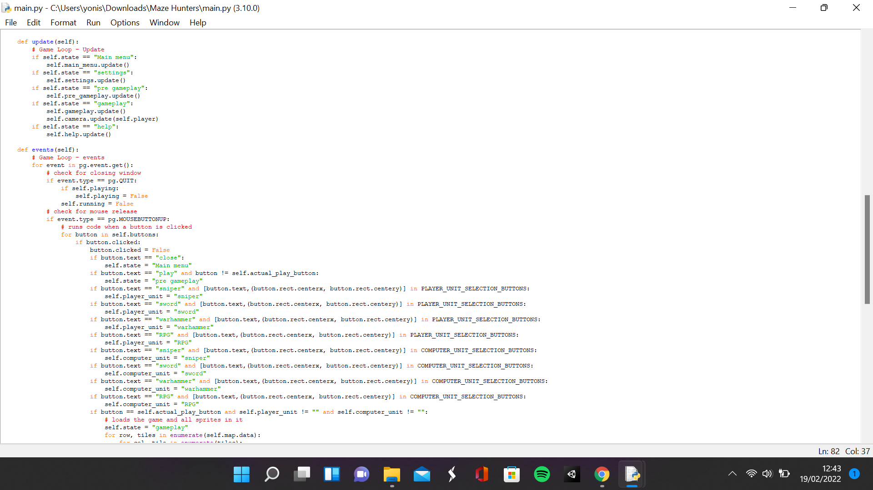

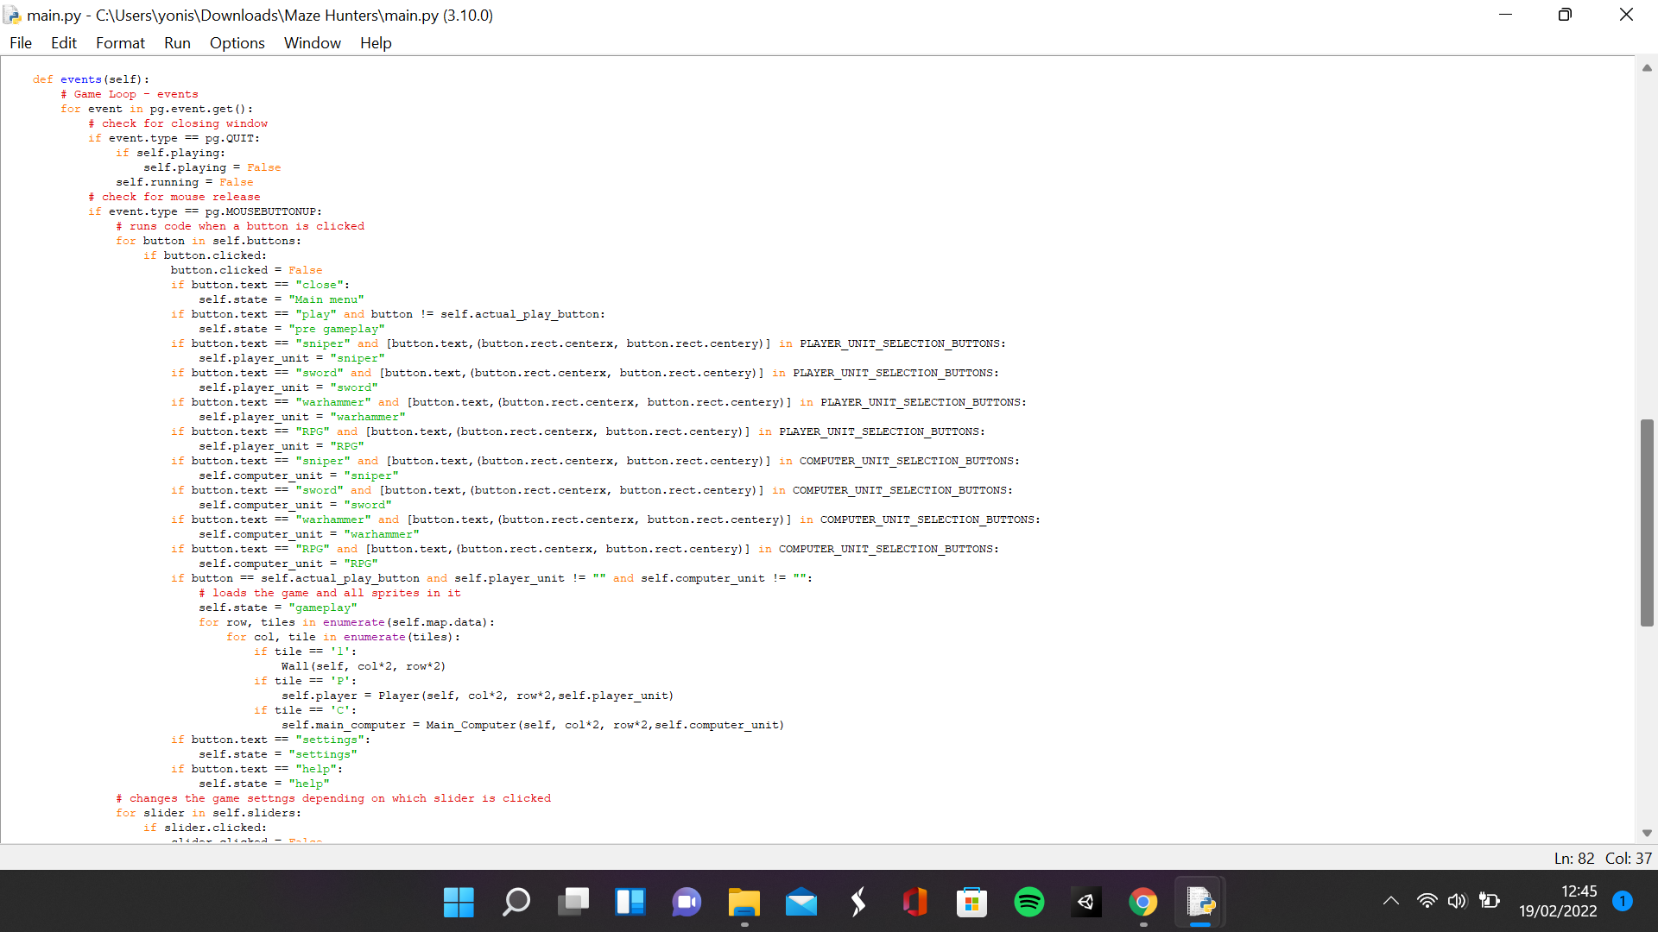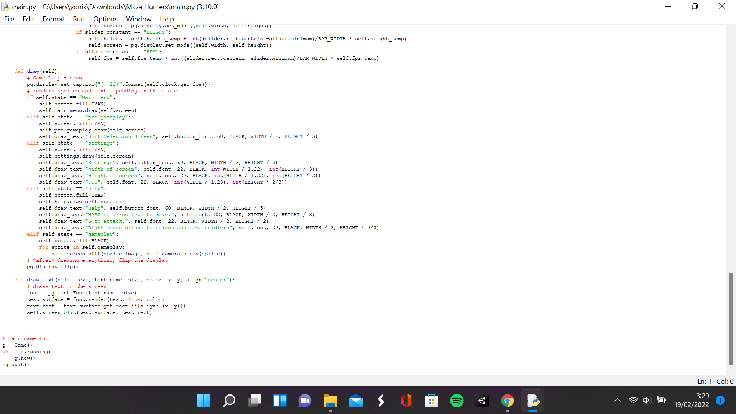

**Sprites.py**

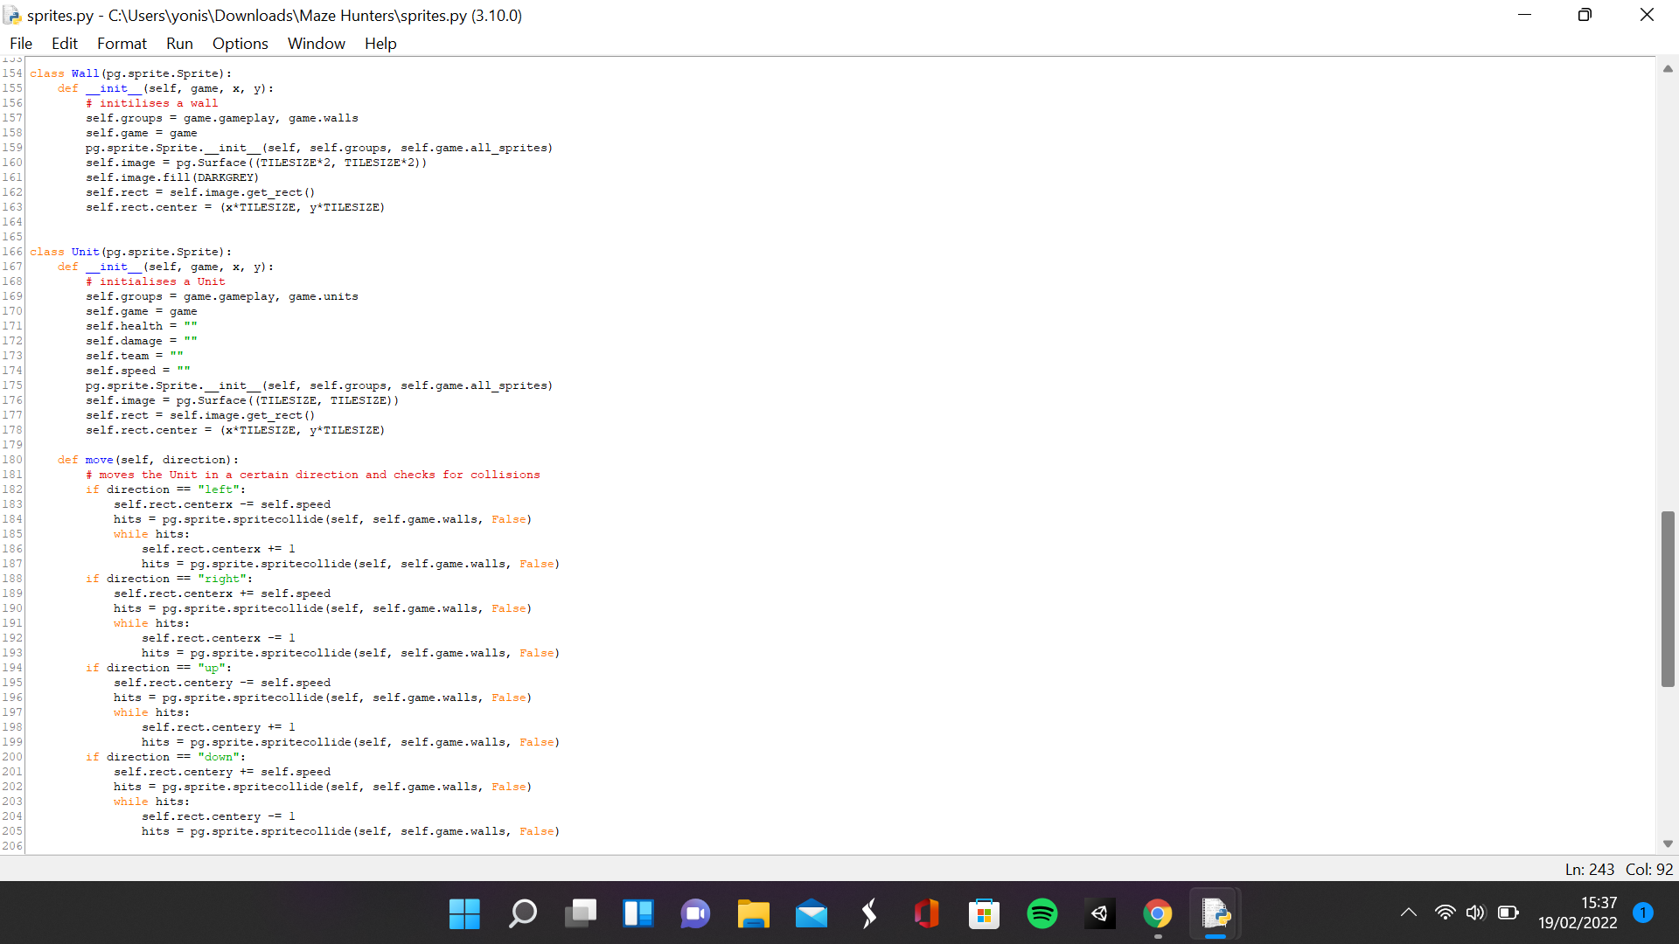

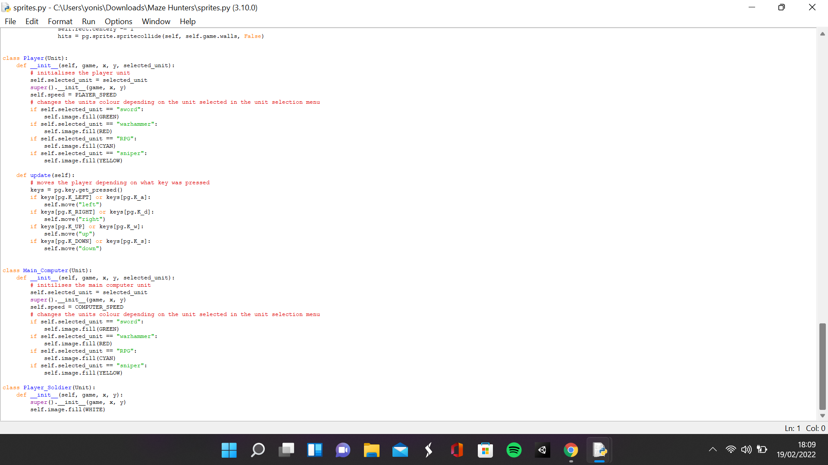

**Settings.py**

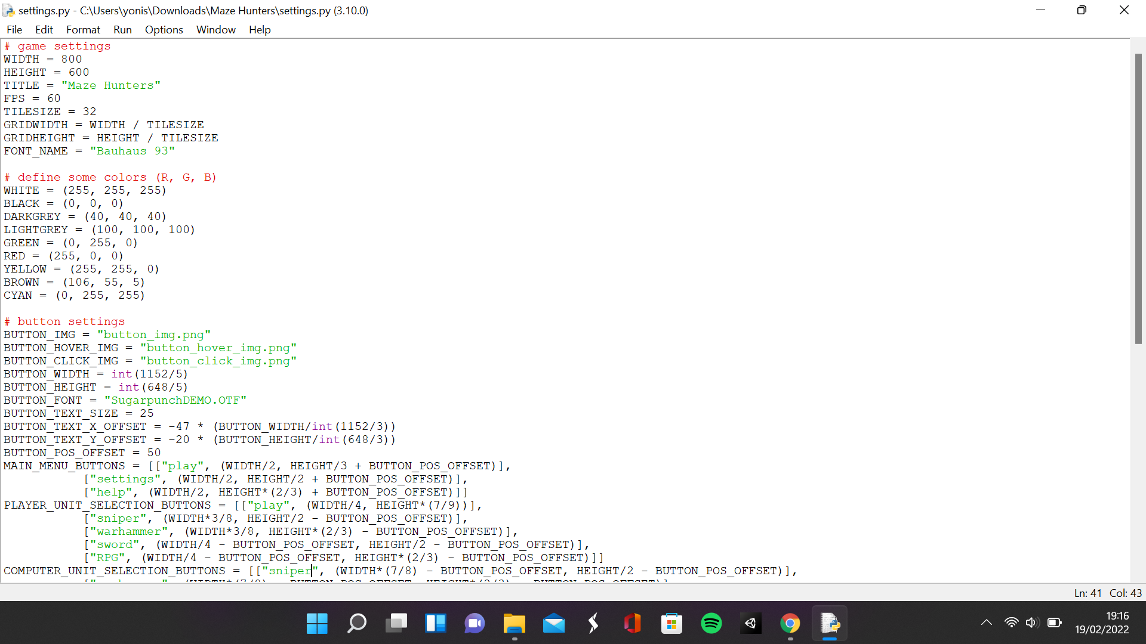

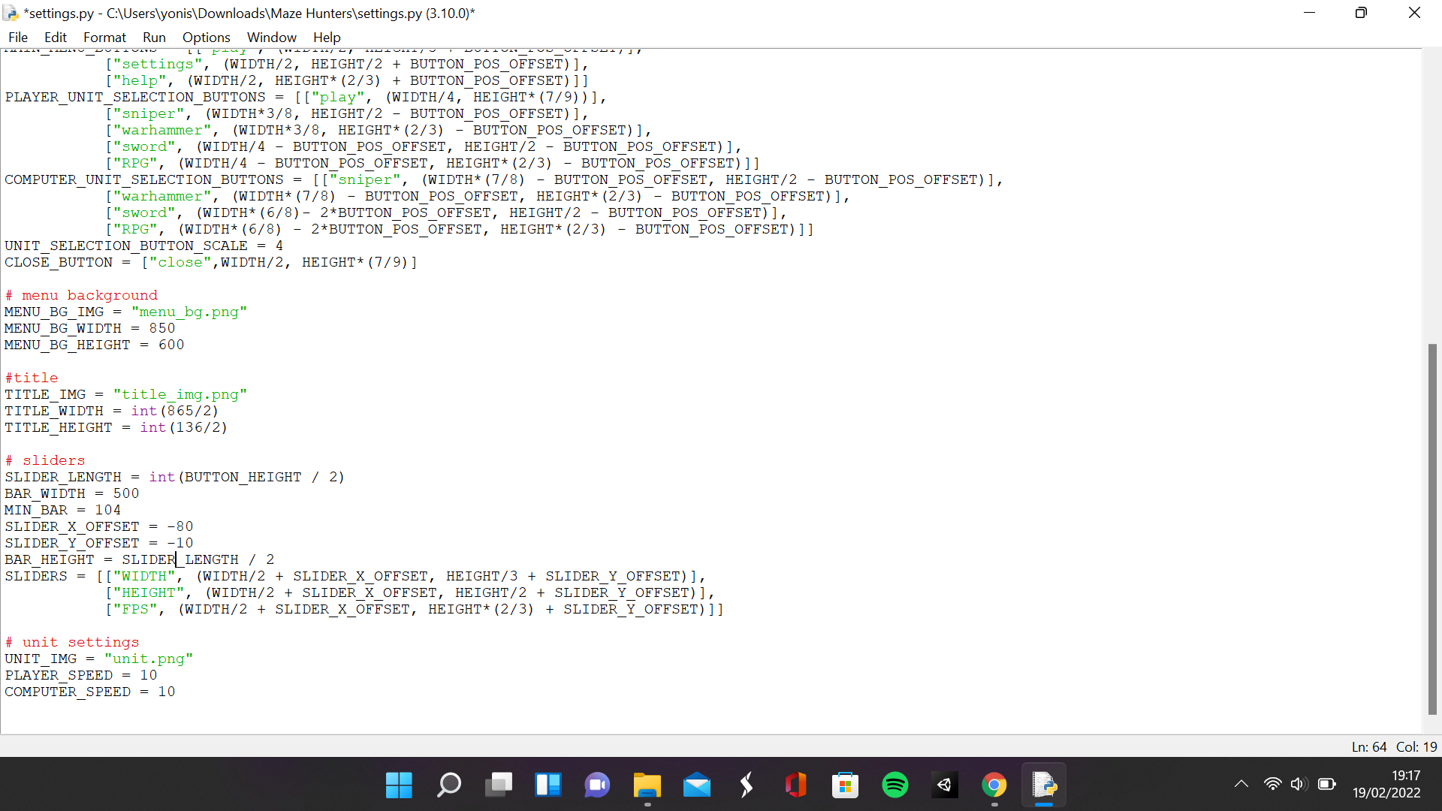

**Map.txt**

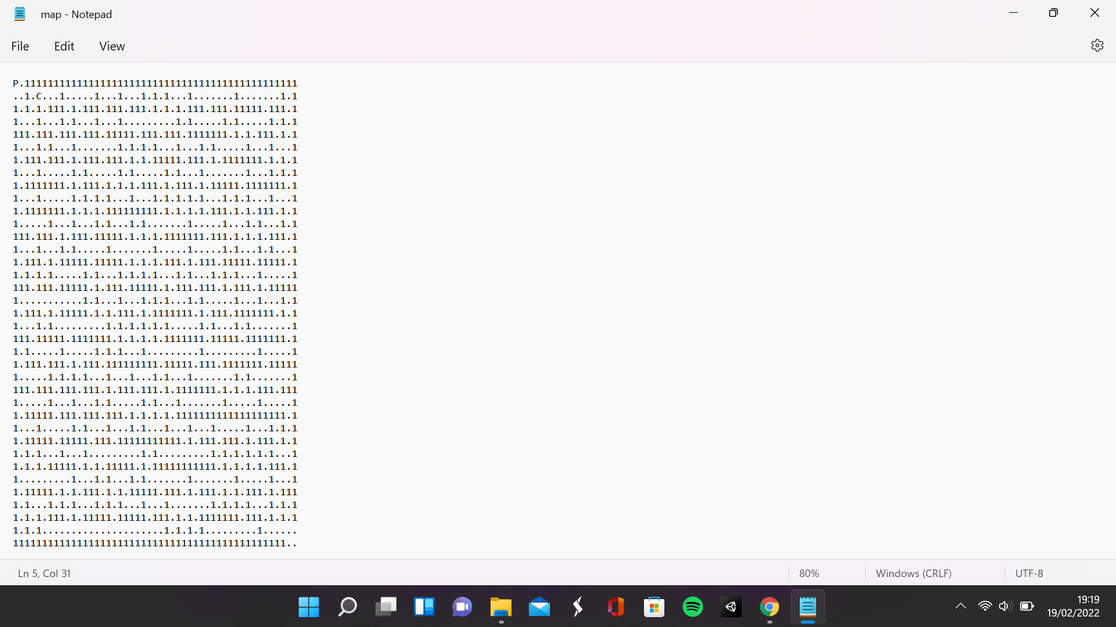

**Tilemap.txt**

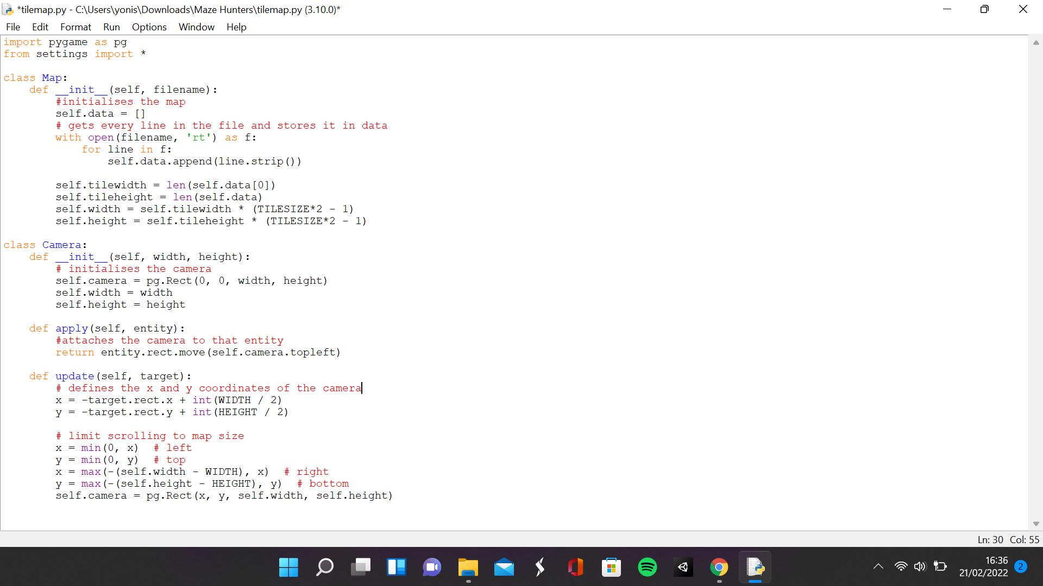

This section is to satisfy 5 requirements of the success criteria: the units selected by the player and the computer are loaded into the game, the maze is rendered from a tile sheet, the maze has collision detection with units, there is a camera following the player and the player moves when the WASD keys or arrow keys are pressed. To render the maze, I created a text file with the text within that file representing the maze with the 1s being the maze itself, the dots being empty space, the letter P being the player unit and the letter C being the main computer unit. Then I created a new script called tile map and created a new class called Map which is instantiated with an attribute called data which is at first empty. Then each line within the parameter file is stored in the data attribute. The tile width attribute is defined as the number of characters in the top row of the maze, the tile height is defined as the number of items in data attribute and the width and height attribute is the tile width and tile height multiplied by the tile size times 2 minus 1 since the walls are twice as big.

In the sprites script, I created a class called Unit which is a sprite instantiated with the parameters game, x and y. The groups attribute contains the all-sprites group and the units group. The team, speed, health, and damage attributes are initially empty, and the image is currently just a surface with a height and width of tile size times 2. The position of the unit is the x and y parameter times the tile size. In the move method, I checked if direction of move men was left, right, up or down and the unit would be moved in that direction by adding the speed attribute to the x or y of the position. If there was a collision from that movement, then it would move in the opposite direction until it no longer collided with the wall. I created another class called player which is a sub class of the unit class and inherits all the attributes and methods from the unit class. A new parameter called selected unit is what the new selected unit attribute is assigned. The speed attribute is redefined as player speed and the colour of the unit is changed depending on the value of the selected unit attribute. In the update method, the move method inherited from the unit class is run when the arrow keys or WASD keys are pressed to move the player left, right up or down depending on what key is pressed. The main computer class is the same as the player class except that it does not have an update function yet. The wall class is initialised with the same attributes as the unit class but without the empty attributes and its width and height is tile size * 2.

The camera class in the tile map script is instantiated with parameters width and height which are used to define the width and height of the cameras and are stored within attributes. The method apply moves an entity by the cameras position, so when the camera moves, the entity is moved by the offset of the camera from its original position. In the update function, the cameras x and y position is defined as the opposite of the targets x and y position so all the entities move in the opposite direction of the player and the width and height of the screen divided by 2 is added so that the player remains in the centre of the screen. The x and y position of the camera is limited to not be less than zero or greater than the distance between the camera's width and height and the screens width and height to prevent the camera from showing the outside of the maze. In the main script, the Camera is assigned as the camera attribute in the new method. Then in the update method, the camera is updated with the target being assigned the attribute player and in the draw method when the state is equal to gameplay, every sprite in the gameplay group is rendered onto the screen, in the position of its rectangle moved by the apply method from the camera attribute.

|  |  |  |  |
| --- | --- | --- | --- |
| What is being tested | Data input | Expected output | Actual output |
| Player can move to the left | A or left arrow key | The player moves to the left and stops when it hits the walls of the maze | The player moves to the left by the amount specified in the player speed and stops moving when colliding with a wall |
| Player can move to the right | D or right arrow key | The player moves to the right and stops when it hits the walls of the maze | The player moves to the right by the amount specified in the player speed and stops moving when colliding with a wall |
| Player can move up | W or up arrow key | The player moves up and stops when it hits the walls of the maze | The player moves up by the amount specified in the player speed and stops moving when colliding with a wall |
| Player can move down | S or down arrow key | The player moves down and stops when it hits the walls of the maze | The player moves down by the amount specified in the player speed and stops moving when colliding with a wall |
| Camera moves with player | Arrow keys or WASD keys | Every sprite’s render is moved in the opposite direction of the player | Sprites appear to move in the opposite direction of the player |

**Player character, computer character and maze when game starts**

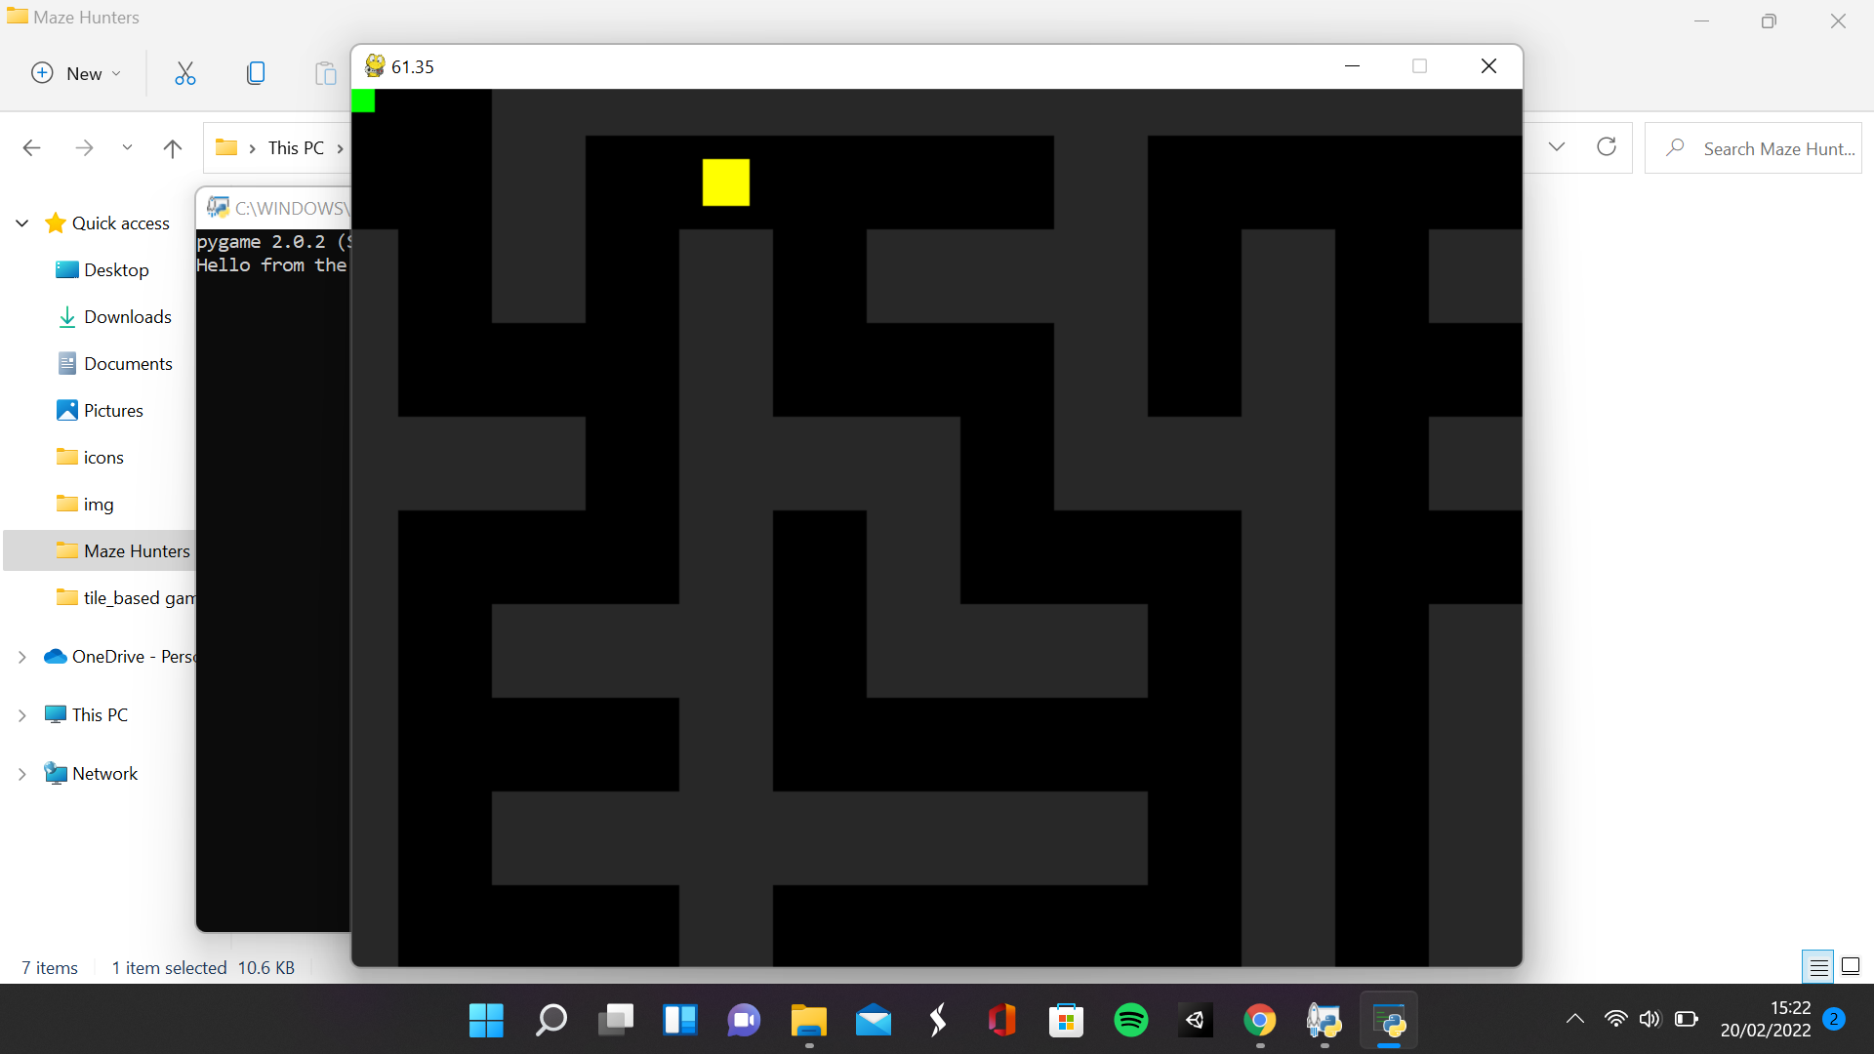

**Camera moving with player**

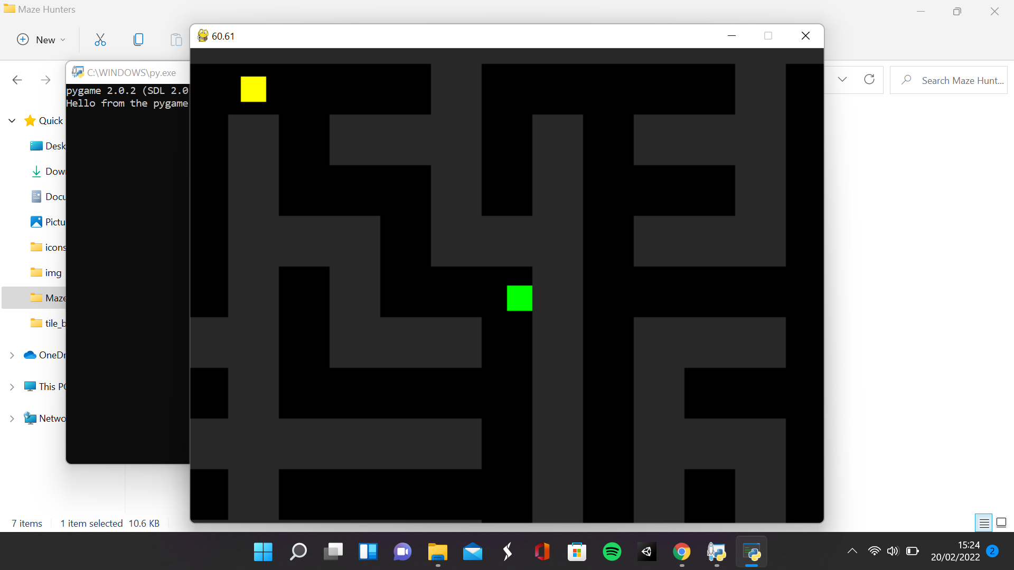

### Making attacks for the units selected in the unit selection menu

**Main.py**

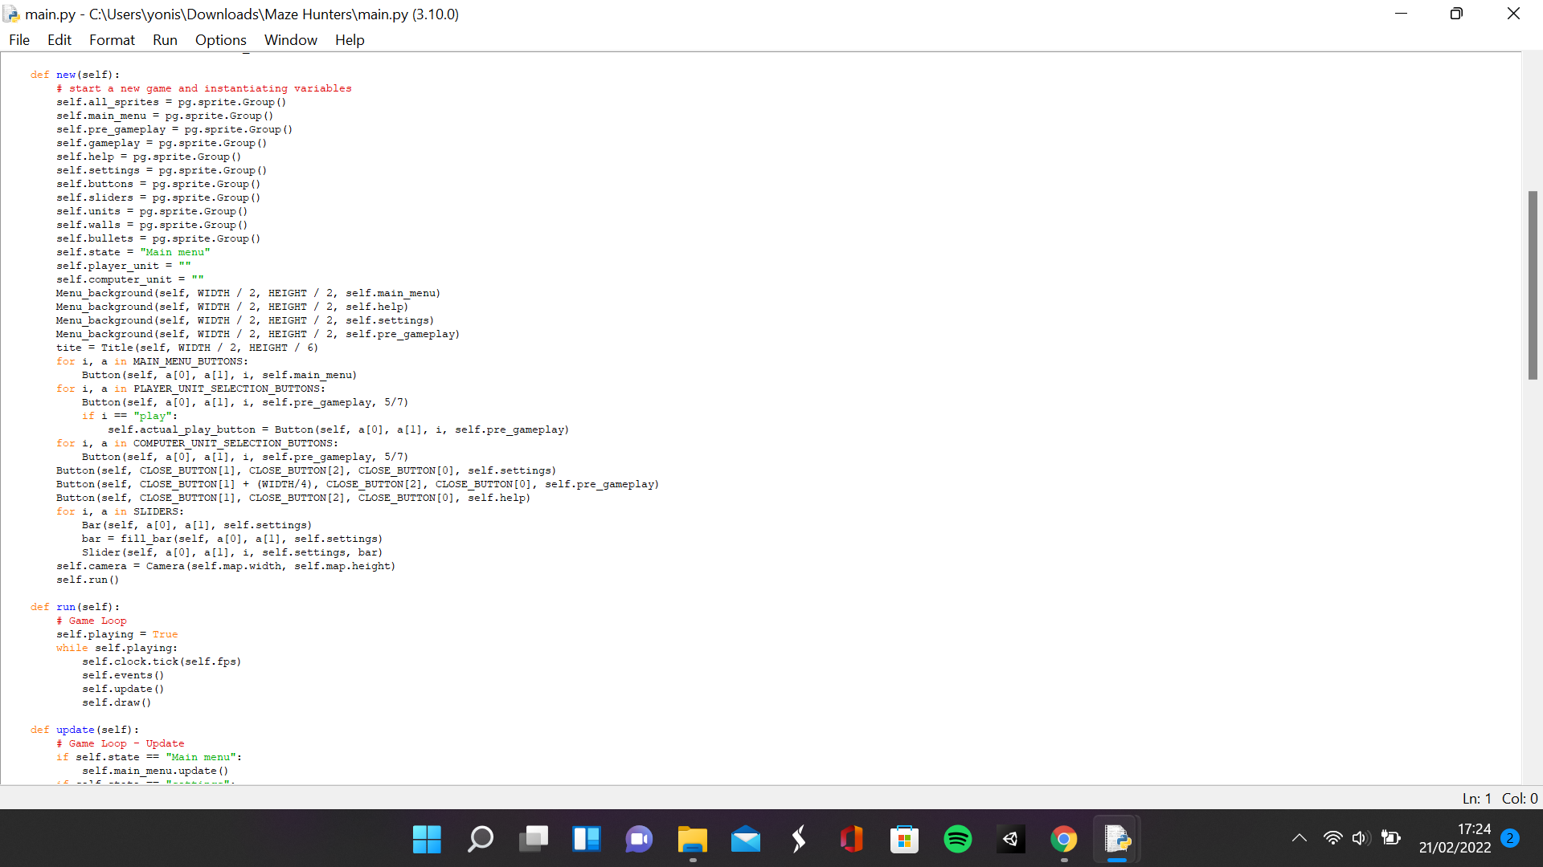

**Sprites.py**

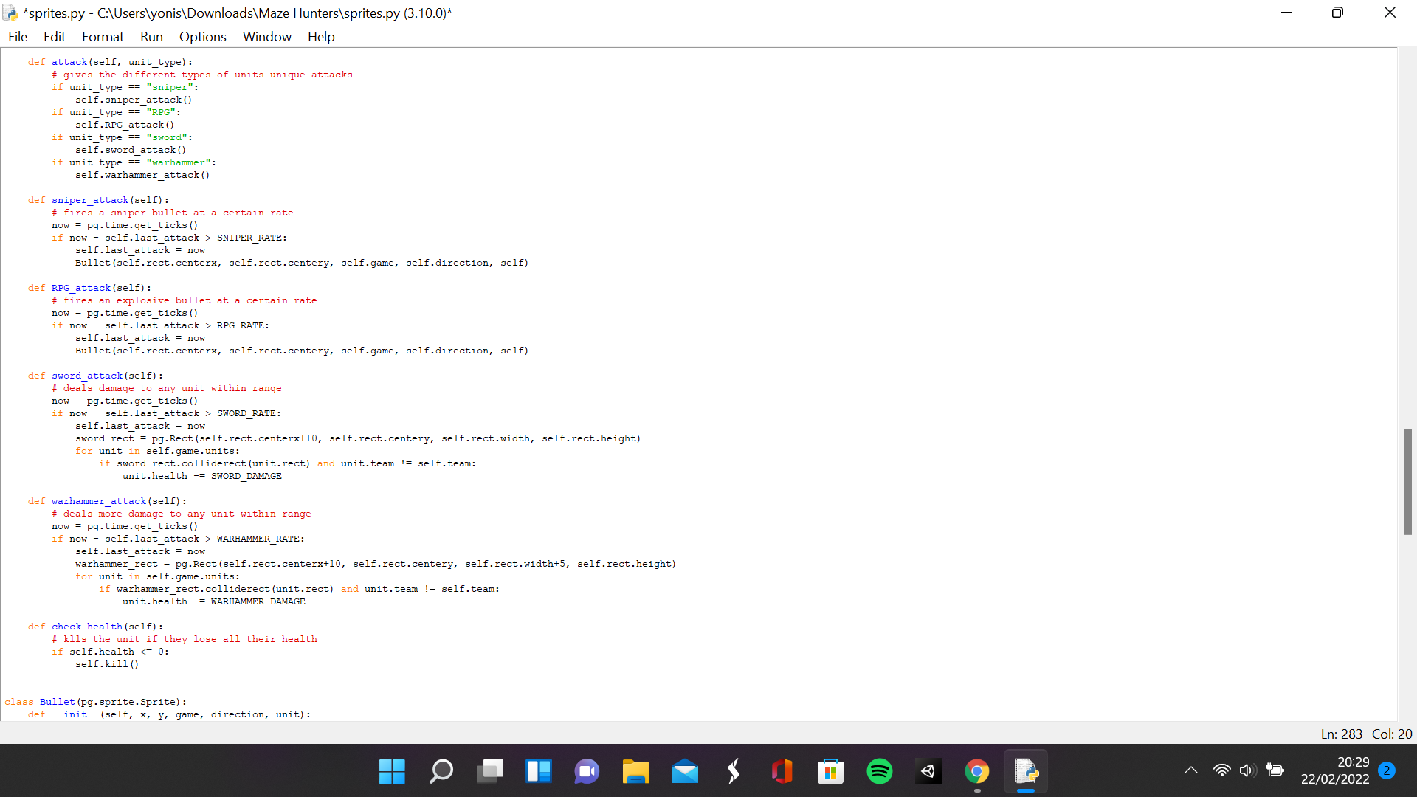

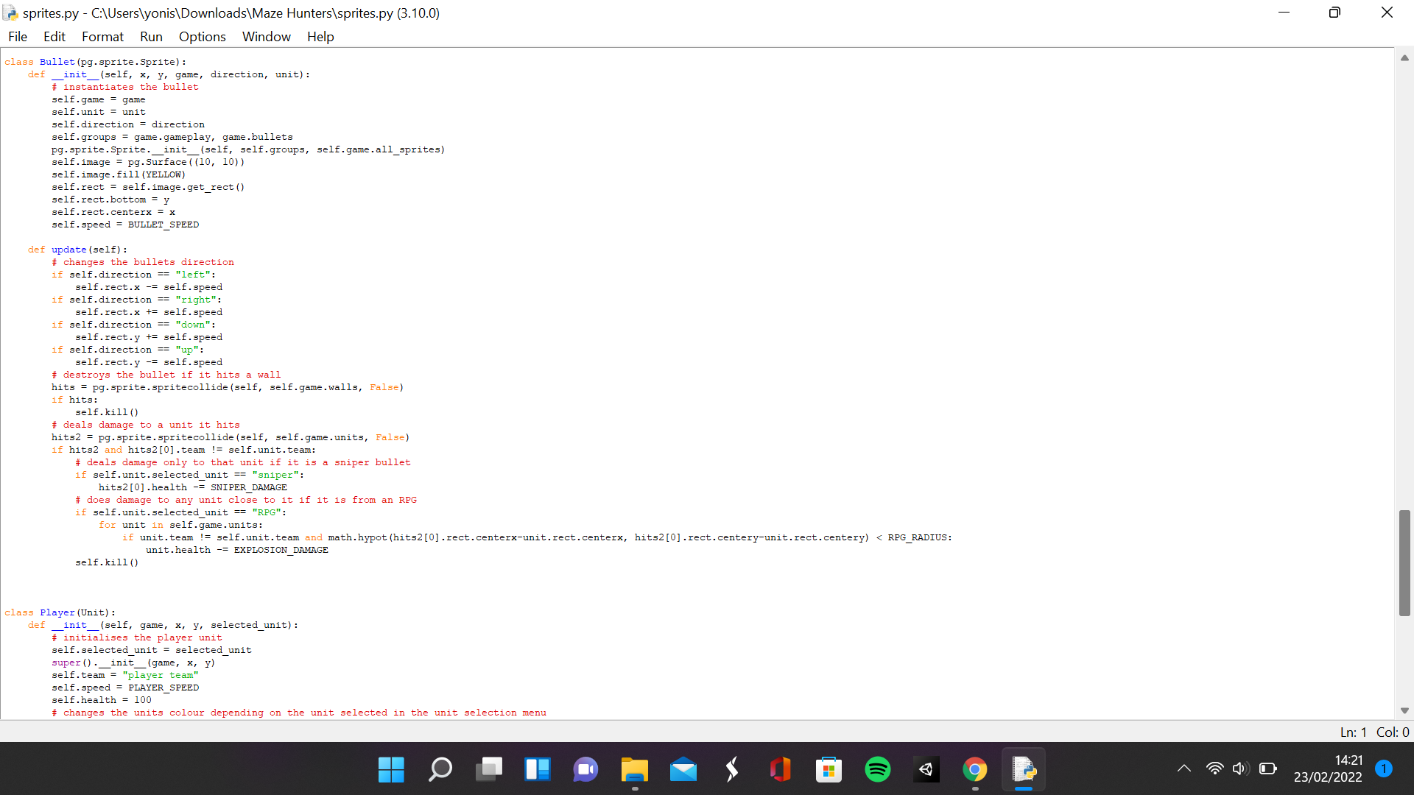

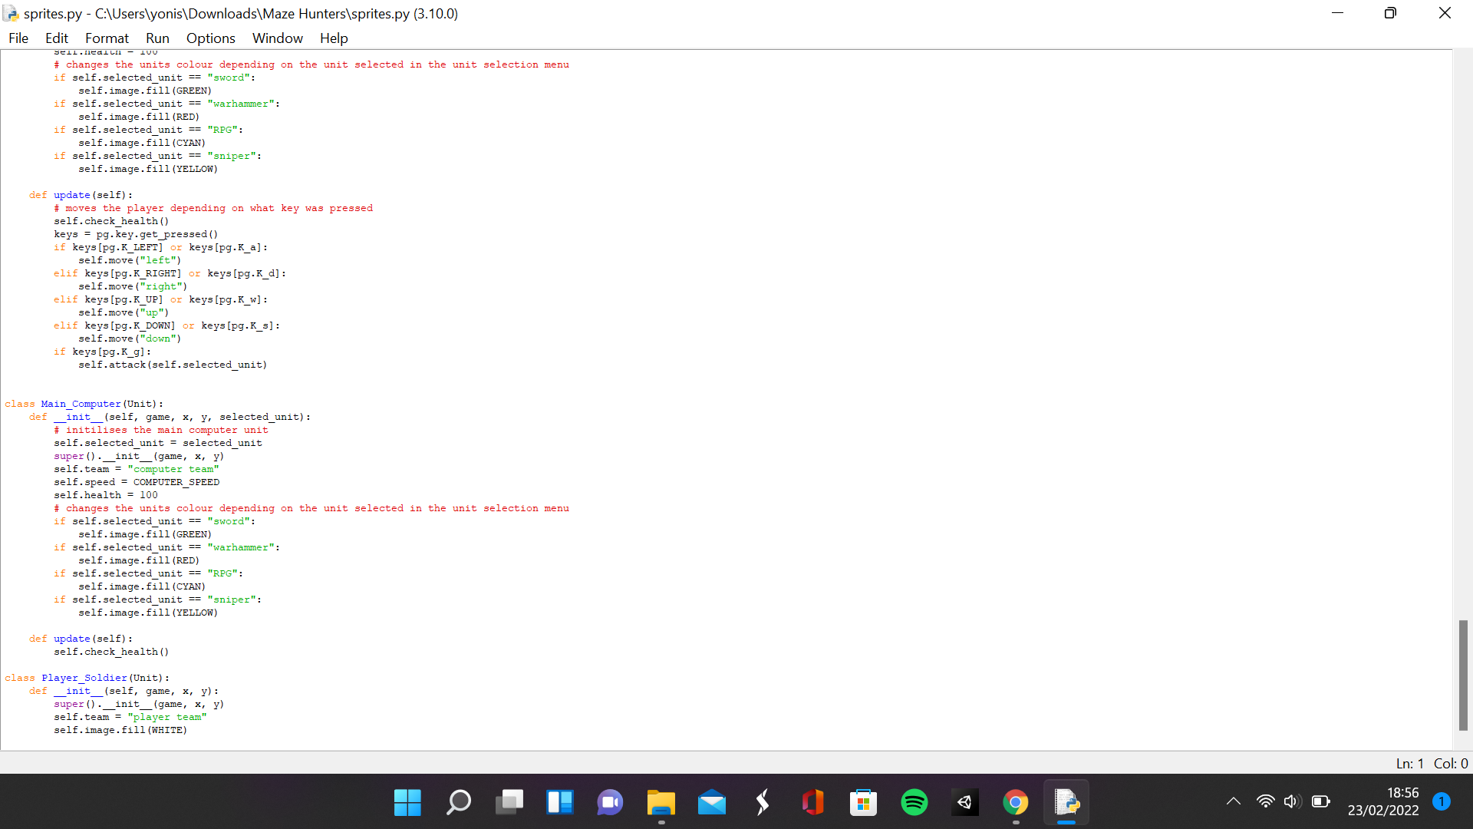

**Settings.py**

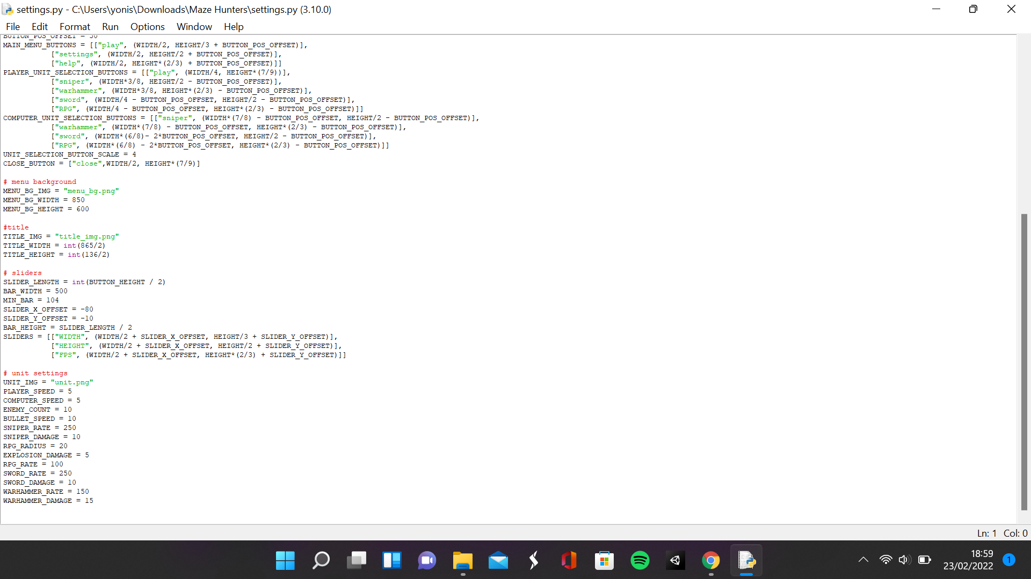

This section is to satisfy 3 requirements of the success criteria, units having a certain amount of health, units take damage from attacks and the player attacking by pressing G. In the update method for the player unit class, I checked if the key G was pressed and if so, run the attack method from the unit class. I also gave the different types of units their attacks. To do that, I created a method in the sprites class called attack which checks the value of the unit type parameter and runs the appropriate method. For example, if the unit type is sniper, then it would run the sniper attack method, and this is done for the other three unit types. The sniper attack function checks if a certain amount of time has passed from the last attack and if so, instantiates a bullet object. The RPG attack method does the same but with a different amount of time between attacks. The sword attack method also checks if a certain amount of time has passed between attacks and then creates a rectangle called sword rect which is the same as the unit's rectangle, but its x position has an offset of 10. If this rect collides with a unit of the other team, then the unit of the other team has its health subtracted by the unit's damage. The Warhammer attack method does the same as the sword rect, but it has a different amount of time between attacks, deals different damage and its Warhammer rectangle is 10 longer than the sword rectangle.

The bullet class is instantiated with parameters x, y, direction, game and unit. Direction, game and unit are stored in their own attributes. The bullet’s image is a surface 10 by 10 which is filled yellow which has the x parameter as the position of the centre x coordinate and y as the position of the bottom y coordinate of the bullet. The bullet’s speed attribute is assigned as the bullet speed variable. In the update method, the bullet is moved in different directions depending on the value of the direction attribute. If the bullet collides with the wall, then the bullet is destroyed and if it collides with a unit of a different team and the unit’s selected unit attribute is sniper, then it would just remove the integer sniper damage from the unit's health and if its RPG, then it would deal damage to any unit less than a certain distance from it. In the settings script, I created new variables for the rates and damage for all the units, the bullets speed and the enemy count.

|  |  |  |  |
| --- | --- | --- | --- |
| What is being tested | Data input | Expected output | Actual output |
| Player can attack | G | The player should attack with the weapon of their choice | The player attacks with the attack of their specific unit |
| If the player selected the sniper button in the unit selection menu, then they should have the sniper weapon and do sniper attacks | G key | A bullet is fired from the sniper gun and that bullet deals damage when it hits something | A bullet is fired and the bullet deals damage to the unit it hits |
| If the player selected the RPG button in the unit selection menu, then they should have the RPG weapon and do RPG attacks | G key | An RPG is fired from the RPG launcher and it explodes when it hits something and deals damage to any unit in range of the explosion | When the RPG is fired, it deals damage to any unit in rage of the explosion. Currently no animations for explosions. |
| If the player selected the Warhammer button in the unit selection menu, then they should have the Warhammer weapon and do Warhammer attacks | G key | The Warhammer is swung and damages any unit it hits | No animations for Warhammer swing but damage is dealt to any unit that the Warhammer rectangle hits |
| If the player selected the sword button in the unit selection menu, then they should have the sword weapon and do sword attacks | G key | The sword is swung and damages any unit it hits | No animations for sword swing but damage is dealt to any unit that the sword rectangle hits |

**Sniper unit attacking**

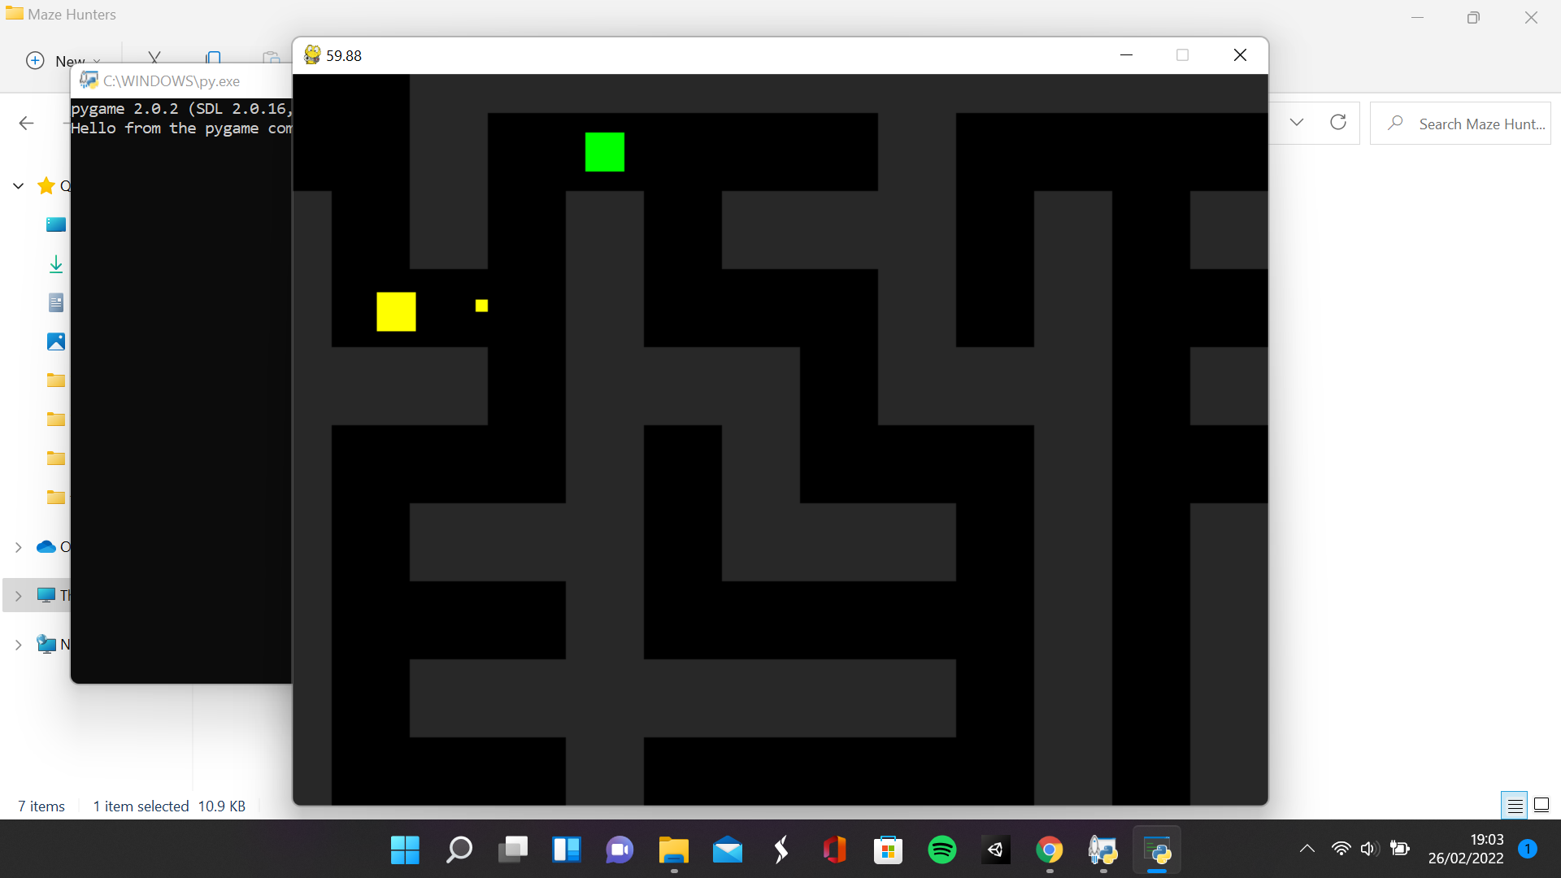

**RPG unit attacking**

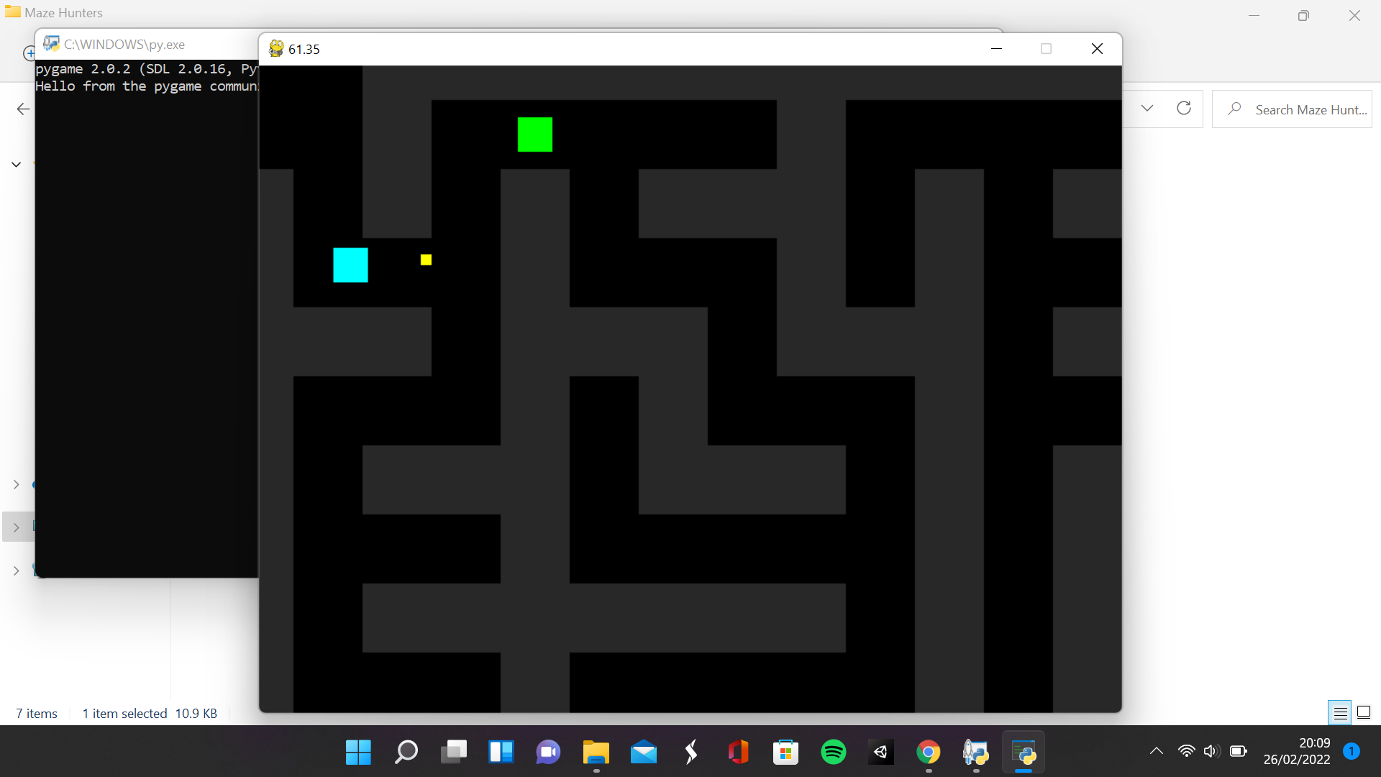

(There is no way of showing Warhammer or sword attacks without an animation)

### Pathfinding for the computer-controlled units and unit collisions

**Sprites.py**

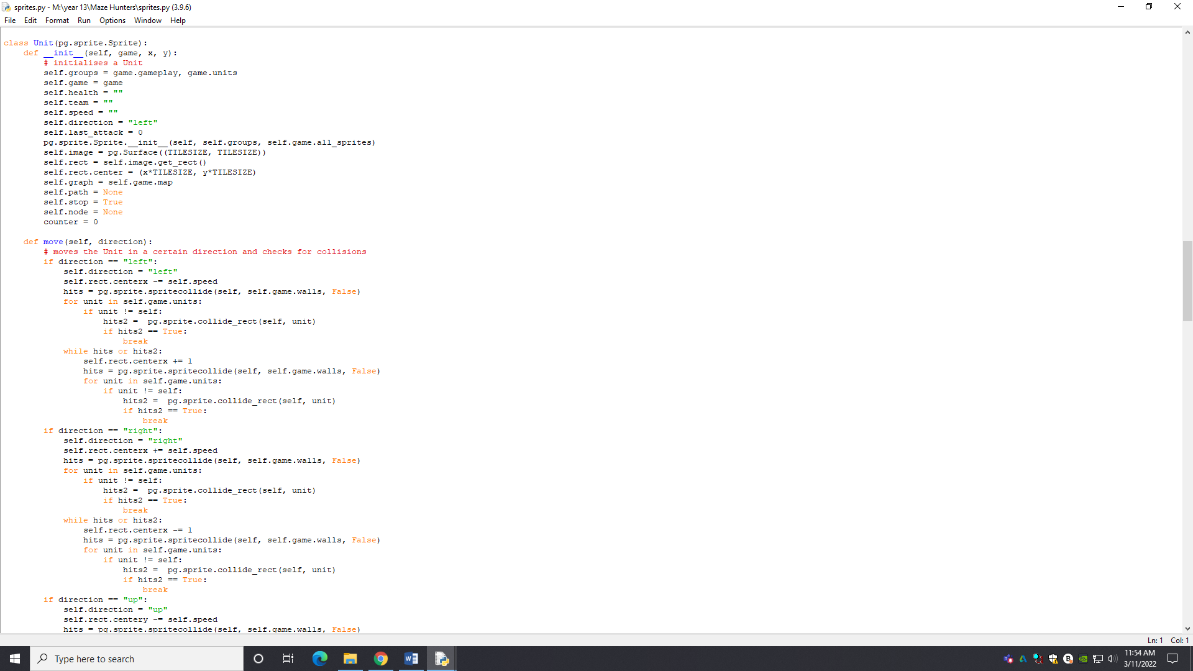

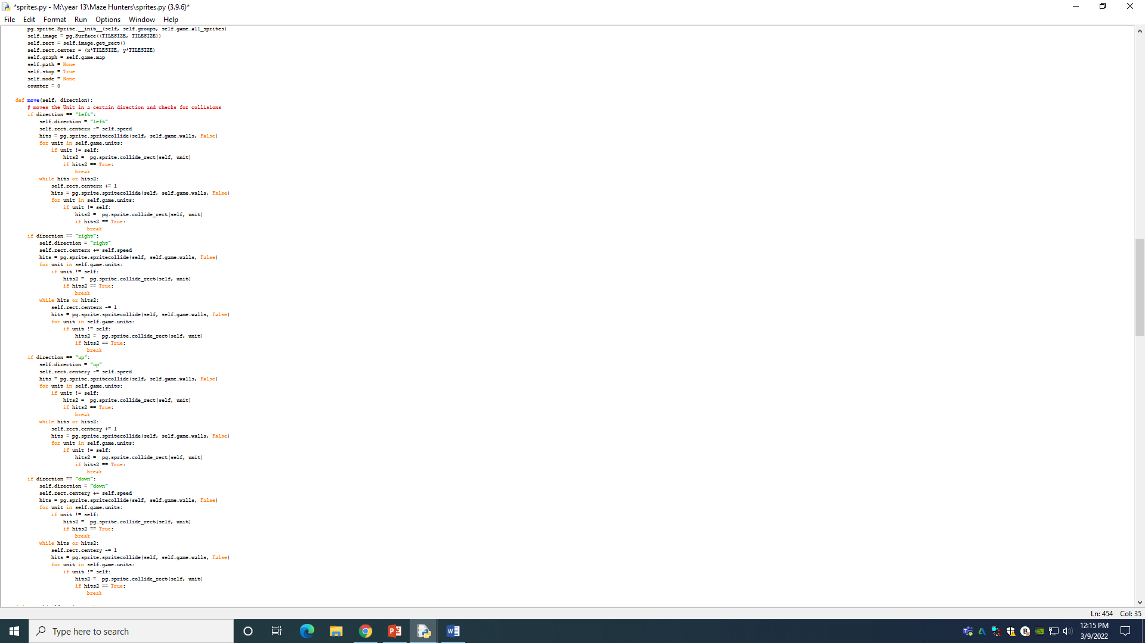

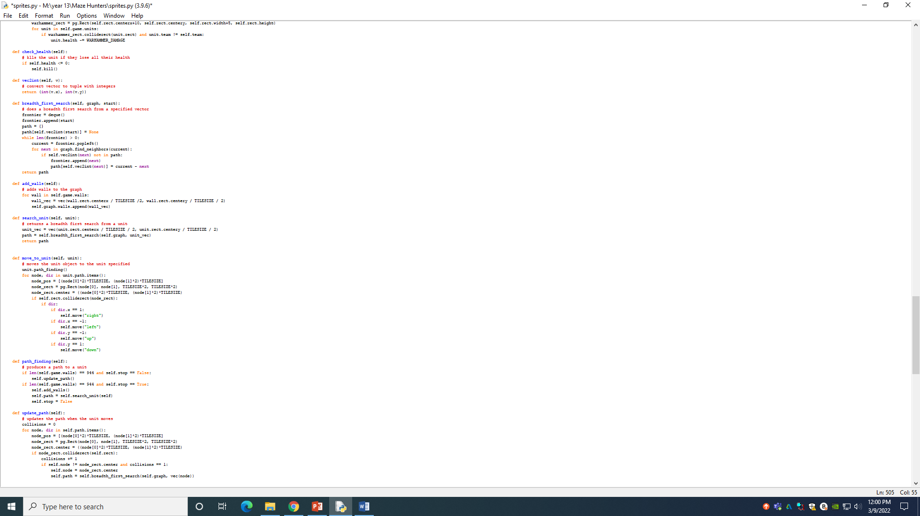

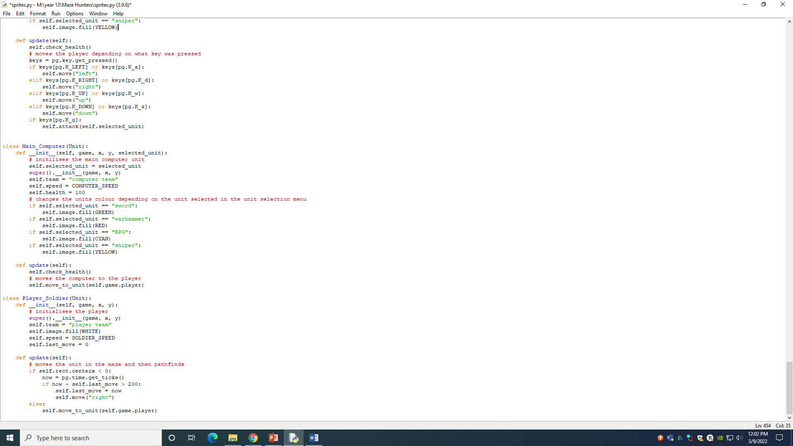

**Tilemap.py**

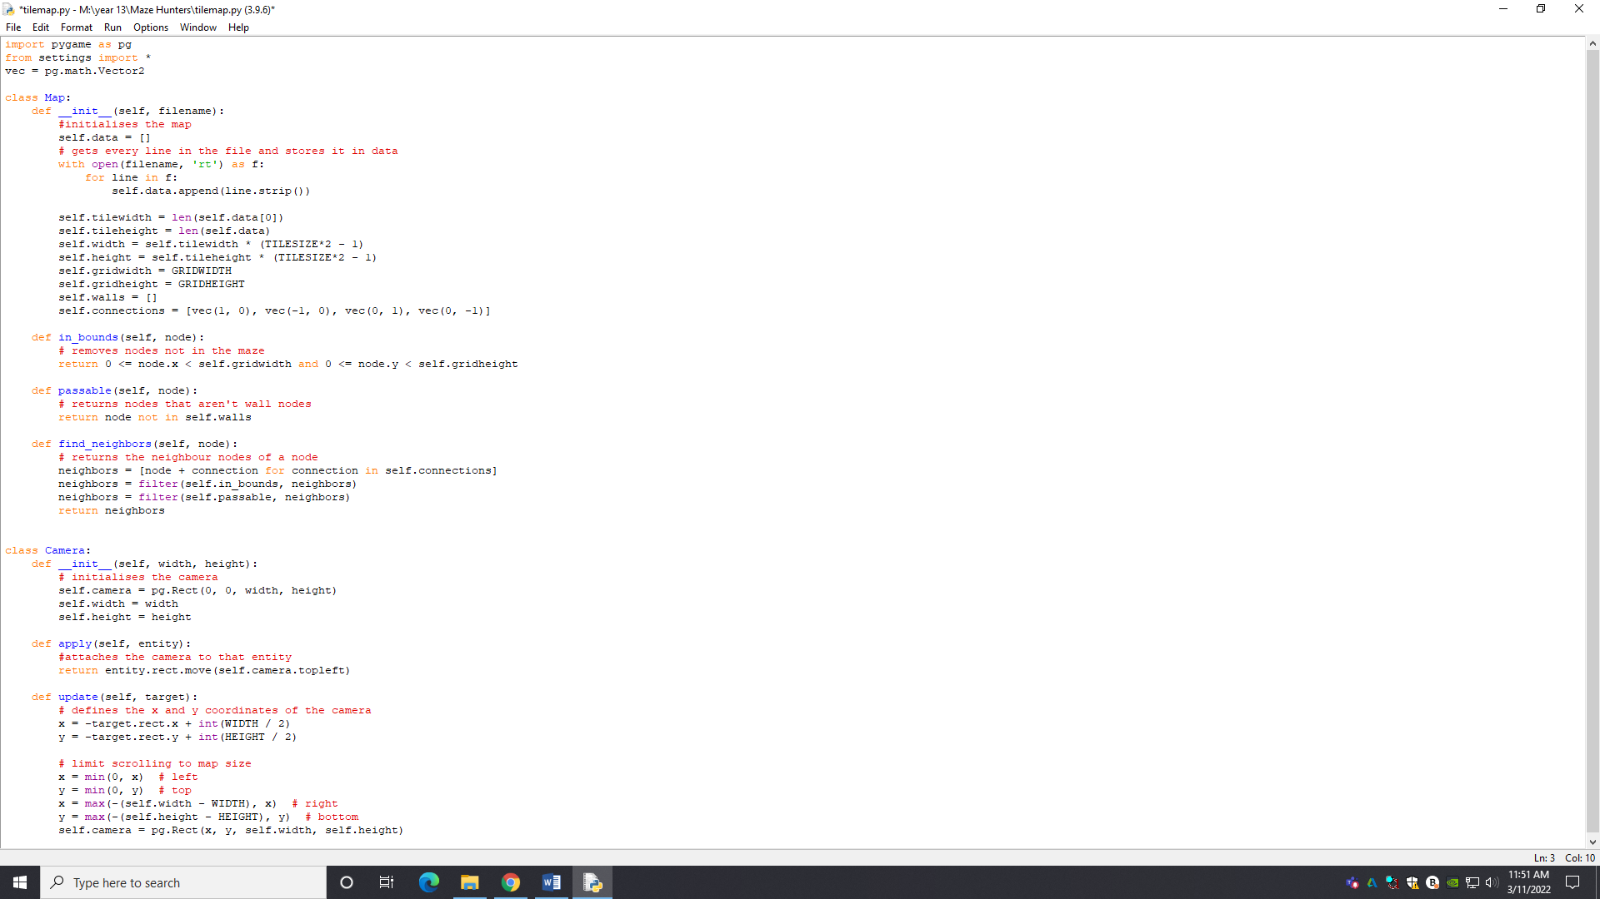

This section only satisfies one requirement, to have the player soldiers follow the player if not given a command. An extra feature was to add unit collisions as well. To do unit collisions, all I did was iterate through the units in the unit’s group and checked if their rectangles collide and if they do, then they are moved in the opposite direction until they are not. For pathfinding, the algorithm I used was breadth first search since I didn’t need the shortest path and I only need to run it for the player and then have all the mobs move on that path. What I did was in the class Map from tile map, I added 4 attributes, grid width and grid height to represent the number of tiles in the maze, walls to store all the wall nodes in and connections to represent up, down, left and right movement. I created a method find the neighbours of every node by adding the node (which is a vector) to the connection and using the inbounds function to remove every node that isn’t in the maze and using the passable method to remove every node that is a wall node. Then the neighbours array is returned.

In the unit class, I created several new attributes. The graph attribute which is just the tile map of the main game, node which represents the current node the unit is on and stop to make a section of code only run once. I created a method called breadth first search which creates a queue called frontier which means the current node. The start parameter is added to the queue and a variable called path which is a dictionary that will store the path to the node is created. Using the vec to int method that turns vectors into integer tuples that can be used as keys for the dictionary, the key start node has its value assigned as none. Then while the length of the frontier is greater that zero, the node at the front of the queue is popped off and stored in the variable current. For every neighbour of the current node that isn’t already in the path dictionary, the neighbour is added to the queue and the value of the key of the neighbour is the vector from the next node to the current node. And afterwards, the path is returned.

The method add walls gets the node of a wall and stores it in the wall attribute of the graph. The method search unit gets the node of a unit and runs the breadth first search with that node as the start node and the graph attribute as the graph. The method update path, creates a variable called collisions which is initially assigned as zero. For every node(key) and direction(value) in the path attribute, the node is converted into its position on the screen and a rectangle is created of length tile size times 2 and the centre of the rectangle is the position of the node. If there is a collision between the unit and the rectangle, then 1 is added to collisions. If collisions are 1 and the node attribute is not equal to the rectangles centre, then the node is assigned the rectangles centre and the breadth first search method is run with that node as the start and with the graph attribute as graph. The pathfinding method runs the update path method is all the walls have been created and the stop attribute is false. It also checks if the walls have been created and stop attribute is true. If so, it runs the add walls method, runs the search unit method with itself as the attribute and stores it in the path attribute and assigns the stop attribute as false. The method move unit runs the pathfinding method of the unit parameter, produces the same node rectangles as the ones in the update path method and checks if the node rectangle collides with the (not parameter) unit and if so, it checks the direction of the node and moves the unit in the same direction as the node using the move method.

The main computer class runs the move unit method with the players path attribute. I created a new class called player soldier which is initialised with the team attribute as player and speed as soldier speed and last move assigned zero. In the update method, the player soldier is moved right until the unit is in the maze and then it runs the main method.

|  |  |  |  |
| --- | --- | --- | --- |
| What is being tested | Data input | Expected output | Actual output |
| Player soldiers follow player | Player moves away from soldiers | The soldier follows them | The soldier follows the player |

**Initial position of the soldier**

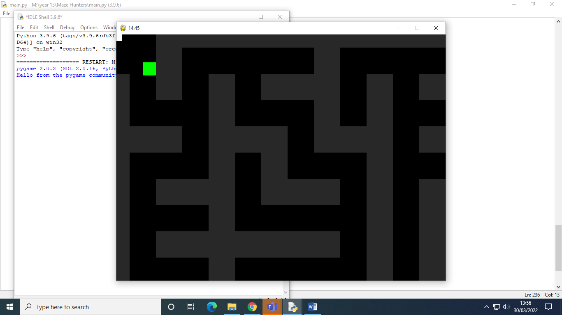

**Soldier moving to the player**

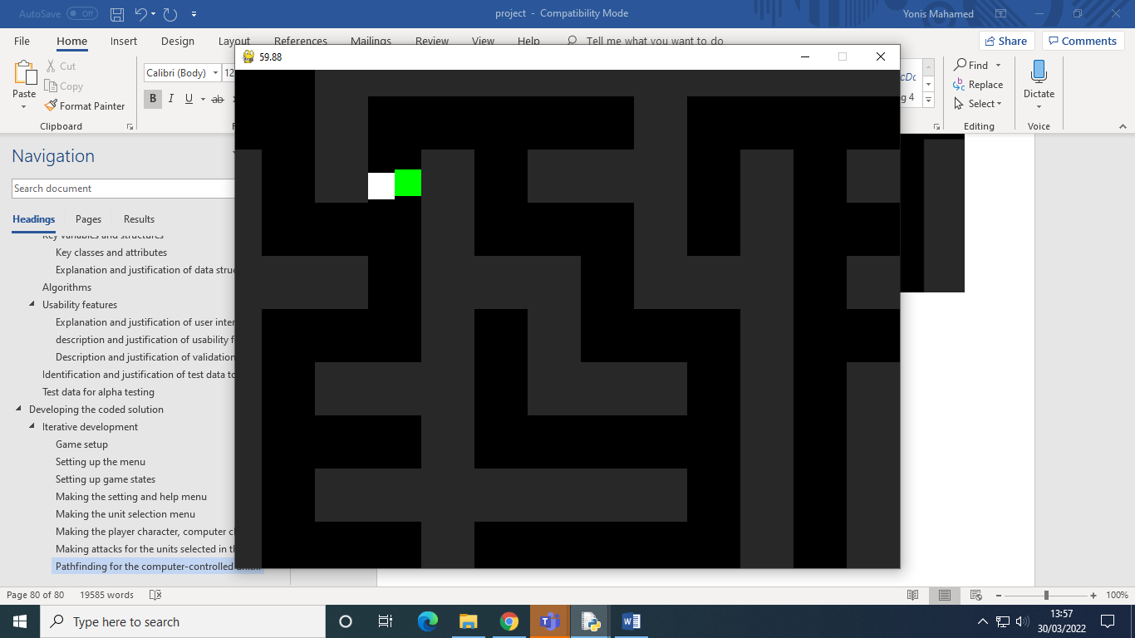

### Finishing the game

**Main.py**

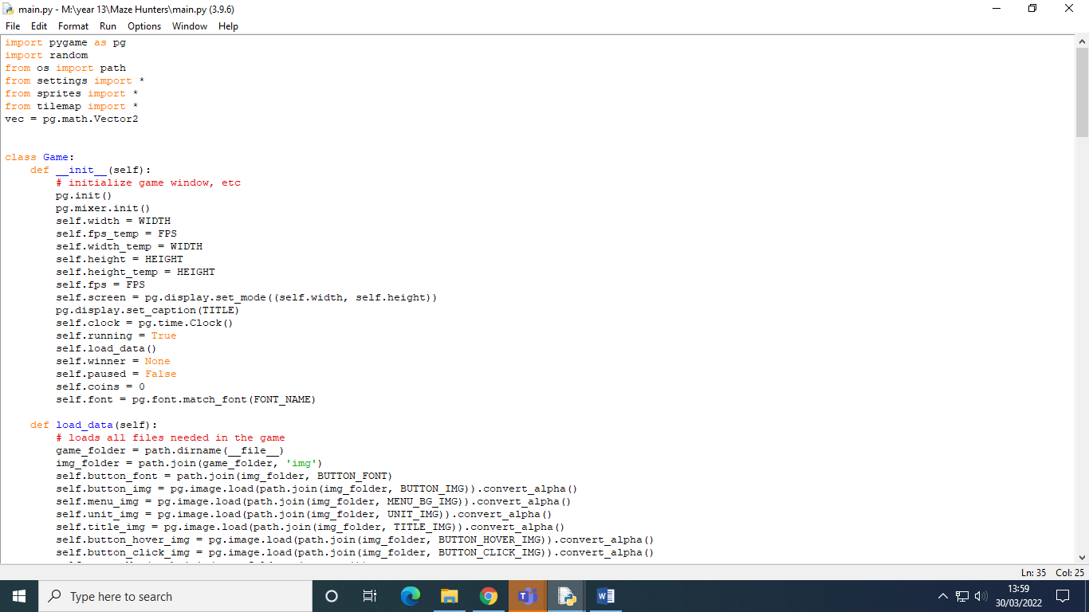

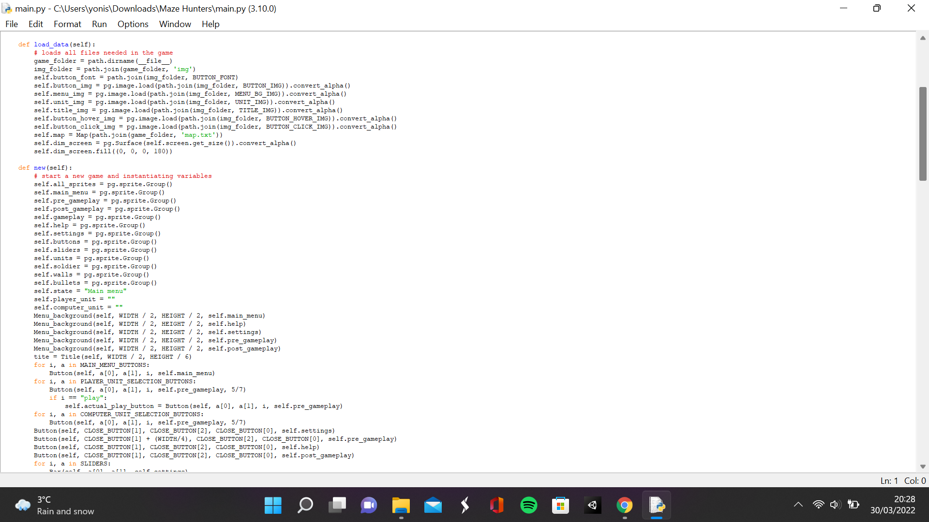

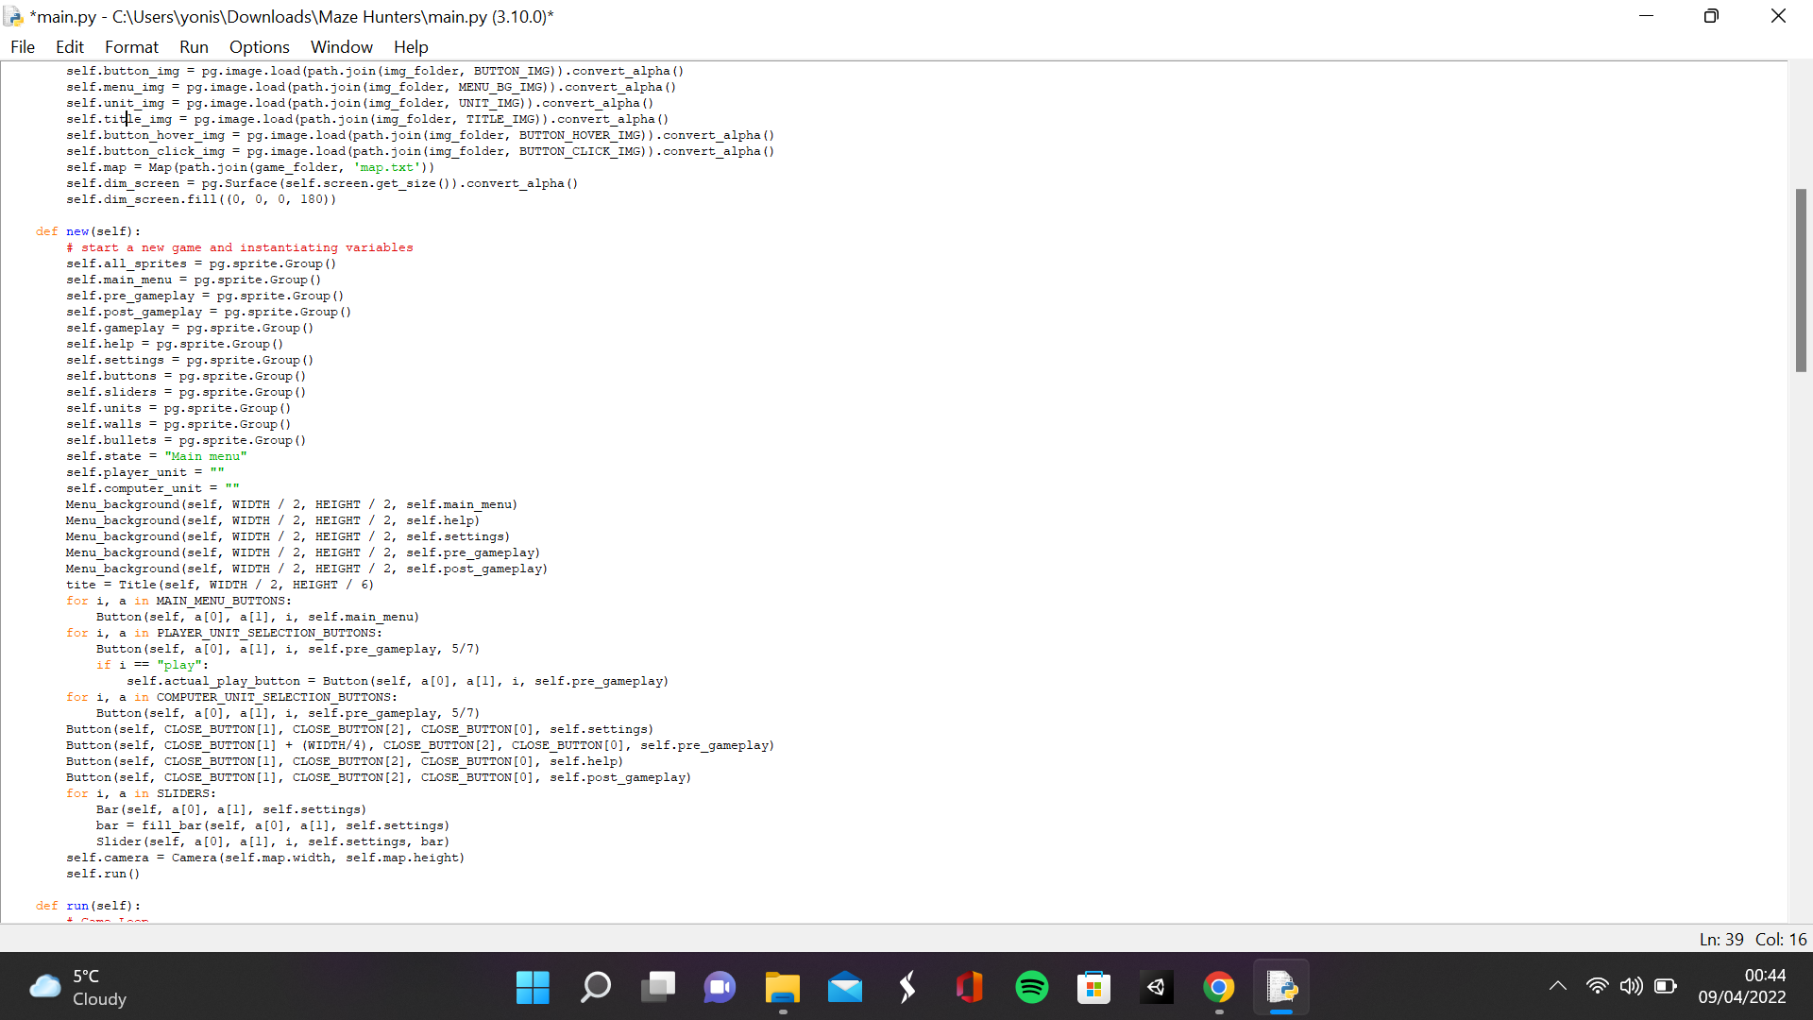

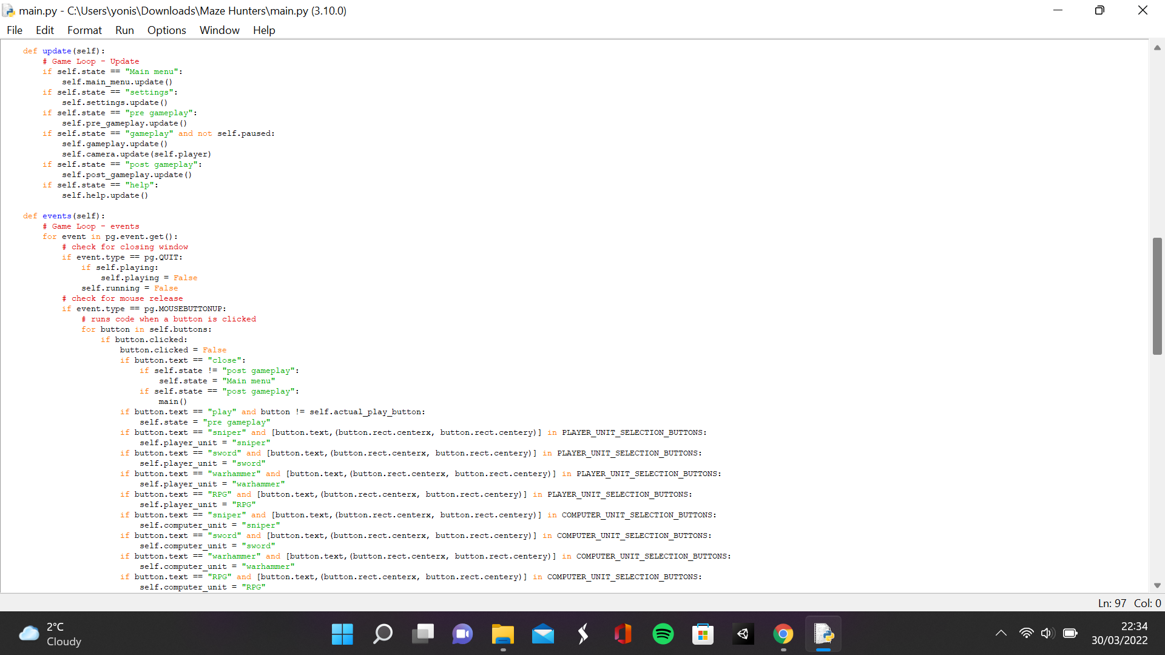

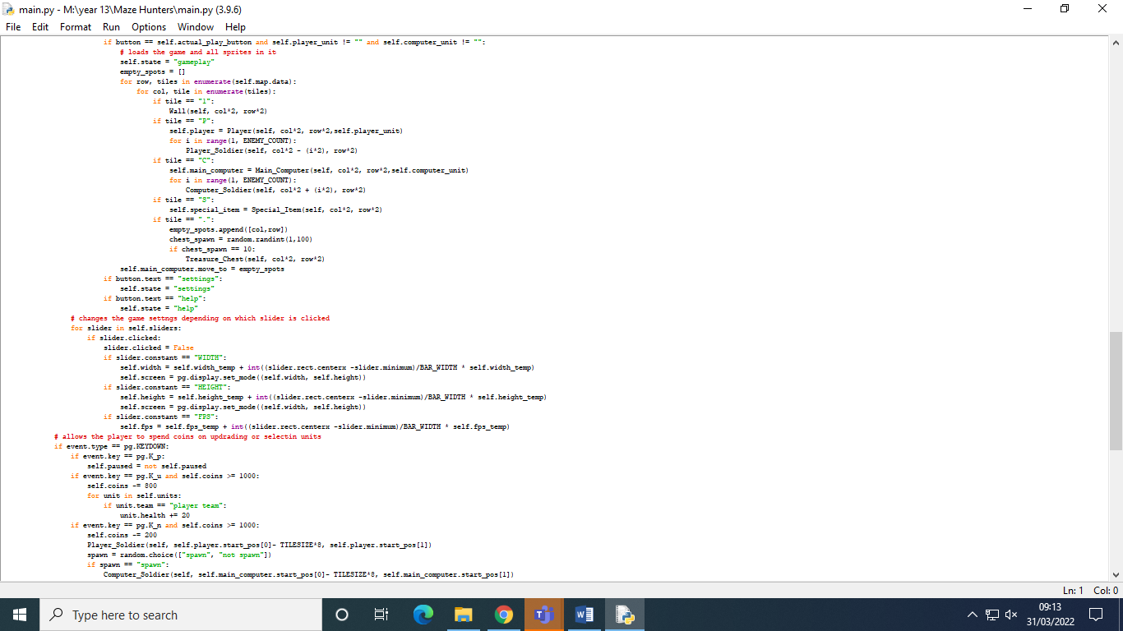

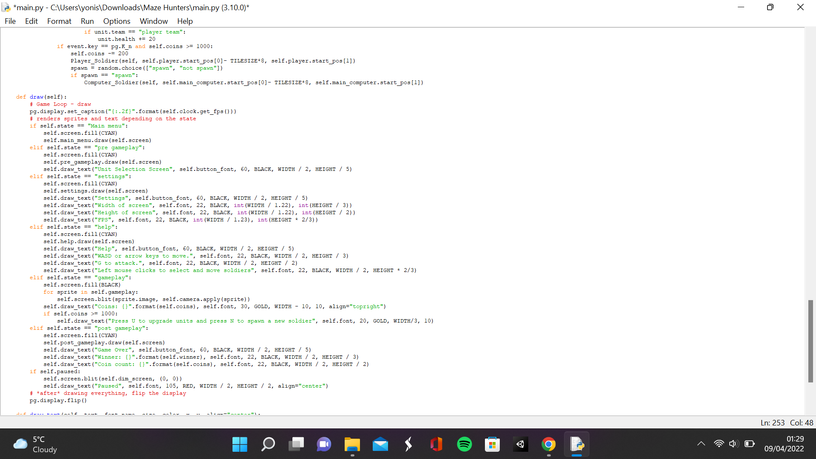

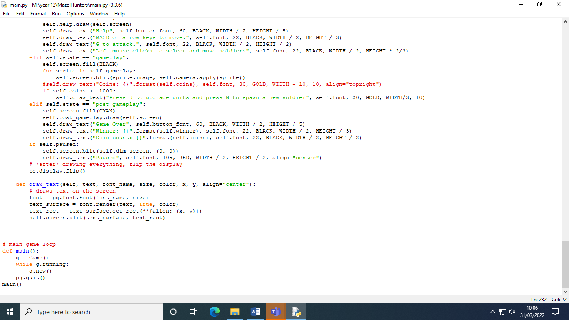

**Sprites.py**

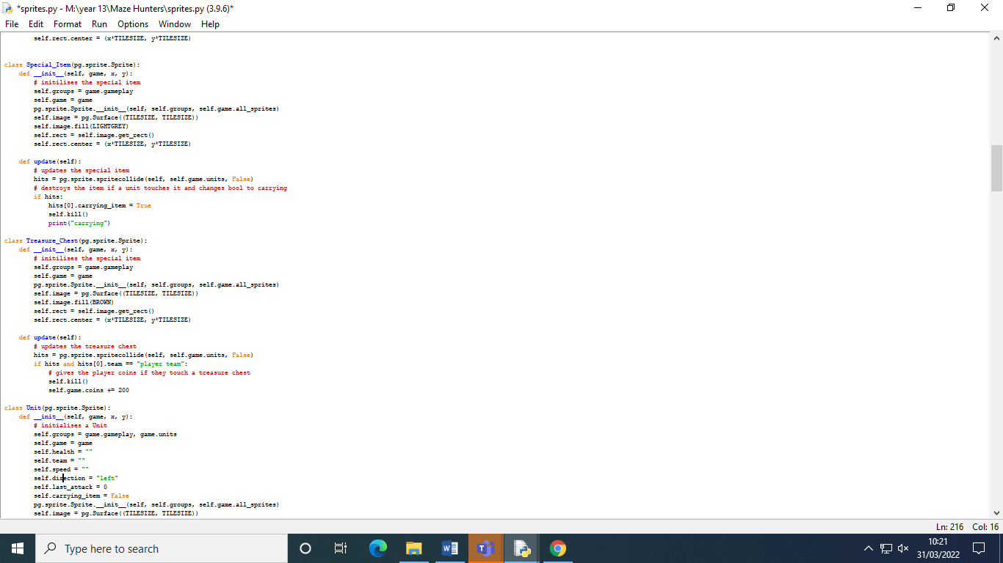

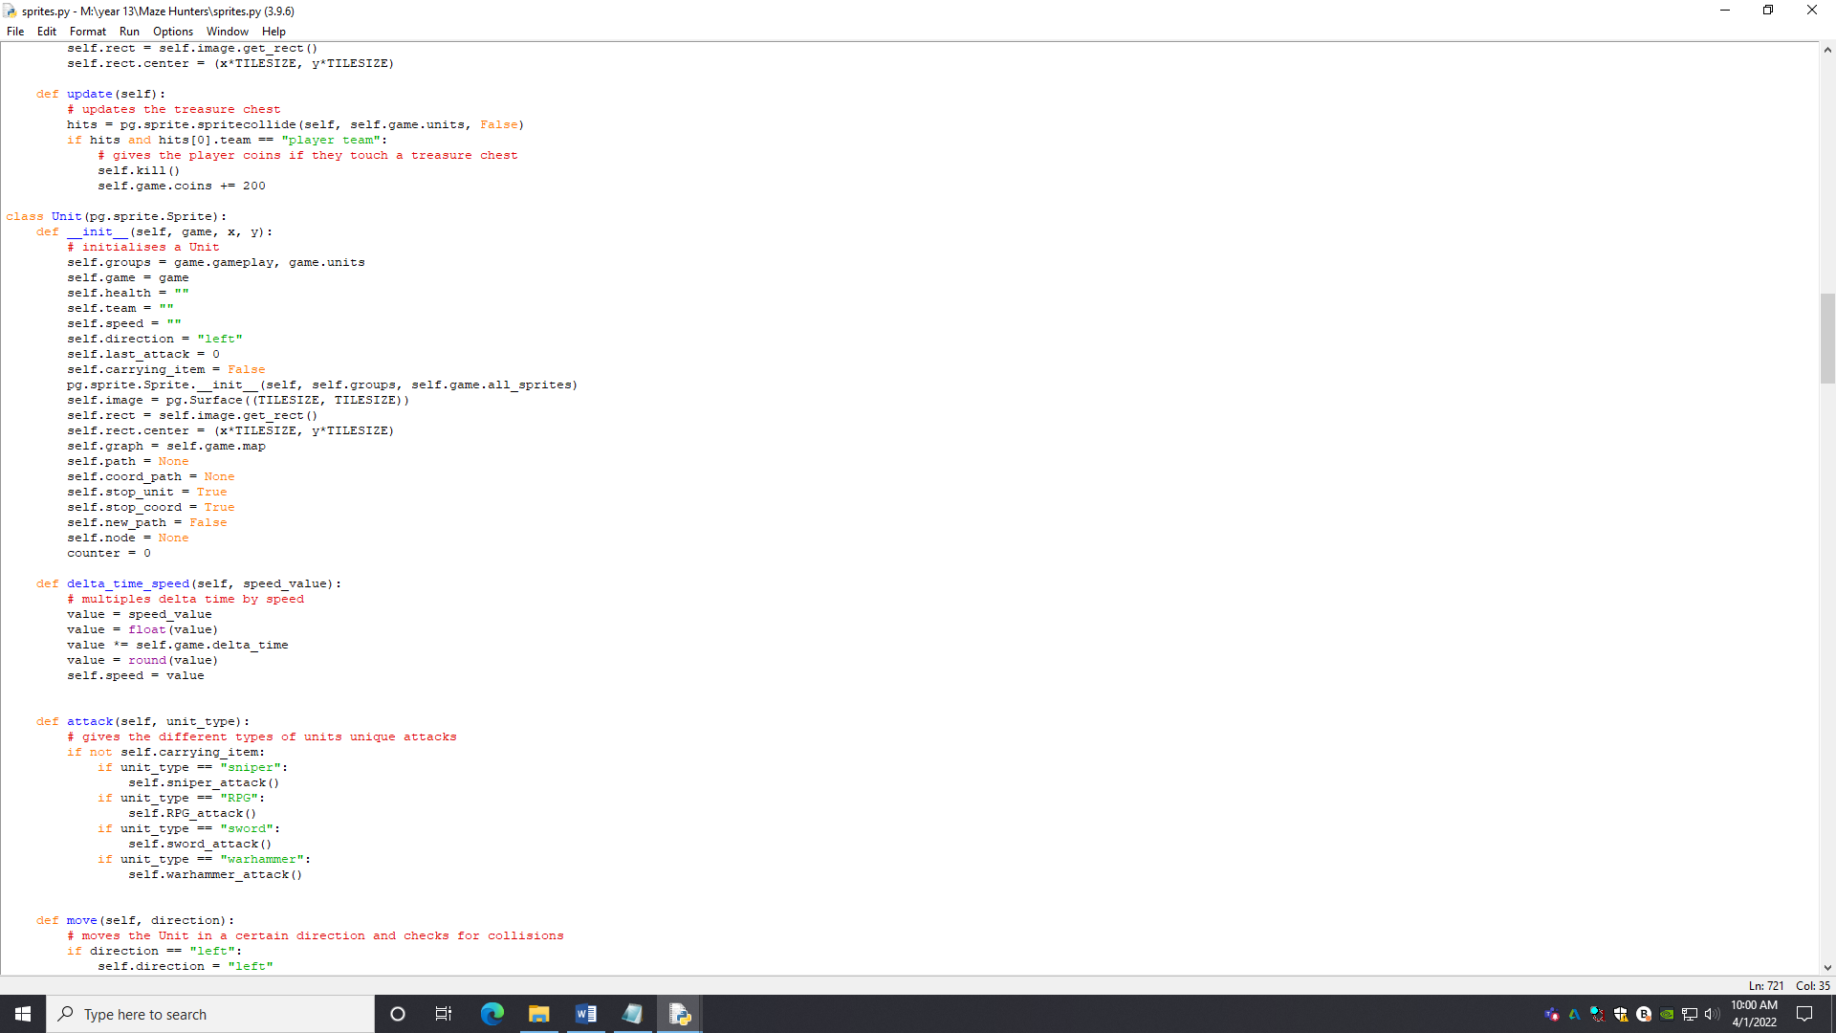

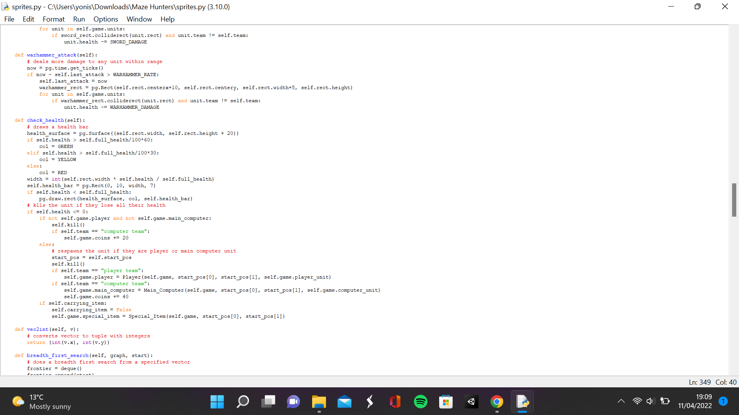

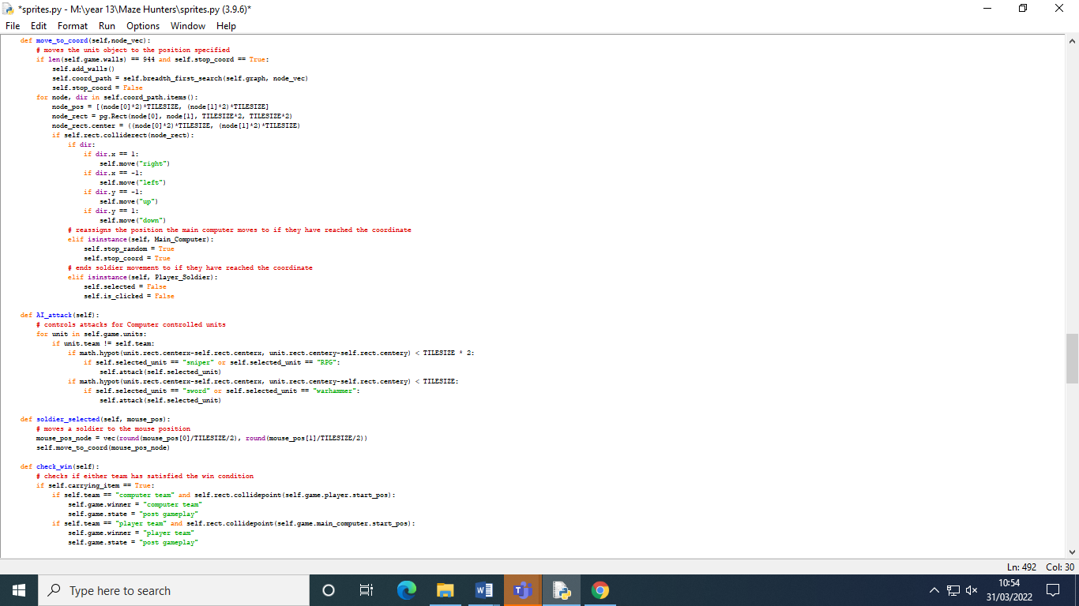

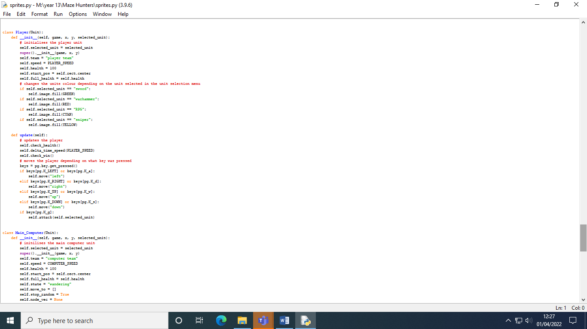

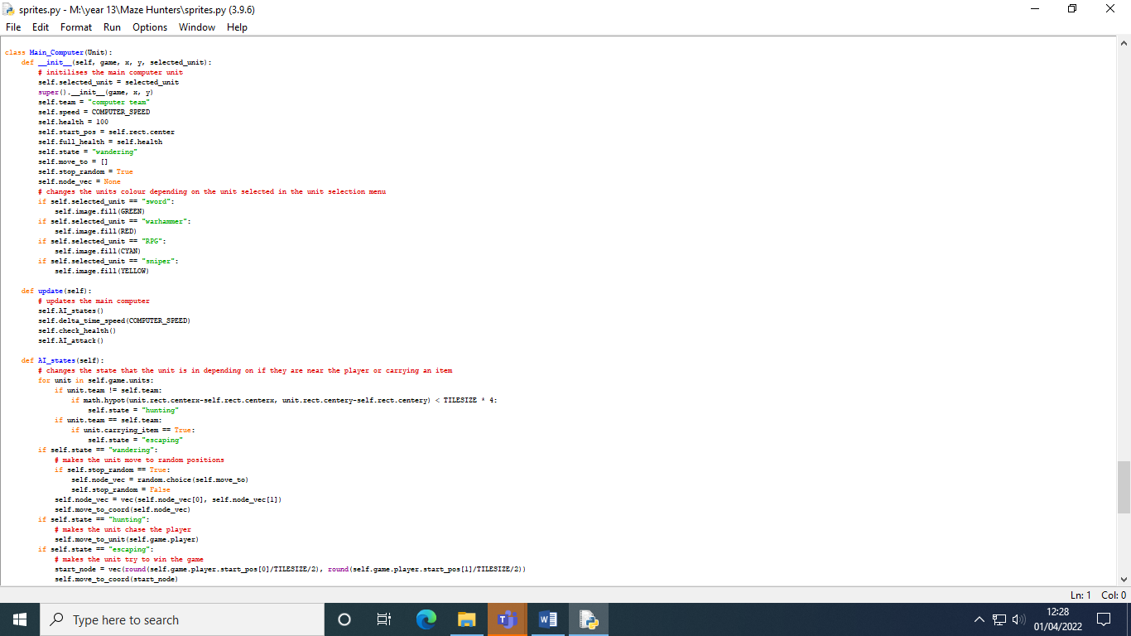

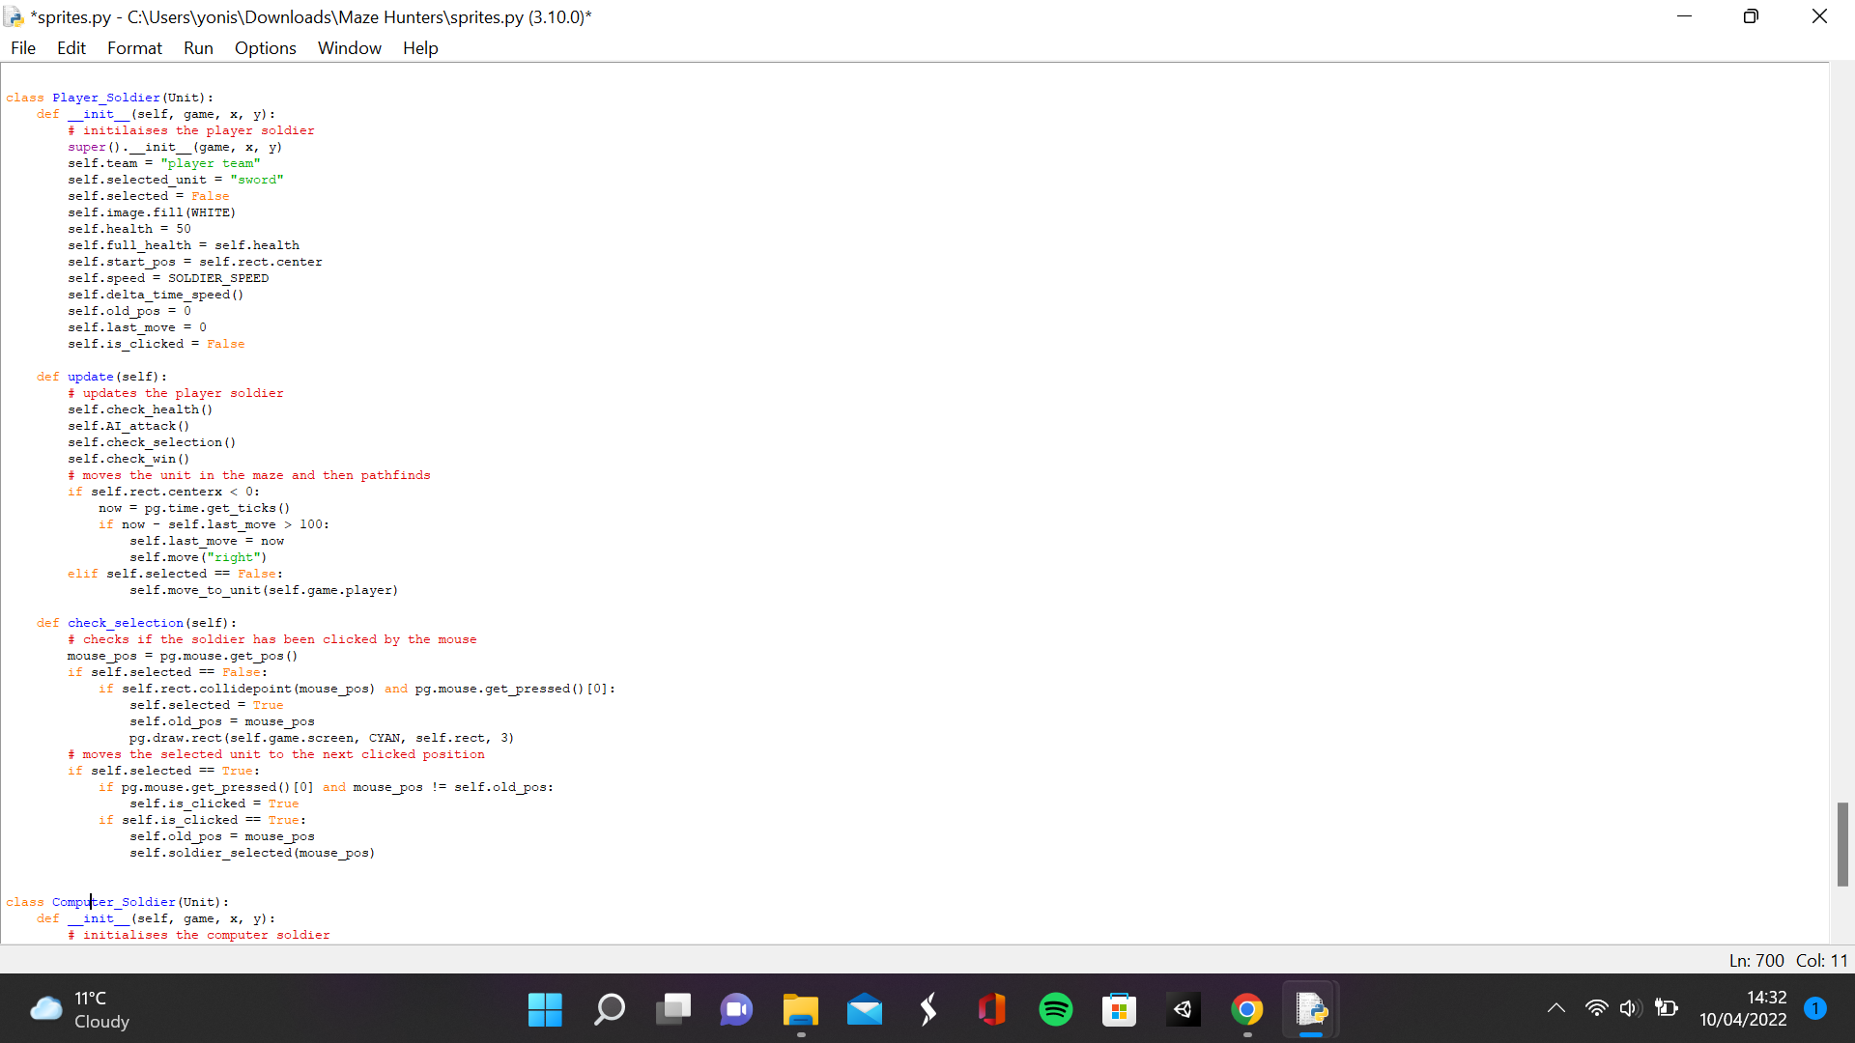

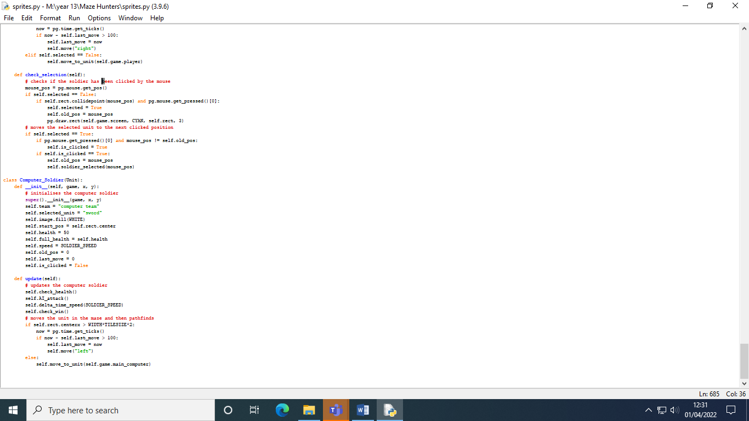

**Settings.py**

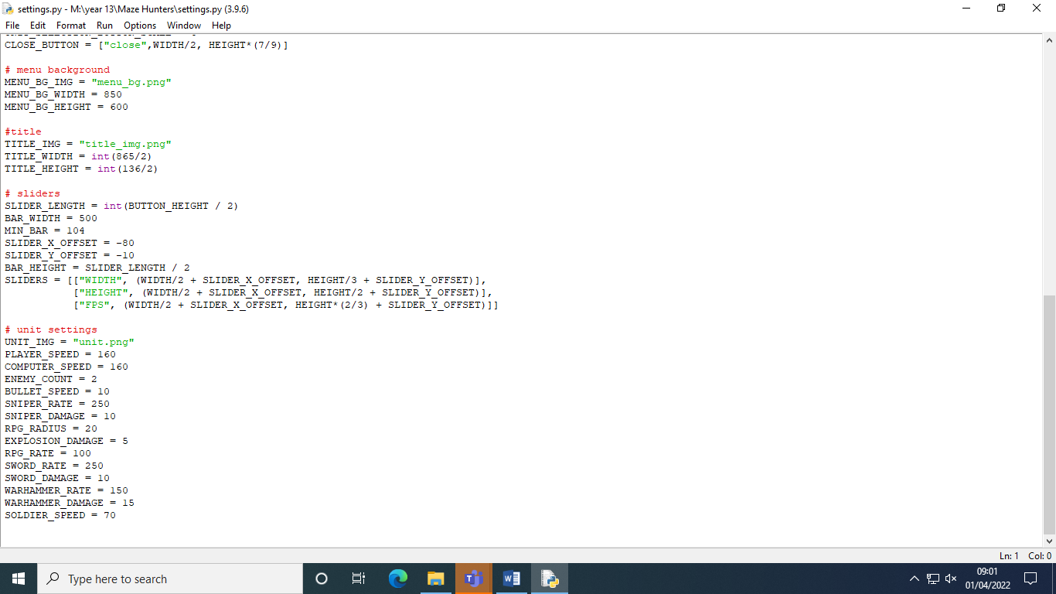

**Map.txt**

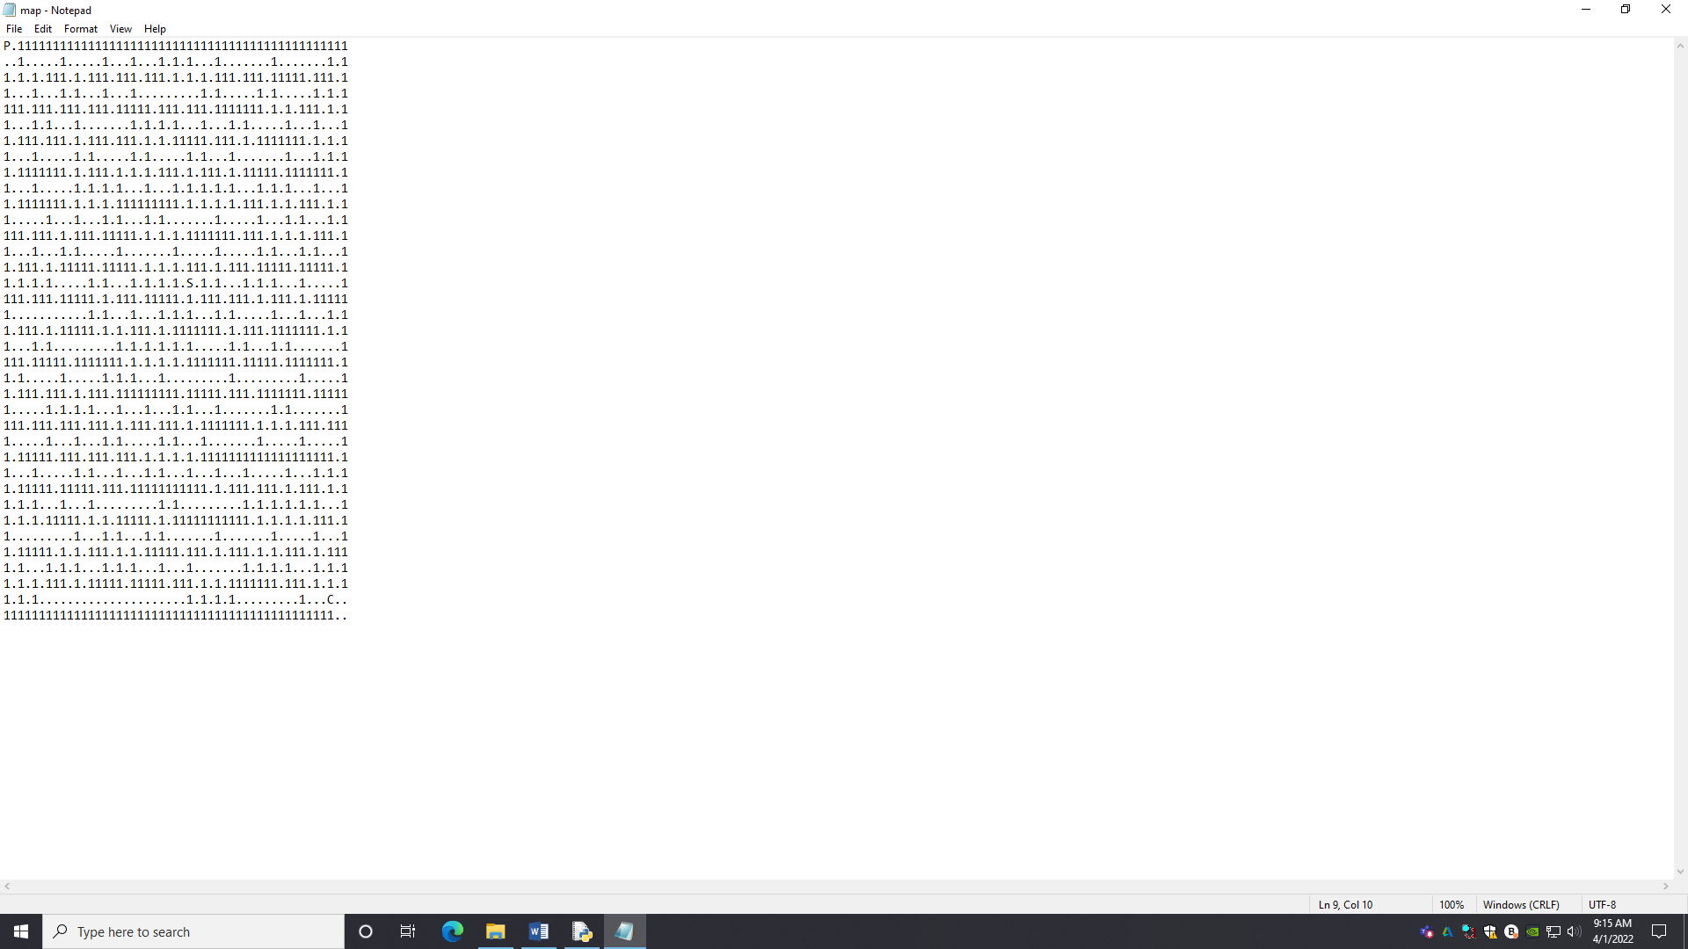

This section is for finishing the game and satisfying every other requirement of the success criteria. The first feature I made was to add a special item that spawns in the centre of the maze. I added an S to the maze and in the main script within the events method, I checked if there was an S and created a special item object in that column and row. The special item class is initialised as a grey square of length 32 with its centre being its x and y parameter multiplied by 32. In the update function, I checked for a collision between the sprites and the units group and if there is a collision, then the carrying item is set to true and the object is destroyed. I also created a treasure chest class which is initialised as a brown square of length 32 with its centre being its x and y parameter multiplied by 32. In its update function, I check if it has collided with a unit and if so, I add 200 to the games coin attribute which was created in the constructor method of the game class.

When I was running my game, I noticed that pathfinding reduced my frame rate a lot when run with multiple units, so I decided to use delta time to make sure that the games speed isn’t influenced by low frame rates. In the run method in the main script, I got the amount of time between frames by getting the number of milliseconds between frames and dividing it by 1000 to get seconds between frames. Then, I created a method in the unit class called delta time speed which multiplies an integer value with delta time and equates the speed attribute to the rounded value. For every child of the unit class, I ran this method in their update method and inputting the value of their speed into the method. In the attack method, I disabled attacks if the unit was carrying an item. In the check health, I implemented health bars for the units. If the amount of health is greater than 60% of their full health, then the health bars colour would be green. If the amount of health is between 60% and 20% then it is yellow and if it is less than 20 % then it is red. The width of the health bar is the width bar multiplied by the units health divided by the units full health. And a health bar rectangle is created at 0, 10 with the width as the width previously defined and a height of 10. Then that health bar is rendered onto the image with the colour previously defined. When the health is less than or equal to zero, if the unit is a soldier, then they are destroyed and if they are a computer soldier, then 20 is added to the games coin attribute. If the unit is not a solider, then they just respawn in their entrances and if they are the main computer unit, then 40 coins is added to the games coin attribute. And then the carrying item attribute is set to false.

I created a new method called move to coord which has the same code as the move to unit method but with some extra Booleans, move to unit constantly follows a unit whilst move to coord, moves to a coordinate, and then immediately stops. The node that doesn’t have a direction is the end node so if the unit has reached the end node, then it wouldn't have a direction. So, I checked if the node did not have a direction and if the unit is the main computer unit, then it has the Booleans used to produce a random position for the main computer to move to assigned to true. If it is a player soldier, then it has the Booleans used for selection set to false. The method unit attack is used to make units controlled by the computer attack. If the unit is of a certain distance to a unit of the opposite team, then they attack buy running the attack method. For sniper and RPG units, the distance is the tilesize times 2 whilst for sword and war hammer the distance is tilesize. The method soldier selected just gets the mouse position and moves the unit to that mouse position. The checks win method checks if a unit is not only carrying an item but also is at the opposing team's entrance and if so, then the winner attribute would be set to the unit's team.

For the Player class, I added a new attribute called start pos which stores the original position of the unit and full health which stores the initial health of the unit. These attributes are added to every unit. In the update method for the player, I run the check win and delta time speed methods. In the main computer class, I added the attribute move to which stores all the possible places the computer could move to. The attribute stop random is a Boolean used to reassign the position the main computer moves to once. The attribute node vec is the current node the main computer is moving towards. The attribute state determines the behaviour of the main computer unit. The method AI states is used to control the state that the AI is in and what the main computer does in that state. So, it checks every unit in the game and if a unit of the opposite team is close to it, then the state attribute is set to hunting and if a unit in the same team is carrying an item, then it is set to escaping. The state attribute is initially set to wandering and when its wandering then it would check if stop random is true and if so, then node vec is assigned to a random position in the move to attribute. Stop random is then set to false. Outside the condition, node vec in converted into a vector and the move to coord method is run with the node vec. If the state is hunting, then the main computer unit would just path find to the player and if the state is escaping then the main computer unit would just path find to the player entrance. The AI states method and the AI attack method are run in the update method.

The player soldier has 1 boolean attributes, the attribute selected checks if the unit has been selected and the attribute clicked checks if the mouse has clicked another location after being selected. The attribute old pos stores the original position of the mouse click. The method check selection checks if the unit has been selected by the mouse. First the mouses position is stored in a variable called mouse pos. If selected is false, the mouse is colliding with the unit and the mouse is being clicked, then selected is set to true and the mouses position is equal to the old pos attribute. If selected is true, then it checks if the mouse is clicked and the mouse’s position is not equal to the old one and if so then the attribute clicked is set to true. If clicked is true then old pos is assigned the value of mouse pos and the soldier selected function is run with the mouse position. The computer soldier class is almost identical to the player soldier class but with a few changes. There isn’t a check selection function, the soldiers follow the main computer unit instead of the player and the soldier moves in the opposite direction to enter the maze.

In the main script, I created 3 new attributes. Winner which stores the current winner of the game, coins which stores the coin count and paused which checks if the game is paused. In the load data method, I also created an attribute called dim screen which is a dim screen that would go over the current screen when the game is paused. I changed my mind in making it a pause menu since I couldn’t make the pause button independent of the camera. In the new method, I created a sprite group called post gameplay for the game over menu and created a menu background and a close button in that group. In the update method, I also checked if the state attribute is equal to post gameplay and if so, sprites in the post gameplay state would update and I also check if the paused attribute is false when the state is gameplay. I put the main game loop in a function called main so that in the events method, if the post gameplay’s close button is pressed, the game is reset. When the play button is pressed, I added an empty array called empty spots, and if a tile is a dot, then the position of the tile is added to the empty spots array. There is also a 1 in 10 chance that a treasure chest would be spawned in that position as well. The main computer unit’s move to attribute is assigned the value of empty spots. The computer soldier units are also created in the same way as the player soldier unit but with the main computer unit tile. If the key P is pressed, then the paused attribute would be set to the opposite boolean value. If the key U is pressed and the coin attribute is greater than 1000, then 800 is subtracted and every unit in the player team has 20 added to their health. If the key n is pressed and the coin attribute is greater than 1000, then 200 is subtracted from coins and a player soldier is spawned with a 1 in 2 chance of a computer soldier spawning as well. In the draw method, when the state is gameplay, the coin count is drawn onto the screen and when the coin attribute is greater than 1000, text telling the player to upgrade team or buy soldiers is rendered onto the screen. When the state is post gameplay, the winner, the coin count and the text game over are rendered onto the screen with all sprites in the post gameplay group. If the paused attribute is true, then the din screen is rendered onto the screen and the text paused is also rendered onto the screen.

|  |  |  |  |
| --- | --- | --- | --- |
| What is being tested | Data input | Expected output | Actual output |
| The player can move their soldier units | A first mouse clicks to select a soldier unit and a second mouse click to move it | The soldier unit should be highlighted in the first click and should then move to the location that the second mouse click leads to | The soldier doesn’t get highlighted but still moves to the location of the second mouse click |
| Player can collect coins from treasure chest | Player moving towards a treasure chest and touches it | The treasure chest should de-spawn and the number of coins the player has should increase | The treasure chest does de-spawn, and the number of coins increases |
| Player can earn coins from killing units | N/A | The number of coins the player has should increase after killing a unit from the computer team | The player’s coin count does increase after killing units |
| Upgrade button increases the stats of the units | Mouse clicks on the button | The health and damage of all the soldier units increase | The health does increase but I decided to not increase the damage |
| Spawn button spawns a new soldier | Mouse clicks on the button | A new soldier will spawn at the player entrance | A new soldier is spawned at the entrance |
| Pressing the pause button pauses the game | Mouse click on the button | The game is frozen, and the pause menu is loaded | I changed it to pressing the key P which does pause the game and a pause screen is loaded |
| Pressing the pause button after the pause menu has loaded replays the game | Mouse click on the button | The pause menu is closed and the game resumes | Pressing the key P replays the game |
| Computer attacks if player or their soldiers get too close | N/A | The computer unit attacks | The computer units do attack |
| Computer unit switches to hunting state when it first attacks the player | Player moves away from the computer units | The computer switches to the hunting state and starts chasing them | The computer unit switches sot hunting state and chases the player |
| Pressing the menu button opens the menu | Mouse clicks on the button | The game over menu is closed and the main menu is opened | The main menu is opened after the game over menu is closed |
| Pressing the replay button opens the unit selection menu | Mouse clicks on the button | The unit selection menu is loaded | Decided not to do this since you can just replay the game from the menu |

**Initial gameplay with coin count displayed**

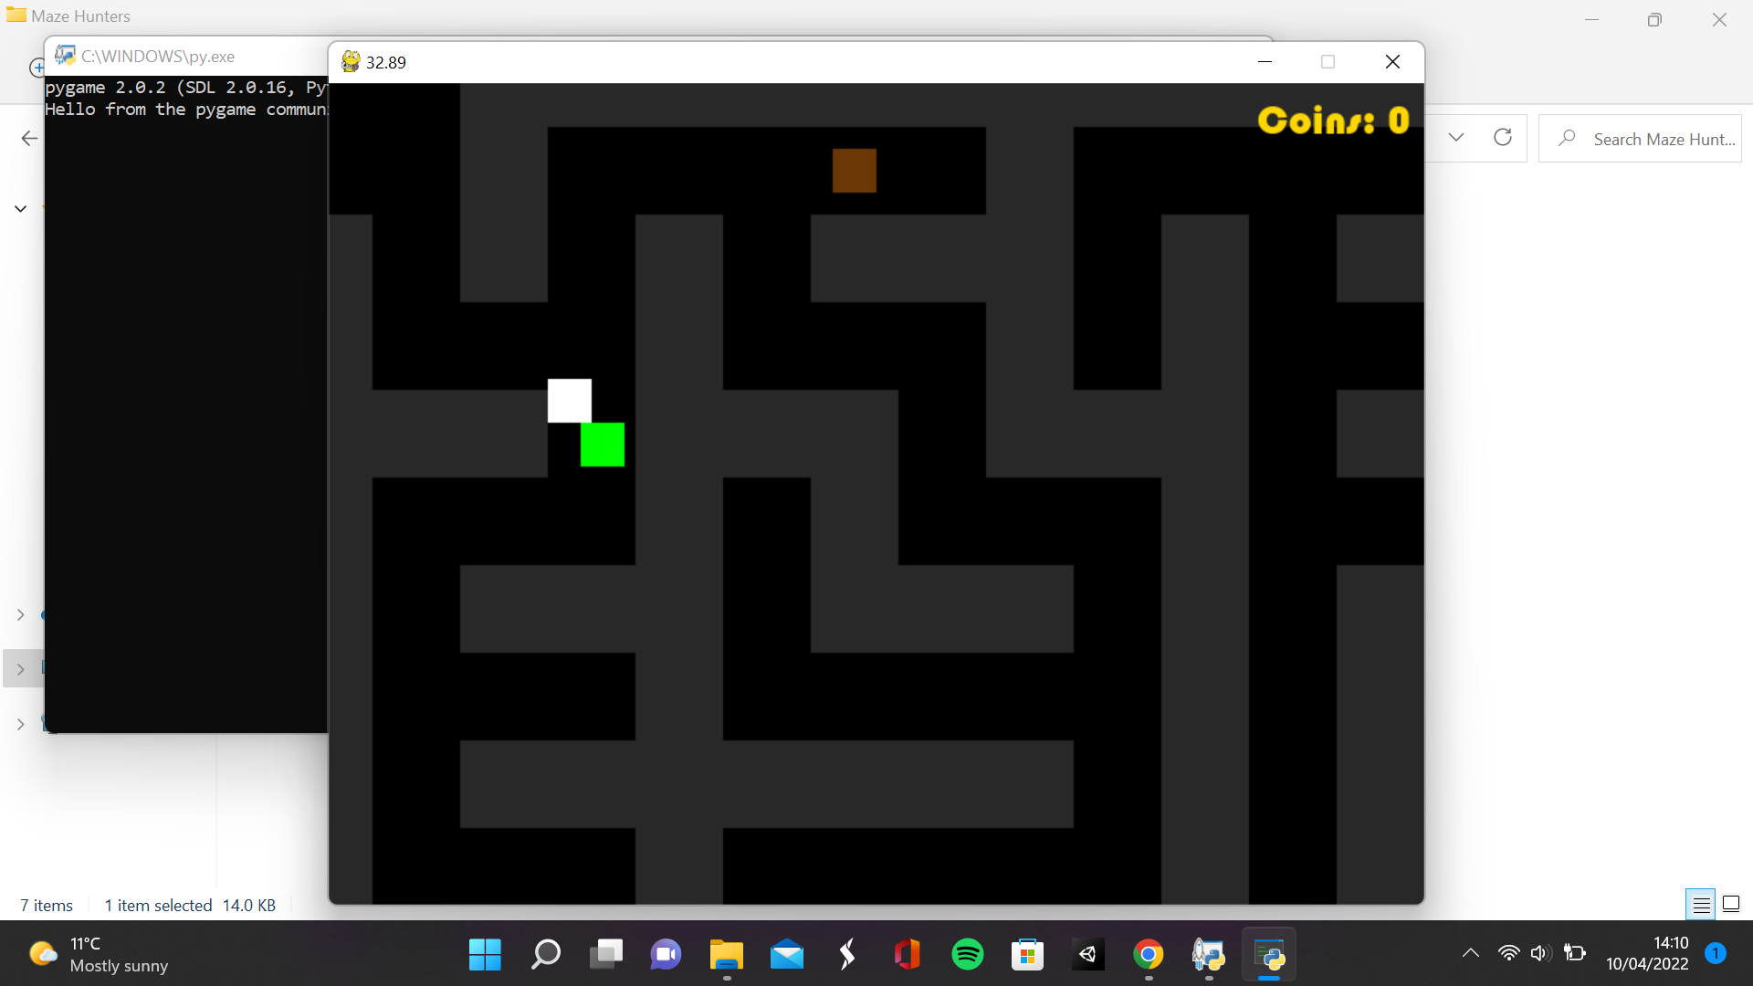

**Moving the soldier**

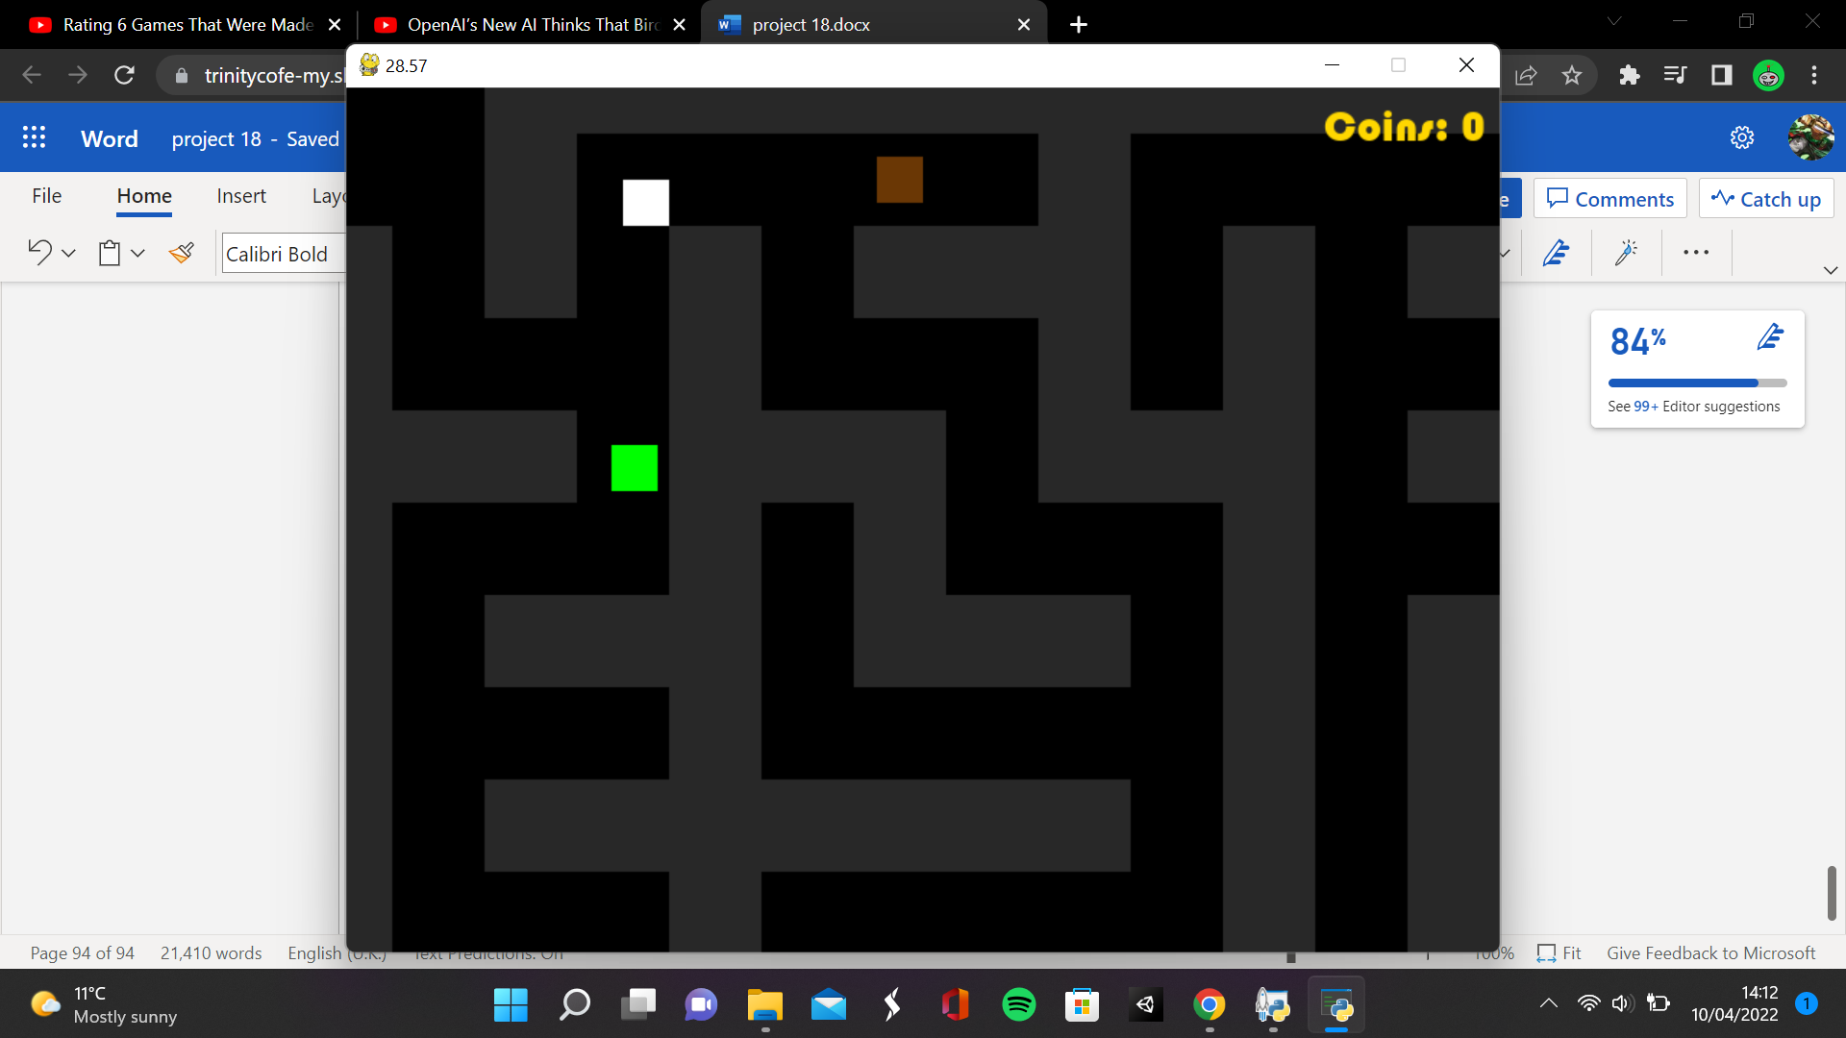

**Collecting treasure chest**

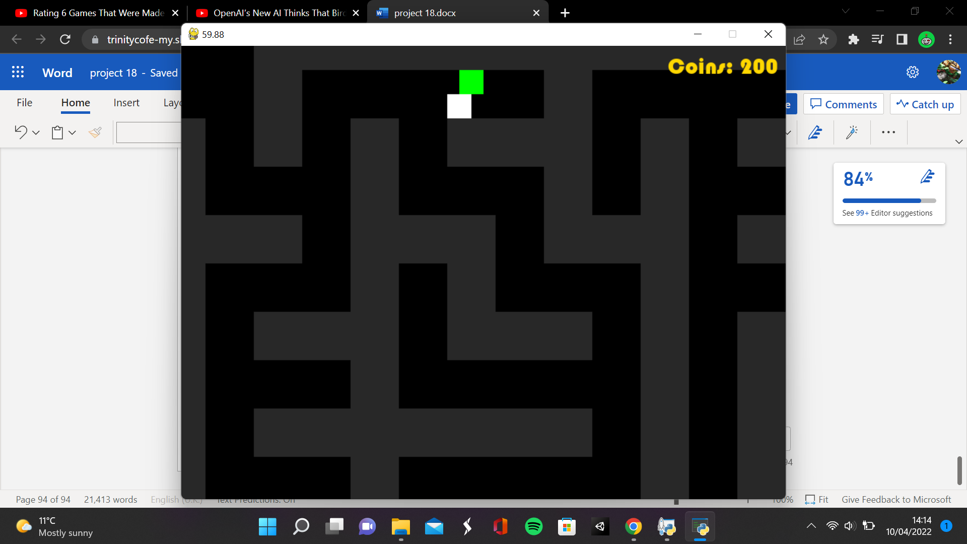

**Paused Game**

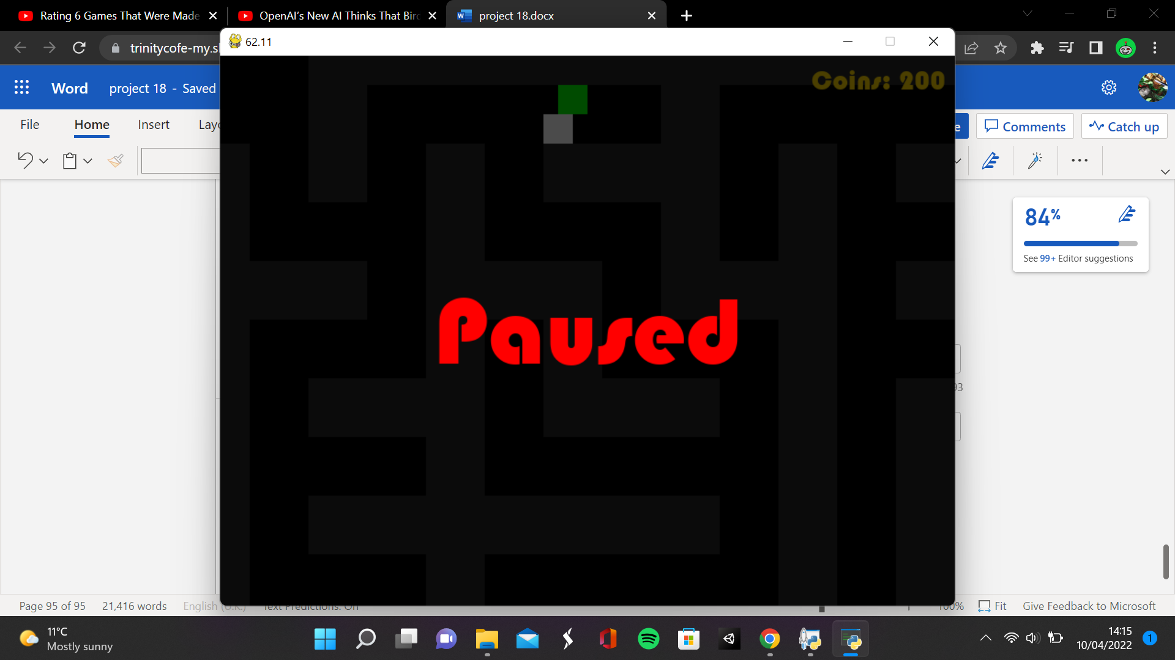

**Coin count after killing computer unit**

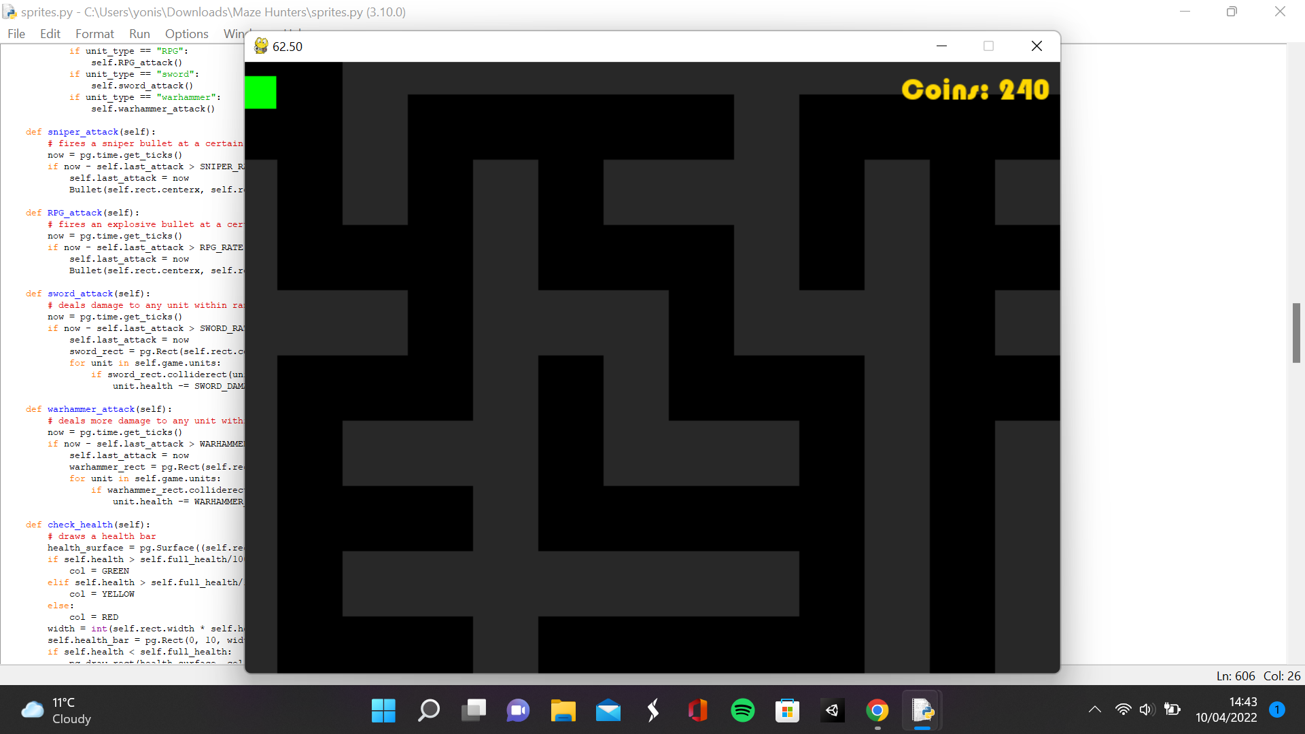

**Game giving option of spending coins**

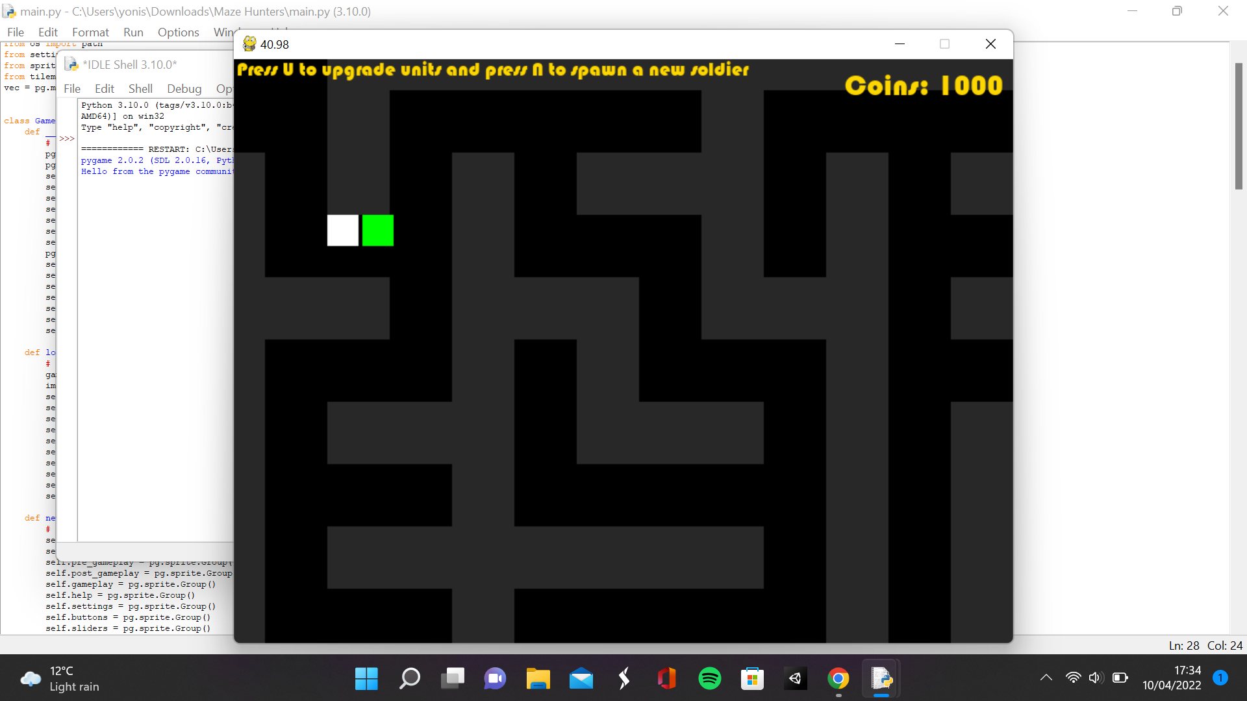

**Computer unit chasing and attacking player**

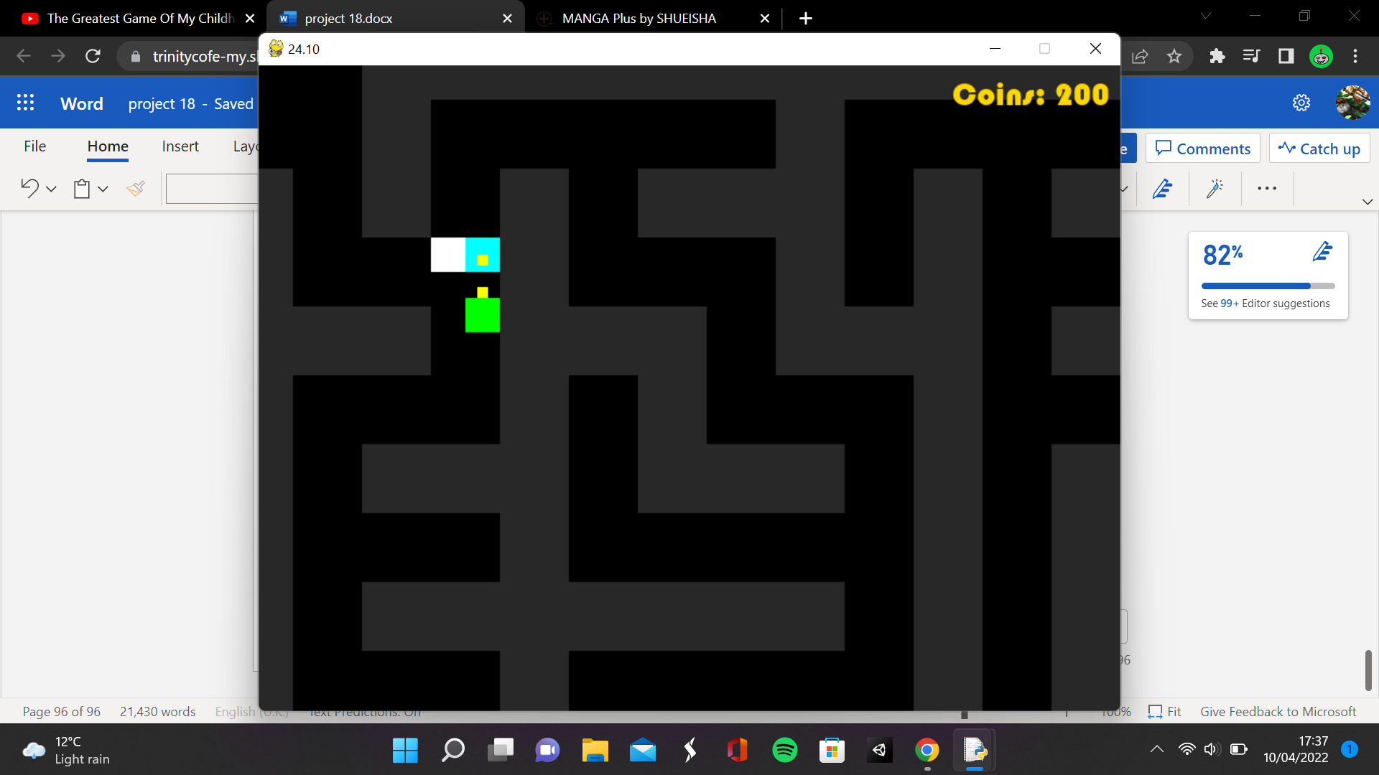

**Game Over screen**

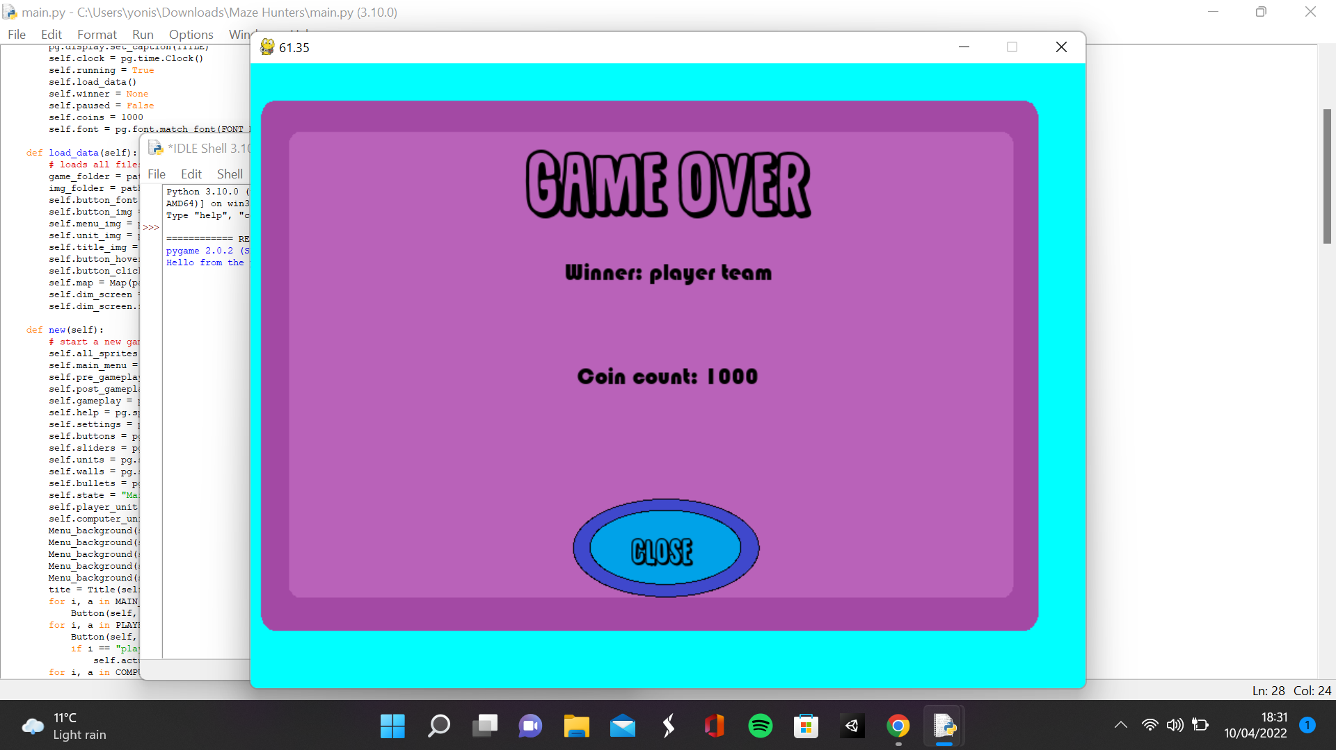

# Evaluation

## Testing to inform evaluation

|  |  |  |  |
| --- | --- | --- | --- |
| What is the requirement | How will it be tested for functionality | Actual outcome | Was the requirement met? |
| The buttons must switch sprites when pressed and clicked | I will hover over every button to see if it changes to the hovering image and then click it to see if it changes to the clicking image | The button changes to the hovering sprite when it is hovered over and to the clicked sprite when it is clicked | Yes |
| The main menu has 3 buttons | N/A | The menu has 3 buttons | yes |
| The play button loads up the pre-gameplay state | Click the play button and if it loads the unit selection menu then it works | The unit selection menu is loaded after the play button is pressed | yes |
| The settings button loads the settings menu | Click the settings button and see if it loads the settings menu | The settings menu is loaded after the settings button is pressed | yes |
| The help button loads the help menu | Click the help button and see if it loads the help menu | The help menu is loaded | yes |
| Constants can be modified in the settings | Drag the sliders and see if the constants change | The constants do change but only with the screen and not the sprites | partially |
| All menus other than the main menu must have a back button | Check all menus to see if they have a back button | All menus have a close button | yes |
| The pre-gameplay state has 4 units to choose for the player and the computer | Look at the unit selection menu and see if there are 4 buttons for each unit | There are 4 buttons for each unit | yes |
| Only one unit can be selected for the player and computer | Select 2 buttons for each unit and see when the game is loaded if only the second button is the one that set the unit | The second button selected is the one set for the unit | yes |
| Each type of unit can be selected for the player and computer | See if there are buttons for sword, RPG, sniper and war hammer for both the player and the computer | There is a button for every type of unit for the player and computer | yes |
| The play button loads the game | Click the play button and see if it loads the game | The game is loaded | yes |
| The play button can only be pressed when a unit is selected for both the player and the computer | Try to press the play button before a unit is selected for the player and computer and nothing should happen | The play button doesn’t work before both units are selected | yes |
| The units selected by the player and the computer are loaded into the game | Load the game and see if the player and main computer unit are the units selected in the unit selection menu | The units selected for the player and computer are loaded into the game | yes |
| All objects spawn in the right locations | See if the player and their soldiers are spawned in the player entrance, the main computer unit and their soldiers are spawned in the computer unit entrance and if the special item spawned in the centre of the maze | The player, main computer unit and their soldiers spawn in their entrances and the special item spawns in the centre of the maze | yes |
| Maze is rendered from a tile sheet | Check if the maze matches the tilesheet | The maze is rendered from a tilesheet | yes |
| Maze has collision detection with units | See if any units phase through the maze | Units collide with maze | yes |
| Camera following the player | See if the camera moves with the player | The camera does follow the player | yes |
| All player soldiers follow the player if not given a command | See if the non selected player soldiers follow the player | The soldiers follow the player | yes |
| All units have a certain amount of health | Output the amount of health the units have | All units do have a certain amount of health | yes |
| All units take damage from attacks | Output the amount of health a unit has after they are hit | All units do take damage from attacks | yes |
| Health bar is displayed at the top of a unit | See if there is a health bar above every unit | Health bar is displayed on a unit instead of on top | partially |
| When a unit loses all their health, they die | See what happens when a unit has no health | A unit dies when they lose their health | yes |
| All units can attack units of the other team | Check to see if there are any units that don’t attack | All units can attack units of the other team | yes |
| If a unit touches a special item, they should then hold it | See if the sprite of the unit switches to the holding sprite | The carry item attribute is set to true so the unit is carrying the item. Didn’t use images since I ran out of time. | yes |
| When a unit is holding the special item then they cannot attack | See if a unit holding the item is attacking anything | Units carrying items can’t attack | yes |
| When the special item is brought to the entrance of the maze, the unit’s team wins | See if the post gameplay screen opens when the unit carrying the item reaches the entrance | Unit’s team wins the game when the item is brought to the entrance | yes |
| If the unit carrying the special item is killed, then the item is dropped | See if the item is there after the unit dies | The item is dropped after the unit dies | yes |
| All states of the AI function as intended | Check the behaviour of the units in the computer team and see if they function like the state they are in | The states function as intended | yes |
| All states are active at the right times | Output the state the AI is in | The states are active at the right times | yes |
| The player moves when the WASD keys or arrow keys are pressed | Press the WASD or arrow keys and see if the player moves in the direction of the key pressed | The player does move when the WASD or arrow keys are pressed | yes |
| The player should attack when pressing the G key | Press the G key and see if the player attacks | The player attacks when the G key is pressed | yes |
| When they player clicks a player soldier unit, they should be able to move them | Click a soldier unit then click a location and see if they are able to move to that location | The player soldier moves to another location after being pressed | yes |
| When a computer soldier is killed by the player units, they earn coins | See if the number of coins increase when a soldier unit is killed | The player does earn coins after killing units | yes |
| The coin count at the top of the screen is accurate | Output the number of coins the player has and see if it matches | The coin count is accurate | yes |
| Treasure chests randomly spawn across the map | See if the chests are spawning in various locations every game | Treasure chests do spawn around the map | yes |
| The player should earn 200 coins if they touch the chest | See what the coin count is before and after touching the chest | The player does earn 200 coins when they touch a chest | yes |
| When the player earns enough money, they can upgrade and replace troops | Check to see if the upgrade and spawn buttons appear after earning 1000 coins | The player can upgrade or spawn soldiers | yes |
| The computer will automatically spawn soldiers | See if new soldiers spawn at the computer entrance | I changed it so the computer soldier has a chance of spawning when player soldiers spawn | partially |
| The pause button pauses the game | Press the pause button and see if it pauses the game | I changed it so pressing P pauses the game | partially |
| When the game is over, the game over menu should appear | When the game is won, see if the game over menu appears | The game over menu does appear | yes |
| The game is fun | Have a user play the game and give feedback | Game is too long and boring | no |
| The game provides some difficulty but is still playable | If I am able to complete the game easily in a short amount of time or fail to beat the game many times in a row then the difficulty needs to be adjusted | The game takes a very long time to complete due to difficuty in navigating maze so difficulty is too high | no |
| The game can perform well with many units | Increase the amount of enemies in the game and keep track of the FPS and see if there is a massive drop | Frame rate drops when pathfinding no matter how many units are in the game | no |
| The game can deal with erroneous inputs | Press buttons on the keyboard other that WASD, arrow keys and G key and see if something happens | The game doesn’t respond to erroneous inputs | yes |

## Usability Features

There were many features I implemented to make the product usable. First, every button is labelled to clearly show the user what each button does. The button labelled settings opens the settings menu, the button labelled play allows you to play the game etc. This makes it easier for the user to understand what each button does. In the game itself, I displayed the amount of coins the user had collected in the game at the top of the screen and had a health bar displayed on a unit when they took damage, so the user has a clear idea of how well they are doing in the game. I used familiar layout controls like WASD keys or arrow keys for movement. I used both so the user can use whatever is familiar to them. Each menu is clearly labelled so the user knows what to do in each menu.

## Commentary on how well the solution matches the requirements

Overall, I think that the solution does match the requirements a lot. There were only a few requirements that were partially met or not met at all. Constants being modified in the settings was a requirement I tried to meet early into development, but I could not due to the way that variables were imported into the game. I could have imported the script instead of the variables so that they could be modified by referring to the script but that would require rewriting every reference to those variables in my code. The health bars were not rendered at the top of the unit due to the health bar being rendered on the image instead of on the screen. I could have tried to render the health onto the screen and manually place it on each unit, but it did not work so I stuck with this.

There were 2 requirements that I decided to not implement into the game. The computer automatically spawning soldiers was something I decided to change since the game is long so the maze could get filled with soldiers. So instead, I changed it so that there is a 50% chance a computer soldier spawns when a player soldier spawns. I couldn’t implement a pause button since the camera affected the pause button as well, so I decided to just use the letter P to pause the game and replay the game instead.

The game wasn’t fun to play for many reasons. First, since I did not add sprites or sound effects, some actions in the game had nothing happen. The sword and Warhammer attacks had nothing happen so the soldiers and the main units (if they chose sword or Warhammer) did nothing when they contacted each over. Another reason is that navigating the maze takes a long time to do. So most of the time is spent wandering through the maze doing nothing since the player is unlikely to encounter the main computer unit. Also, when the computer unit is chasing the player, you are guaranteed a win since the computer unit isn’t going to get the special item so you can just have the computer unit chase behind you until you win the game. A lot of these are design issues due to not having well thought out the games design. I could have tried to add extra items.

The games difficulty does need to be adjusted since the game can range from impossible to incredibly easy. The main computer unit can beat the entire game without the player even noticing if they path find to the special item before they encounter the player. Or if the player finds the main computer unit, they can just have the main computer unit tail behind them whilst they collect the special item and beat the game. And due to the way that I programmed the pathfinding, you can have the main computer unit not attack in your direction. So I probably should add more obstacles in the way of winning the game like having more items to collect so that the computer can’t just beat the game without the player noticing.

The frame rate was not great at all. The frame rate halved when it went to the unit selection screen, and I don’t know why. It might be due to the 10 buttons on screen but I am not sure. The game had difficulties with pathfinding and was lagging a lot when pathfinding. Initially it worked fine but when I tried to make the main computer unit path find to random locations, the game dropped to single digit fps. Sometimes, the game would just freeze for several seconds when moving. I think that the reason for this was due to having many for loops running per frame. A lot of the times I would be iterating through and entire group or array just to only use one sprite in the group or one item in an array. So if I could find a way to get specific items in a group or array, the game would run a lot better.